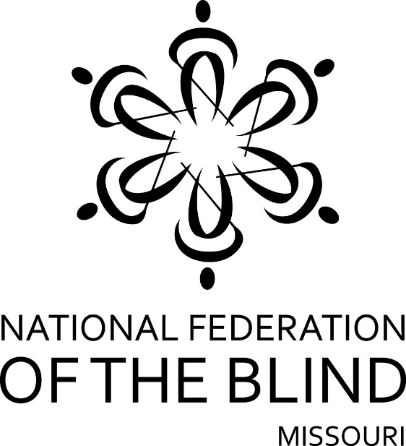

FIFTY-SIXTH ANNUAL CONVENTION

NATIONAL FEDERATION OF THE BLIND
OF MISSOURI

April 5 to April 8, 2018

Capitol Plaza Hotel
415 W. McCarty Street, Jefferson City, MO 65101
(573) 635-1234
Top of Form
Bottom of Form

PLEDGE OF THE
NATIONAL FEDERATION OF THE BLIND

I pledge to participate actively in the efforts of the National Federation of the Blind to achieve equality, opportunity, and security for the blind: to support the policies and programs of the Federation and to abide by its Constitution.

Welcome to Jefferson City,

Members of the Jefferson City Chapter are proud to host this year’s annual state convention and extend a warm welcome to you.
Our Jefferson City Chapter invites you to join them for Hospitality in the Kansas City Room on the Second floor. Hospitality will run from 5:00 to 10:00 Friday evening.
Registration will be held Friday morning from 8:45 AM to 9:15 AM outside the Missouri Room, Friday evening in the hotel Atrium from 5:00 until 7:00 and again on Saturday morning from 8:00 to 8:30. Registration at the convention will cost $20.00 per person and $40.00 for a banquet ticket. Please register so you will be eligible for door prizes and other convention activities. Even if you have pre-registered, please come to this area to pick up your registration packet. The hotel is not obligated to honor convention rates if proof of registration for the convention is not available when you check-out.

Exhibits will be in the Hotel Atrium Friday evening from 5:00 until 10:00 PM and again on Saturday during the lunch break.

Room rates are $89.00 a night plus 14.725% tax for up to four in a room. The hotel has an indoor swimming pool, fitness center, pet friendly, free parking, free Wi-Fi, a business center, and a 24-hour gift shop. This is a smoke-free hotel. Hotel Check-in is 4:00 PM and checkout is at 11:00 AM.

Located in the stunning atrium of the Capitol Plaza Hotel Jefferson City, Park Place is considered one of the best downtown restaurants in Jefferson City. For a quick meal, a snack, or your favorite cocktails and beverages, visit the Fountain Court Lounge, also located in the hotel’s atrium featuring appetizers, sandwiches a variety of cocktails, and an impressive wine list. Room service is available after 4:00 pm daily.

Check-out time for the hotel is 11:00 AM on Sunday. Please check out before the Sunday morning session begins.

The hotel has a guide dog relief area. Please check with the desk to be directed to it, and be prepared to pick up to keep the area clean for other guide dogs that follow you.

Please remember that all of our events are smoke-free, and the hotel reserves the right to fine anyone who leaves a room that has been used for smoking.

There will be planned lunches on Friday and Saturday in the Carnegies Room. If you did not purchase your tickets during preregistration and you still would like to obtain one, please check at registration to see if they are still available. These are the first counts the hotel will need, so if you do not obtain them when you first arrive, sales may be closed.

A prayer breakfast led by the Jefferson City Chapter will be held on Sunday morning at 7:00 AM in the Carnegies Room.

Door prizes will be given throughout the convention, and each chapter is encouraged to bring their donations to the registration table in the exhibit area. You must be in the room or must be working on convention business to win. Please see that prizes get to Nina Theroff, this year’s door prize chair.

The general sessions on Saturday and Sunday will be held in the Missouri Room and the banquet will be held in the Jefferson Room.

THURSDAY, April 5

7:00 PM One Touch Self Defense Class ($10.00 per person) Roger Crome and Amy Wilson, Certified One Touch Coaches – Carnegies Room

8:00 PM The Federation Meet-Up Spot – Come get acquainted members and have fun – Carnegies Room

FRIDAY, April 6

9:30 AM – 11:30 AM National Federation of the Blind of Missouri Board of Directors Meeting – Missouri Room

9:00 AM – 11:30 AM Diabetes Action Network – Jefferson B

11:45 AM Luncheon, Carnegies Room

FRIDAY AFTERNOON

12:45 PM The Film “Do You Dream In Color?”
Presented by the NFB of Missouri Public Relations Committee, Daniel Garcia, Chair – Missouri Room

2:15 PM Parents of Blind Children Seminar –Missouri Room

3:30 PM Building the Federation: A Membership Workshop, Julie McGinnity, Chair – Jefferson B

5:00 PM Registration and Exhibits Open – Atrium

5:00 PM Hospitality Opens – Kansas City Room Hosted by the Jefferson City Chapter

5:00 PM One Touch Self-Defense Class ($10.00 Per Person) — Amy Wilson & Roger Crome, One Touch Certified Coaches – Jefferson A

FRIDAY EVENING

6:00 PM Missouri Association of Guide Dog Users – Debbie Wunder, President –Jefferson B

7:00 PM Missouri Association of Blind Merchants, Gene Fleeman, President – Jefferson A
8:00 PM Resolutions Committee, Erin Magoon, Chair
Missouri Room

8:30 PM Missouri Association of Blind Students Seminar — Mark Myers, Vice President – Jefferson B

10:00 PM Nominating Committee – Melissa Smith, Location to Be Announced

SATURDAY, April 8

6:30 AM Scholarship Breakfast (Scholarship Recipients and committee members), Julie McGinnity, Chair – Carnegies Room

All General Sessions—Missouri Room

Saturday Morning Session

8:30 AM Call to order

8:35 AM Presentation of the Colors, Missouri Army National Guard, Ike Skelton Center, Jefferson City
National Anthem Led by Aminah Hirsch, Jefferson City Chapter Member
Recognition of Veterans

8:45 AM Welcome from the Mayor of Jefferson City – Mayor Carrie Tergin

8:50 AM Welcome from Our Host Chapter - Melissa Kane, President, Jefferson City Chapter

8:55 AM Recognition of Our Visitors from Out of State

9:00 AM Meet the 2018 Scholarship Class
Julie McGinnity

9:10 AM Report of the Nominating Committee
Melissa Kane, Chairman

9:15 AM Who Are We?—Mark Riccobono, President, National Federation of the Blind

9:55 AM Questions from the Floor

10:00 AM Fit Break — Robin House, Chairman, Sports and Recreation Committee

10:05 AM Making Roads, Building Resources, and Equipping Blind Consumers for Successful Outcomes — Keith Roderick, Deputy Director, Rehabilitation Services for the Blind, Family Support Division, Department of Social Services

10:25 AM Questions from the Floor

10:30 AM Consumer and Professional: an Artificial Line that Divides and Hurts the People we Want to Help – Gary Wunder, President Emeritus, National Federation of the Blind of Missouri and Editor, The Braille Monitor

10:45 AM Building A Solid Foundation For Your Future: Essential Elements In NFB Training Centers — Julie Deden, Executive Director, Colorado Center for the Blind and Jennifer Wenzel, Blindness: Learning in New Dimensions, Inc.

11:05 AM Thoughts on STEM Careers and My Experience as a Youth Slam Volunteer – Mark Myers, Vice President, Missouri Association of Blind Students

11:20 AM The Promise and the Challenge of the Autonomous Vehicle – Daniel Garcia, President, Kansas City Chapter

11:35 AM What About That Fitness Challenge; Where Did All the Steps Lead Us? – Robin House, Chair, Debra Busch, and Amy Wilson, NFB of Missouri Sports and Recreation Committee

11:50 AM All the Important Things You Need To Know – Gene Fleeman, Second Vice President

12:00 PM Adjourn For Lunch

Saturday Afternoon Session

1:30 PM The King and Queen Envelopes, Please!
Jeff Giffen, Ways and Means Committee

1:40 PM Presidential Report – Shelia Wright, President, National Federation of the Blind of Missouri

2:00 PM What’s New At Wolfner: — Abbey Rimel, Deputy Director, Wolfner Talking Book and Braille Library

2:25 PM Fresh Perspectives and Incredible Opportunities Through the Business Enterprise Program –
James Brinkman, Supervisor, Business Enterprise Program; Jay Rettstatt, Self Employed Blind Manager, Jefferson Building; and Gerome Pope, Temporary Manager, Business Enterprise Program

2:45 PM Programs to Meet the Needs of the Senior Blind - Duncan Larsen, Senior Blind Services, Colorado Center for the Blind, Littleton, Colorado

3:05 PM Fit Break — Robin House, Chairman, National Federation of the Blind of Missouri Sports and Recreation Committee

3:10 PM Ringing the Bell so that Opportunity Knocks -Nathan Deeds

3:20 PM Rittgers Fund – Gene Coulter, Chairman

3:25 PM Travel: The Essential Element for Those on the Move – Julie McGinnity, First Vice President

3:45 PM It’s Only A Click Away – Randy Carmack, WebMaster, WWW.NFBMO.ORG

4:00 PM What I Do When I Am Not Doing Federation Work – Dan Keller, Robin House, and Ruby Polk

4:20 PM Resolutions and Constitutional Amendments – Erin Magoon, Chairman, Resolutions Committee

4:45 PM Adjourn

6:00 PM Doors Open for Banquet and Cash Bar (Bar will be closed from 7:00-9:00)

6:30 PM Banquet of the National Federation of the Blind of Missouri — Melissa Kane, Mistress of Ceremonies

Invocation

Crowning of the King and Queen

Introduction of Guests

Presentation of Awards

Other Business at the discretion of the MC

Banquet Address: President Mark Riccobono, National Federation of the Blind

9:00 PM State Affiliate Auction – Gene Fleeman, Second Vice President

9:30 PM Social Hour – Join the Jefferson City Chapter to visit with your Federation family.

SUNDAY, April 8

7:00 AM Prayer Breakfast hosted by the Jefferson
City Chapter — Carnegies Room

General Session — Missouri Room

8:30 AM Call to Order

8:35 AM A Little Something Everyone Can Use – Amy Wilson, President, Board of Directors, One Touch Project

8:50 AM Report of the Audit Committee — Gene Fleeman, Chairman

8:55 AM Treasurer's Report — Carol Coulter, Treasurer

9:15 AM Governmental Affairs Report — Roger Crome, Chairman

9:30 AM Missouri BELL Academy – Debbie Wunder,
Statewide Coordinator

9:45 AM Our Challenge For Tomorrow

10:10 AM Membership Report – Julie McGinnity
10:20 AM Resolutions and Constitutional Amendments continued — Erin Magoon, Chairman

10:40 AM Elections

11:25 AM Old Business

11:35 AM New Business: Appropriation of Funds to tenBroek, the National Treasury, National Convention Stipend, 2019 Scholarship Program,
Matters presented from the Floor

12:00 PM Adjourn

