DON’T MISS OUT!
Hand Made Quilt Auction
Benefits the Federation Center of the Blind
Measures 72 X 80 inches
Hand Crafted & Pieced by Vicki Willis, South Carolina
(Quilted by Sally Cotrell, All Occasions Quilting
North Carolina)
Split Rail Pattern
Bidding starts at $250 (wholesale value)
Submit your sealed bid to:
Quilt Auction
Federation Center of the Blind
119 S. Kilbourne Rd.
Columbia, SC 29205
Any questions? Call 803-254-3777 Email nfbsc@sc.rr.com
Final Auction, sealed bids will be unsealed and live bids taken
at NFB of SC Convention Banquet on August 19, 2023
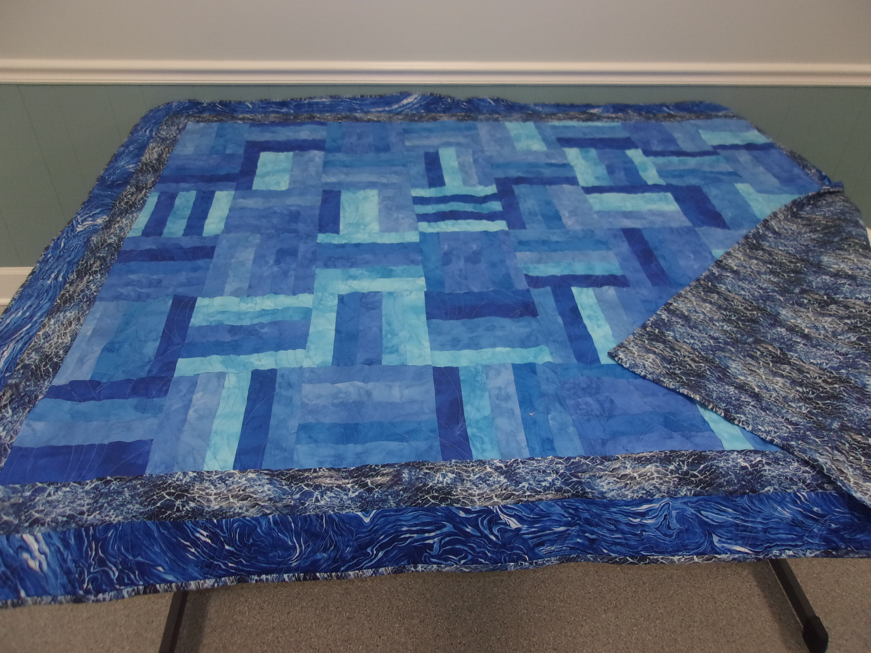
A water motif resembling the ocean on back
Front side uses water motif for trim with
strips of varying shades of blue throughout
This quilt could be yours!

