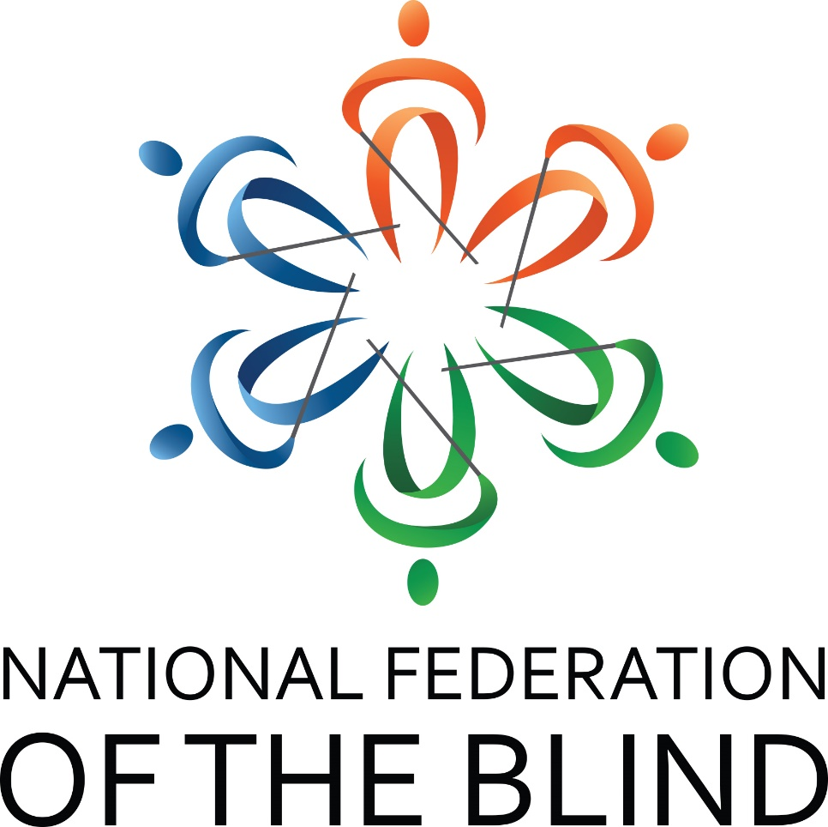

A Winning Team

67th Annual State Convention
National Federation of the Blind of South Carolina

Marty R. McKenzie, President
Embassy Suites by Hilton
200 Stoneridge Drive
Columbia, SC 29210
803-252-8700
Thursday, August 17 – Sunday, August 20, 2023

CONVENTION NOTES

NATIONAL FEDERATION OF THE BLIND PLEDGE
I pledge to participate actively in the efforts of the National Federation of the Blind to achieve equality, opportunity and security for the blind; to support the programs and policies of the Federation and to abide by its constitution.

NATIONAL FEDERATION OF THE BLIND

ONE MINUTE MESSAGE
The National Federation of the Blind knows that blindness is not the characteristic that defines you or your future. Every day we raise the expectations of blind people, because low expectations create obstacles between blind people and our dreams. You can live the life you want; blindness is not what holds you back.

INTEGRITY AND RESPECT
As with all NFB of SC functions, our members are held to the highest standards of decorum outlined in the National Federation of the Blind Code of Conduct. To allow all attendees the chance to benefit from all aspects of the convention, we are committed to providing a harassment-free environment for everyone. We appreciate your assistance in cultivating an atmosphere in which participants from diverse backgrounds may learn, network, and share with each other in an environment of mutual respect. Thank you for doing your part to contribute to our community and the high expectations we strive to maintain.

WELCOME

Welcome to the Embassy Suites Columbia-Greystone. It is our pleasure to have you here with us for your 2023 convention. We are looking forward to a couple of successful days of learning and camaraderie. We hope you enjoy your time here with us and if there is anything we can do while you’re visiting, please don’t hesitate to reach out. Nicole Blackwell is the Director of Sales and Jordan Francisco is our General Manager. Enjoy!

DOG RELIEF AREA
For those with dog guides, there are two specific dog relief areas. A trash receptacle has been placed there for convenience and tidiness. The first area is straight out the front door of the hotel across the parking lot. The second area is out a door near the elevators. This area has a set of steps that must be descended. Ask the front desk if more information is needed.

Contact Us
We have several convenient ways for you to connect with us. They are:

Website: www.nfbofsc.org

Phone: 803-254-3777

Address:
Federation Center of the Blind
119 S. Kilbourne Rd.
Columbia, SC 29205

NFB of SC President:
Marty R. McKenzie
marty2music@outlook.com
843-939-8091

You can also find us on Facebook and Twitter.

National Representative

Ron Brown was born in Gary, Indiana, the first of eight children, to Marzette and Myra Brown on May 15, 1956. When he was a senior in high school, he became blind after he was shot on his way home from a basketball game. At the time he knew nothing about blindness and was overwhelmed by the feeling that his entire life had been radically changed in an instant. One of the first painful lessons he learned was that many of his friends could not deal with his blindness and stayed away from him. Luckily, he began to make new friends, members of the National Federation of the Blind. They became inspiring role models for Ron, teaching him that it was respectable to be blind and that he could continue to strive for the goals he had set for himself.

“I have been an advocate for blind people for more than twenty-five years, and with every passing year my commitment to serving the blind of this nation increases. My life indeed changed the night I became blind, but with the perspective I now have, I must say that it was for the better.”

Armed with this newfound freedom, Ron graduated from Ball State University with a bachelor of science degree in health science. He then went to work at Tradewinds Rehabilitation Center in Indiana, where he met his wife Jean, who was on the staff. Eventually he was offered a job in the Business Enterprise Program. He had always wanted to own his own business, and this gave him the opportunity to do so. He has now been in business for himself for twenty years.

Recently Ron returned to school and earned a master's degree in educational psychology with a certification in orientation and mobility from Louisiana Tech University. He now owns a second business, teaching cane travel to blind people in the state of Indiana.

As Ron Brown has developed and matured in his personal life, his commitment to and service in the National Federation of the Blind have deepened as well. In the early years he was a chapter president and was then elected to the NFB of Indiana's board of directors. He was first elected president of the affiliate in 1996 and has been reelected every two years since. In 2001 he was elected to serve on the NFB board of directors.

SCHEDULE

Thursday, August 17, 2023
5:30–7:30 PM Embassy Suites Complimentary Evening Reception
7:30–9:30 PM Blind Merchants Pre-Convention Prep Session -- Suite
7:30–8:30 PM Rookie Round-Up -- Salons AB

Friday, August 18, 2023
10:00–6:00 PM Registration – Terrace Lounge Wall
10:00–6:00 PM Exhibit Hall – Salons AB
10:00–11:50 AM Blind Merchants Pre-Convention Prep Session - Suite
10:00–10:50 AM SC Association of Guide Dog Users – Salon E
11:00–11:50 AM At-Large Chapter – Salon F
1:00–1:50 PM SC Association of Blind Students – Salon E
1:00–1:50 PM Senior Division – Salon F
2:00–3:50 PM SC Parents of Blind Children – Salon E
Navigating an Individualized Education Program
Carol Castellano, Dr. Tina Herzberg
and Sonia Timmons
2:00–3:50 PM Back to the Basics:
Beginning O&M Skills Refresher
Ron Brown – Salon F

For anyone who never had formal orientation and mobility training or would like to review basic skills. This will be a hands-on session to practice human guide, trailing, self-protective techniques; locating dropped objects; and basic cane techniques. There will be people available to help participants execute the skills as the presenter explains the techniques. It does not take the place of formal O&M training, but will be a good introduction or review of the basic skills.

3:00–3:50 PM Computer Science and Technology Division–
Salon G
4:00–4:50 PM Blind Merchants Division – Salon E
4:30–5:30 PM Resolutions Committee – Salon F
5:30–6:30 PM NFB of SC State Board Meeting – Greystone Hall
7:00–10:00 PM Reception – Salons CD

Saturday, August 19, 2023
7:30–8:45 AM Buffet hot breakfast in restaurant – Self-serve – Boy Scouts available to assist
8:00–8:50 AM Registration – Terrace Lounge Wall
8:00–8:50 AM Exhibit Hall – Salons AB

MORNING GENERAL SESSION – Salons CD

9:00–9:15 AM Welcome Marty R. McKenzie
Invocation Debra Canty
Presentation of Colors Boy scouts
National Anthem Sarah Massengale
Host Chapter Remarks Isaiah Nelson
9:15–9:30 AM NOPBC Representative
Carol Castellano, President
9:30–10:00 AM National Report,
Ron Brown, National Representative
10:00–10:15 AM SC Commission for the Blind,
Darline Graham, Commissioner
10:15–10:30 AM SC School for the Deaf and the Blind,
Scott A. Falcone, Director,
Division of Outreach Services
10:30–10:35 AM Fit Break, Janice Bright, Sports and Rec
10:35–10:50 AM SC Talking Book Services,
Jennifer Falvey, Director
10:50–11:00 AM Palmetto ABLE
Karen Crider
11:00–11:15 AM Invigorating Our Students
Lauren Altman, NABS President
11:15–11:30 AM Diversity, Equity and Inclusion
Derique Simon, Chair
11:30–12:00 PM Presidential Report
Marty R. McKenzie, President
12:00 PM Adjourn

LUNCH BREAK

12:00–2:00 PM Box Lunches – Garden Atrium
12:15–1:45 PM Registration – Terrace Lounge Wall
12:15–1:45 PM Exhibit Hall – Salons AB
12:15–1:45 PM SC Association of Black Leaders – Salon G

AFTERNOON GENERAL SESSION Salon CD

2:00–3:00 PM Where the Blind Work: A Panel Discussion
Sonia Timmons, Moderator
SCPOBC Leader
3:00–3:15 PM Federation Legislative Update from the
Legislative and Advocacy Committee
Ed Bible, Chair and Anna Price, Co-chair
3:15–3:20 PM Fit Break, Janice Bright, Sports and Rec
3:20–3:30 PM Celebrating Forty Years in the Movement
Parnell Diggs, Frank Coppel and Ed Bible
3:30–3:50 PM Breaking Barriers: A Journey to Becoming a Triathlete Amy Hatten, Sports and Rec
3:50—4:05 PM Project Inspire and STEAM Camp
Dr. Tina S. Herzberg
Professor, Visual Impairment Program
University of South Carolina Upstate
Dr. Mary E. Robbins
Teacher of the Visually Impaired
SC School for the Deaf and the Blind Outreach
4:05—4:20 PM NFB-NEWSLINE, Steve Cook, Administrator
4:20–4:40 PM Rocky Bottom Report, Thom Spittle, RBRCCB Chair
4:40–5:00 PM Federation Center Report, David Houck, Executive
Director and Ed Bible, FCB Board Chair
5:00 PM Adjourn

EVENING BREAK
5:15–6:45 PM Registration – Terrace Lounge Wall
5:15–6:45 PM Exhibit Hall – Salons AB
5:15–5:45 PM Nominating Committee – Parnell Diggs, Esq., Chair – Salon G

CONVENTION BANQUET
7:00–10:00 PM

Welcome Marty R. McKenzie
Invocation Demetrius Williford
Keynote Address Ron Brown, National Representative
Awarding of Scholarships Shannon Cook, Scholarship Chair
Recognition of Sponsors Marty McKenzie
Midlands Gives Award Valerie Warrington, Treasurer
Educator of the Year Award Tracy Spittle, Chair
Employer of the Year Award David W. Bundy, Chair
Donald C. Capps Award David Houck, chair
Distinguished Service Award Marty R. McKenzie
Presidential Citation Marty R. McKenzie, President

Banquet Fundraiser
Our annual banquet fundraiser is an opportunity for individuals, chapters, divisions, and business partners to contribute to the NFB of SC to further programs, services, and policies of the affiliate. Donations can be made through PayPal on
www.nfbofsc.org, by cash or writing a check made payable to the NFB of SC and mailed to Federation Center of the Blind. See page 3 for the address.

Adjourn

Sunday, August 20, 2023
7:30–8:20 AM Breakfast
8:00–8:25 AM Registration – Terrace Lounge Wall

MORNING GENERAL SESSION
8:30–9:00 AM Remembering Those Who Went Before Us
A Memorial, Melinda Jones and Doug Hudson
9:00–9:30 AM Rocky Bottom, NFB of SC, and Successful Transitions Treasurers’ Report
Valerie Warrington, Treasurer
9:30–10:00 AM Resolutions, Parnell Diggs, Committee chair,
10:00–10:20 AM Update on SUN, PAC, Dream Maker’s Circle, Frank Coppel, chair, Doing Our Fair Share Committee
10:20–10:25 AM Fit Break, Janice Bright, Sports and Rec
10:30–11:50 AM Elections
11:50–12:00 PM Chapter, Committee, and Division Drawings
12:00 PM Adjourn

