Handmade Quilt Auction Fundraiser

- Proceeds will benefit the Federation Center of the Blind
- Measures approximately 72 X 80 inches
- Hand pieced by Vicki Willis of South Carolina
- Quilted by Sally Cotrell of All Occasions Quilting in North Carolina
- Split Rail Fence Pattern
- Varying shades of blue throughout reminiscent of tranquil waters.

Bidding starts at $250

Quilt Auction
Federation Center of the Blind
119 S. Kilbourne Rd.
Columbia, SC 29205

The auction will conclude at the NFB of SC State Convention Banquet
on August 19, 2023 at Embassy Suites.
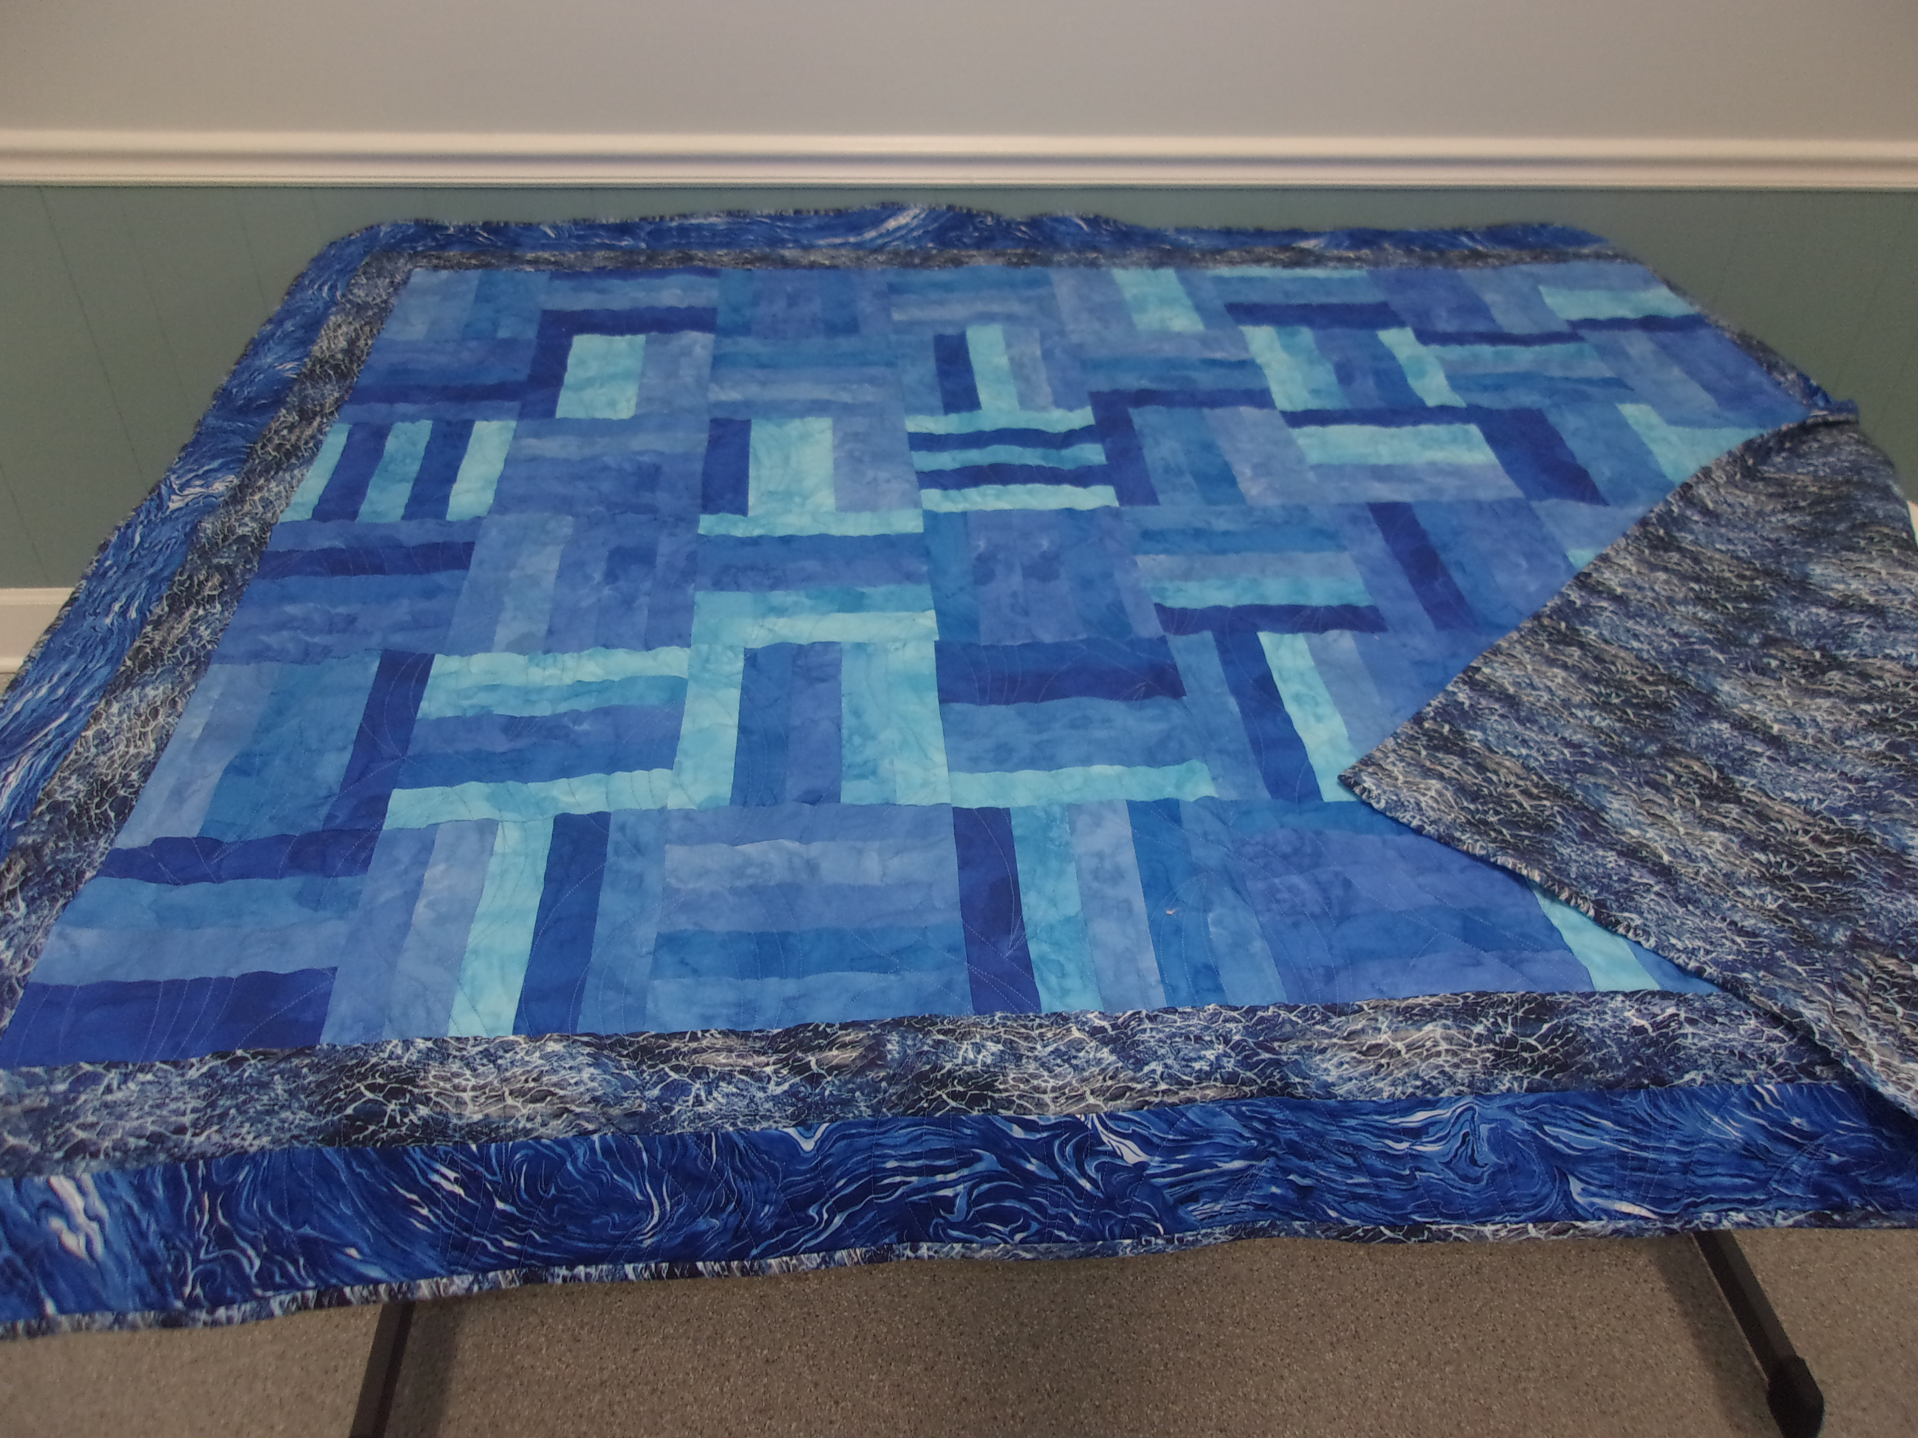
A watery motif resembling the ocean on back
For questions, call the Federation Center at (803) 25403777.

