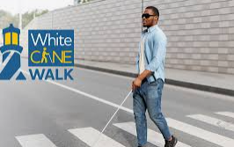 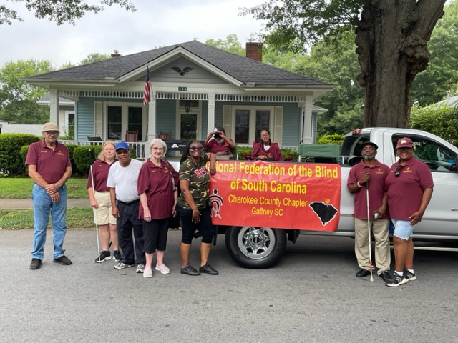

The National Federation of the Blind

Of South Carolina

Cherokee County Chapter

Cordially invites everyone to a special celebration

in honor of Blind Equality Achievement Month and

White Cane Awareness Day, along with the 10th anniversary of the Cherokee chapter’s reorganization.

The event will take place at the Cherokee County Administration Building 110 Railroad Ave. Gaffney from 10:00 am until 1:00 pm on Saturday, October 14th, 2023

Proclamations from the City of Gaffney and Cherokee County will be presented, along with a feature speaker and other recognitions.

Food vendors will be available during the event, with some proceeds benefiting the chapter.

Donations are also accepted.

Contacts: James Byers – President @ 864-219-1378

IV Dawkins – DEI Coordinator @ 864-649-5030

Martha Stockwell – Secretary @ 864-489-7926

Jamie Allison - Teacher of the Visually Impaired/Teacher of Nonvisual Skills 864-838-0338 nfbsccherokeejamie@gmail.com