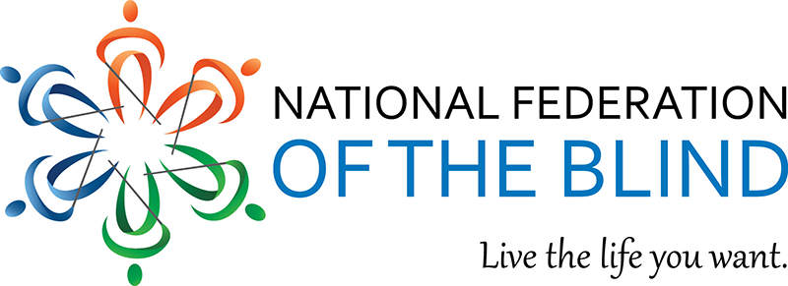

Hello everyone,
Please join the National Federation of the Blind, National Organization of Blind Black Leaders (NOBBL) as we conduct our next division meeting. The meeting will take place via Zoom on Tuesday, January 16th at 8 PM EST. We will hear reports from the NOBBL groups and committees. Also, we will have a special guest speaker Andre “Dr. Dre” Brown. Dr. Brown is a Hip Hop artist, Television Show Host and Disc Jockey. He is most known for teaming with Ed Lover on the popular show Yo MTV Raps and on New York’s Hot 97FM. DR. Dre will discuss his life as a person with vision loss and his desire to make this world accessible for all blind people. To participate in the meeting, please utilize the zoom information below. Thanks and Happy New Year to all.
https://nfb-org.zoom.us/j/96352447190
National Federation Of The Blind Of The District Of Columbia Washington, DC is inviting you to a scheduled Zoom meeting.
Topic: National Organization of Blind Black Leaders monthly meeting
Time: Jan 16, 2024 08:00 PM Eastern Time (US and Canada)
Join Zoom Meeting
https://nfb-org.zoom.us/j/96352447190
Meeting ID: 963 5244 7190

