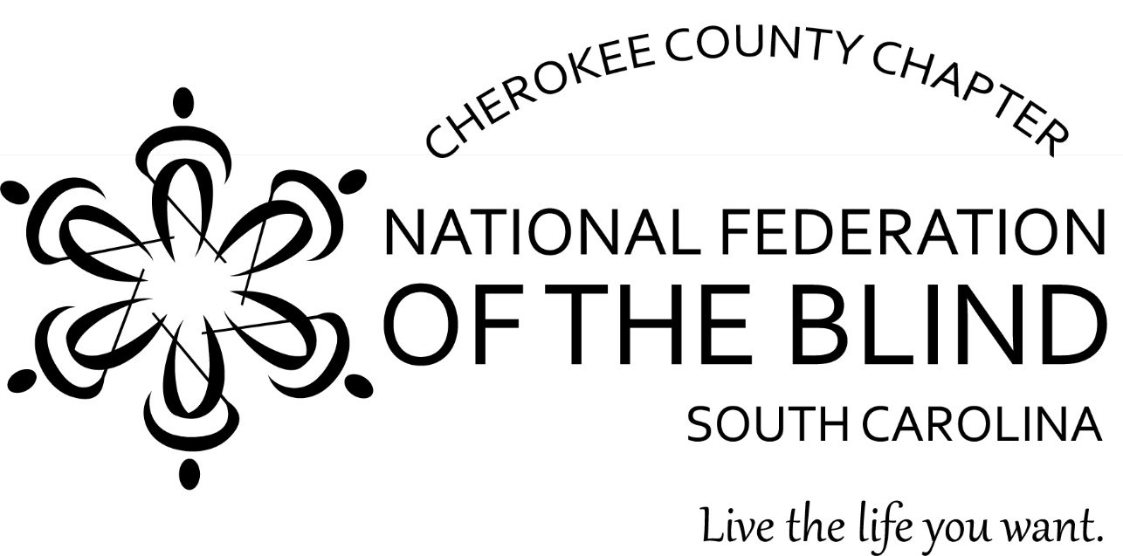

The Cherokee County chapter of the National Federation of the Blind of South Carolina is a 501c3 nonprofit civic organization that knows blindness does not have to define a person or their future. Our mission is to achieve full integration of blind people into society on a basis of equality, advocating for their rights, providing support, and promoting the belief that blind individuals have the full capacity to achieve their dreams and live independently.

Our chapter sincerely requests your presence at our “Hope Springs Eternal” Fundraising Banquet, to take place on Saturday, May 10th from 7:00-10:00pm at the MK’s Event Center at 126 Willis Plaza in Gaffney. Sponsorship opportunities are available for local businesses and organizations. Tickets are $25.00 each. Funds raised will be used for the chapter scholarship fund to support local students and to facilitate travel opportunities to organizational events. Please contact Jamie for more details.

For more information, please contact
Jamie Allison, Chapter President
864-838-0338
nfbsccherokeejamie@gmail.com

