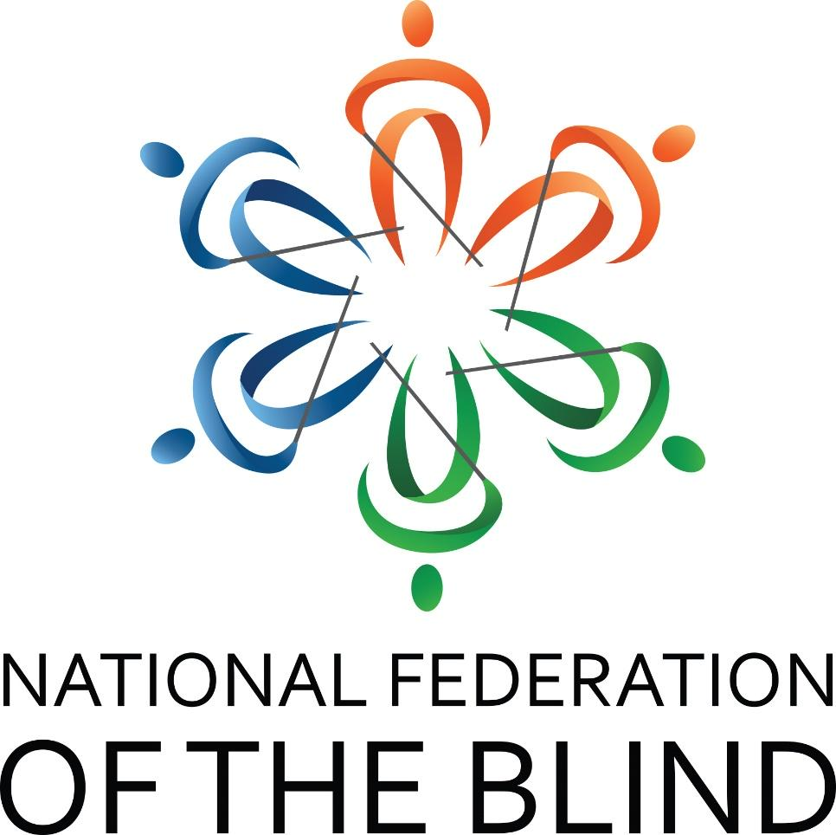

Learning Lifting Leading

69th Annual State Convention
National Federation of the Blind of South Carolina

Marty R. McKenzie, President
Doubletree by Hilton
2100 Bush River Road
Columbia, SC 29210
803-731-0300
Thursday, August 14 – Sunday, August 17, 2025

Convention Notes

National Federation of the Blind Pledge
I pledge to participate actively in the efforts of the National Federation of the Blind to achieve equality, opportunity and security for the blind; to support the programs and policies of the Federation and to abide by its constitution.

National Federation of the Blind One Minute Message
The National Federation of the Blind knows that blindness is not the characteristic that defines you or your future. Every day we raise the expectations of blind people, because low expectations create obstacles between blind people and our dreams. You can live the life you want; blindness is not what holds you back.

Integrity and Respect
As with all NFB of SC functions, our members are held to the highest standards of decorum outlined in the National Federation of the Blind Code of Conduct. To allow all attendees the chance to benefit from all aspects of the convention, we are committed to providing a harassment-free environment for everyone. We appreciate your assistance in cultivating an atmosphere in which participants from diverse backgrounds may learn, network, and share with each other in an environment of mutual respect. Thank you for doing your part to contribute to our community and the high expectations we strive to maintain.

Welcome
Welcome to the DoubleTree by Hilton Columbia, SC. It is our pleasure to have you here with us for your 2025 convention. We are looking forward to a couple of successful days of learning and camaraderie. We hope you enjoy your time here with us and if there is anything we can do while you’re visiting, please don’t hesitate to reach out. Rick Lackland is the Director of Sales and Matt Burros is our General Manager. Enjoy!

Dog Relief Area
For those with dog guides, there are two specific dog relief areas. A trash receptacle has been placed there for convenience and tidiness. The first area is straight out the front door of the hotel across the parking lot. The second area outside has multiple entry points. It can be accessed from the Congaree B meeting space door (to the left) or the Sleeping Room E + F doors (to the right). Ask the front desk if more information is needed.

Contact Us
We have several convenient ways for you to connect with us. They are:

Website: www.nfbofsc.org

Phone: 803-254-3777

Address:
Federation Center of the Blind
119 S. Kilbourne Rd.
Columbia, SC 29205

National Federation of the Blind of South Carolina President:
Marty R. McKenzie
president@nfbofsc.org
843-939-8091

You can also find us on Facebook and X.

National Representative

Shelia Wright, M.Ed.

Shelia Wright grew up in a small town in South Carolina. Though her vision was never good, she did not know that she was blind until she was sixteen, when she finally saw an eye doctor that talked openly about her blindness and the importance of her learning Braille while she was young. He urged Shelia and her parents to check to see if South Carolina had a school for the blind. This led her family to contact the Commission for the blind, but the agency did little to provide the services she needed. They claimed she had too much vision to need training in Braille and Cane travel.

Shelia attended the University of South Carolina and received a B.A. in Psychology and an M.Ed. in Vocational Rehabilitation. She worked in the field of Rehabilitation for the Blind for over thirty years.

Shelia came to the Federation as a struggling blind person, having been told that she would never make it through a semester in college. When the National Federation of the Blind, through its then-President Donald Capps, weighed in on her behalf, rehabilitation services in South Carolina looked at Shelia in a whole new light. The Federation believed in her so much that frequently it asked her to do things she thought she could not do, but with every accomplishment, she became the woman she is today.

Shelia currently serves as the President of the National Federation of the Blind of Missouri. She was elected to the National Board of Directors in July 2022.

Schedule

Thursday, August 14, 2025
7:00 – 9:00 PM Rookie Round-Up Capital Room
7:30 – 9:30 PM Blind Merchants Pre-Convention Prep Session –
Boardroom

Friday, August 15, 2025
6:30 – 8:45 AM Hot breakfast buffet in restaurant – Self-serve – Boy Scouts and volunteers available to assist
10:00 – 6:00 PM Registration – Capital Room Exterior
10:00 – 6:00 PM Exhibit Hall – Congaree Prefunction
10:00 – 5:00 PM Blind Merchants Snack Bags – Capital Room
11:00 – 12:50 PM SC Association of Black Leaders Division – Newberry
12:00 – 5:00 PM Youth Track Breakout One – Richland
Fun-filled session of interactive games designed to energize, connect, bond and spark friendly competition.
12:00 – 5:00 PM Youth Track Breakout Two – Fairfield
Peaceful space to relax, get creative, engage in smaller team games.
1:00 – 1:50 PM Computer Science and Technology Division –
Newberry
2:00 – 2:50 PM SC Association of Blind Students Division - Calhoun B
2:00 – 2:50 PM At-Large Chapter – Newberry
2:00 – 2:50 PM SCSDB Blind Alumni Calhoun A
3:00 – 3:50 PM Experiences from the Louisiana Center of the Blind
James Byers, LCB Graduate -- Saluda
4:00 – 4:50 PM Blind Merchants Division – Calhoun B
4:00 – 4:50 PM Senior Division Meeting – Saluda
4:30 – 5:30 PM Resolutions Committee – Calhoun A
5:30 – 6:30 PM NFB of SC State Board Meeting – Saluda
7:00 – 10:00 PM Reception – Congaree B

Saturday, August 16, 2025
6:30 – 8:45 AM Hot breakfast buffet in restaurant – Self-serve – Boy Scouts and volunteers available to assist
8:00 – 8:50 AM Registration – Congaree B Prefunction
8:00 – 8:50 AM Exhibit Hall – Congaree Prefunction

Morning General Session – Congaree B
9:00 – 9:30 AM Welcome Marty R. McKenzie
Invocation Hubert Holmes
Presentation of Colors Eagle scouts
National Anthem Landon Bryson and
Kaitland Davis
Host Chapter Remarks Andrew Adams
9:30 – 10:00 AM National Report,
Shelia Wright, National Representative
10:00 – 10:20 AM SC School for the Deaf and the Blind,
Valerie Feiling, Director of Education Services
10:20 – 10:35 AM Summer Camps
Dr. Tina Herzberg, Professor, USC Upstate
10:35 – 10:40 AM Fit Break
10:40 – 11:00 AM SC Talking Book Services,
Jennifer Falvey, Director
11:00 – 11:20 AM SC Commission for the Blind, Luis Mendoza,
Director of Administration
11:20 – 11:30 AM Parents of Blind Children Update
Sonia Timmons, SCPOBC Leader
11:30 – 12:00 PM Presidential Report
Marty R. McKenzie, President
12:00 PM Adjourn

Lunch Break

12:00 – 2:00 PM Box Lunches – Congaree B
12:15 – 1:45 PM Registration – Congaree B Prefunction
12:15 – 1:45 PM Exhibit Hall – Congaree Prefunction

Afternoon General Session – Congaree B

2:00 – 2:05 PM Welcome
2:05 – 3:05 PM Generational Stories: Finding Common Ground
Sonia Timmons and Dr. Tina Herzberg, Moderators
3:05 – 3:35 PM Wearables: What They Can Do for You
Steve Cook and David Bundy, Federationists
3:35 – 3:40 PM Fit Break
3:40 – 4:00 PM Legislative and Advocacy Committee Updates
Janice Bright and David Houck, Co-chairs
4:00 – 4:20 PM Federation Center Report, David Houck, Executive
Director and Ed Bible, FCB Board Chair
4:20 – 4:40 PM ADA Title II: Web Accessibility Final Rule
Sarah Massengale, ADA Coordinator
4:40 – 5:00 PM Rocky Bottom Report, Thom Spittle, RBRCCB Chair
5:00 PM Adjourn

Evening Break

5:15 – 5:45 PM Nominating Committee – Frank Coppel, Chair – Newberry
6:00 – 6:45 PM Registration – Congaree B Prefunction

Convention Banquet – Congaree B

7:00–10:00 PM

Welcome Marty R. McKenzie, President
Invocation Frank Loza, District 3 Representative,
NFB of SC
Keynote Address Shelia Wright, National Representative
Special Awards
Awarding of Scholarships Shannon Cook, Scholarship Chair
Midlands Gives Award Valerie Warrington, Treasurer
Educator of the Year Award Tracy Spittle, Chair
Donald C. Capps Award David Houck, Chair
Betty R. Capps Award Julie Bible, Chair
Presidential Citation Marty R. McKenzie, President

Banquet Fundraiser
Our annual banquet fundraiser is an opportunity for individuals, chapters, divisions, and business partners to contribute to the NFB of SC to further programs, services, and policies of the affiliate. Donations can be made through Pay Pal on www.nfbofsc.org, by cash or writing a check made payable to the NFB of SC and mailed to Federation Center of the Blind. See page 3 for the address.

Adjourn

Sunday, August 17, 2025
6:30–8:45 AM Hot breakfast buffet in restaurant – Self-serve – Boy Scouts and volunteers available to assist
8:30–8:45 AM Registration – (CONGAREE B PREFUNCTION)

Morning General Session – Congaree B
9:00 – 9:30 AM Remembering Those Who Went Before Us
A Memorial, Melinda Jones
9:30 – 10:00 AM NFB of SC, Successful Transitions and Rocky
Bottom Treasurers Reports -- Valerie Warrington
and Roger Webb, Treasurers
10:00 – 10:15 AM Resolutions, The Honorable Parnell Diggs,
10:15 – 10:30 AM Update on SUN, PAC, Dream Maker’s Circle, Frank Coppel, chair, Doing Our Fair Share Committee
10:30 – 10:35 AM Fit Break
10:35 – 11:50 AM Elections
11:50 – 12:00 PM Chapter, Committee, and Division Drawings
12:00 PM Adjourn

Convention Live Stream Information
https://us02web.zoom.us/j/8032543777?pwd=QTVQd2RzN3l6QnNmZ0Fm Snp6NG8vQT09

Phone Number: 929-205-6099
Meeting ID: 803 254 3777
Passcode: 124578
One tap mobile
+19292056099,,8032543777#

