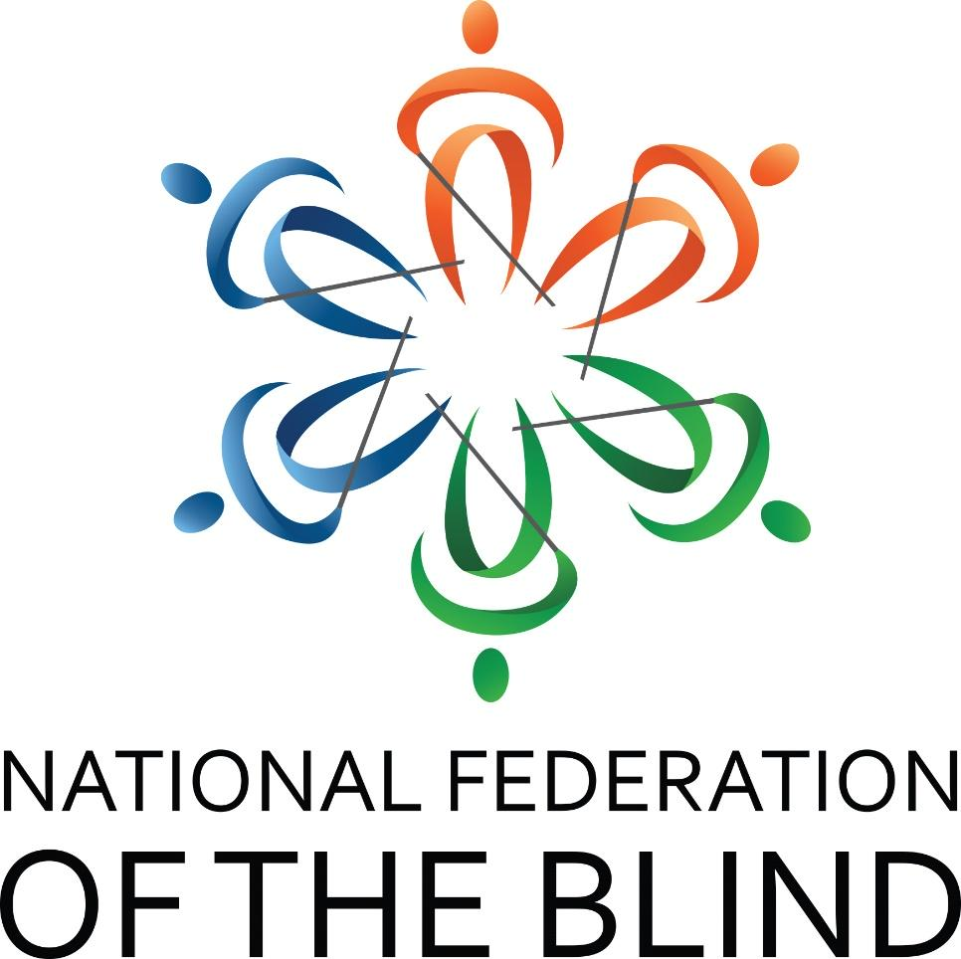

70th Annual State Convention Agenda
The Bonds We Share Strengthen Us
National Federation of the Blind of South Carolina

Marty R. McKenzie, President
DoubleTree by Hilton
2100 Bush River Road
Columbia, SC 29210
803-731-0300
Thursday, August 13 – Sunday, August 16, 2026

Welcome
Welcome to the DoubleTree by Hilton Columbia, South Carolina. It is our pleasure to have you here with us for your 2026 convention. We are looking forward to a couple of successful days of learning and camaraderie. We hope you enjoy your time here with us, and if there is anything we can do while you’re visiting, please don’t hesitate to reach out. Our general manager, Erik Kohlenstein, and the rest of the team here at the DoubleTree welcome you!

Dog Relief Area
For those with guide dogs, there are two specific dog relief areas. A trash receptacle has been placed there for convenience and tidiness. The first area is straight out the front door of the hotel across the parking lot. The second outdoor area has multiple entry points. It can be accessed from the Congaree B meeting space door (to the left) or the doors near Sleeping Rooms E and F (to the right). Ask the front desk if more information is needed.

Convention Livestream Information
https://us02web.zoom.us/j/8032543777?pwd=QTVQd2RzN3l6QnNmZ0FmSnp6NG8vQT09

Phone Number: 929-205-6099
Meeting ID: 803 254 3777
Passcode: 124578
One-tap mobile
+19292056099,,8032543777#

Thursday, August 13, 2026
4:00 PM to 6:00 PM Blind Merchants Pre-Convention Prep Session – Boardroom

Friday, August 14, 2026
6:30 AM to 8:45 AM Hot breakfast buffet: Restaurant and Lower Lobby – Self-service – Help available from hotel staff and volunteers
10:00 AM to 6:00 PM Registration – Capital Room Exterior
10:00 AM to 6:00 PM Exhibit Hall – Congaree B
10:00 AM to 5:00 PM Blind Merchants Snack Bags – Capital Room
11:00 AM to 12:50 PM SC Association of Black Leaders Division – Newberry
12:00 PM to 5:00 PM Emerging Leaders Track Breakout – Richland
Fun-filled session of interactive games designed to energize, connect, bond, and spark friendly competition.
1:00 PM to 1:50 PM Computer Science and Technology Division – Newberry
2:00 PM to 2:50 PM At-Large Chapter – Newberry
2:00 PM to 2:50 PM Exercise and Self-Defense – Fairfield
3:00 PM to 3:50 PM Practical Uses of AI – Sarah Massengale, CPACC, ADS, Founder, SM Accessibility Consulting – Saluda
4:00 PM to 4:50 PM Blind Merchants Division – Calhoun B
4:00 PM to 4:50 PM Senior Division Meeting – Saluda
5:00 PM to 6:00 PM NFB of SC State Board Meeting – Saluda
7:00 PM to 9:30 PM Reception – Congaree A

Saturday, August 15, 2026
6:30 AM to 8:45 AM Hot breakfast buffet: restaurant and Lower Lobby – Self-service – Help available from hotel staff and volunteers
8:00 AM to 8:50 AM Registration – Congaree A Pre-function
8:00 AM to 8:50 AM Exhibit Hall – Congaree B

Morning General Session – Congaree A
9:00 AM to 9:30 AM Welcome – Marty R. McKenzie, President
Invocation – Frank Loza, District 3 Representative
Pledge of Allegiance – Mari Gladden
Presentation of Colors – Eagle Scouts
National Anthem – Sarah Massengale, District 6 Representative
Host Chapter Remarks – David Bundy, President
9:30 AM to 10:00 AM National Report – Shawn Callaway, National Representative
10:00 AM to 10:20 AM SC School for the Deaf and the Blind – Scott A. Falcone, Executive Director of the Division of Outreach Services
10:20 AM to 10:40 AM SC Talking Book Services – Jennifer Falvey, Director
10:40 AM to 11:00 AM SC Commission for the Blind – Luis Mendoza, Interim Commissioner
11:00 AM to 11:30 AM Successful Transitions: Ten Years Changing Lives – Andrenia Corder, Director, and Oversight Committee Members
11:30 AM to 11:40 AM Parents of Blind Children Update – Sonia Timmons, SCPOBC Leader
11:40 AM to 12:00 PM Presidential Report – Marty R. McKenzie, President
12:00 PM Adjourn

Lunch Break
12:00 PM to 2:00 PM Box Lunches – Congaree A
12:30 PM to 1:45 PM Registration – Congaree A Pre-function
12:30 PM to 1:45 PM Exhibit Hall – Congaree B

Afternoon General Session – Congaree A
2:00 PM to 2:05 PM Welcome
2:05 PM to 2:20 PM Forty Years of Training and Rehabilitation: A BISM Story – Derique Simon
2:20 PM to 2:30 PM Working with the Lived Experiences of Blind and Low Vision Individuals – Dr. Tina S. Herzberg, Professor, USC Upstate
2:30 PM to 3:00 PM The Voice-Powered Home: Overview of Smart Homes – Sarah Massengale and Marty R. McKenzie, Federationist
3:00 PM to 3:20 PM Legislative and Advocacy Committee Updates – Janice Bright and David Houck, Co-Chairs
3:20 PM to 3:30 PM The Final Rule – Sarah Massengale, CPACC, ADS
3:30 PM to 3:50 PM Federation Center Report – David Houck, Executive Director and Ed Bible, FCB Board Chair
3:50 PM to 4:10 PM Rocky Bottom Report – Thom Spittle, RBRCCB Chair
4:10 PM to 4:30 PM Update on SUN, PAC, Dream Makers Circle – Frank Coppel, Chair, Doing Our Fair Share Committee
4:30 PM to 4:45 PM Personal Finance: Tips and Tricks – Adam Thayer, Thrivent Financial Group
4:45 PM to 5:00 PM Musings of a National Representative – Shawn Callaway
5:00 PM Adjourn

Evening Break
5:15 PM to 5:45 PM Nominating Committee – Valerie Warrington, Chair – Newberry
6:00 PM to 6:45 PM Registration – Congaree A Pre-function

Convention Banquet – Congaree A
7:00 PM to 10:00 PM
- Welcome – Marty R. McKenzie, President
- Invocation – Debra Canty, Second Vice President
- Keynote Address – Shawn Callaway, National Representative
- Awarding of Scholarships – Shannon Cook, Scholarship Chair
- Midlands Gives Award – Valerie Warrington, Treasurer
- Educator of the Year Award – Tracy Spittle, Chair
- Donald C. Capps Award – David Houck, Chair
- Betty R. Capps Award – Julie Bible, Chair
Banquet Fundraiser
Our annual banquet fundraiser is an opportunity for individuals, chapters, divisions, and business partners to contribute to the NFB of SC to further programs, services, and policies of the affiliate. Donations can be made through PayPal on www.nfbofsc.org, in cash or by check payable to the NFB of SC and mailed to the Federation Center of the Blind. See the Contact Us section for the address.
Adjourn

Sunday, August 16, 2026
6:30 AM to 8:45 AM Hot breakfast buffet: restaurant and Lower Lobby – Self-service – Help available from hotel staff and volunteers
8:30 AM to 8:45 AM Registration – Congaree A Pre-function

Morning General Session – Congaree A
9:00 AM to 9:30 AM Remembering Those Who Went Before Us: A Memorial – Melinda Jones
9:30 AM to 10:00 AM NFB of SC, Successful Transitions, and Rocky Bottom Treasurers’ Reports – Valerie Warrington and Roger Webb, Treasurers
10:00 AM to 11:50 AM Elections- Newberry
11:50 AM to 12:00 PM Chapter, Committee, and Division Drawings- Newberry
12:00 PM Adjourn

National Representative

Shawn Callaway, M.S.W.
Shawn Callaway is a locally acclaimed disability advocate, motivational community leader, and currently a Program Specialist for the United States Department of Health and Human Services. For more than 23 years, he has leveraged his own experience, professional career, and personal time to helping others overcome obstacles that are largely attributable to the attitudes, misconceptions, and perceptions of what it means to be a person with disabilities. In his current position as a Program Specialist, Shawn manages grant programs that focus on establishing innovative opportunities for individuals with intellectual and developmental disabilities and traumatic brain injuries. Shawn has also dedicated a portion of his professional career as a social worker, currently for Columbia Lighthouse for the Blind, and previously for the DC Department of Behavioral Health (DBH) and the Catholic Communities nonprofit organization. In these roles, Shawn has worked with consumers struggling with a variety of conditions related to vision impairment, mental health, or addiction. He facilitated peer support groups and helped them gain access to resources that help them achieve the best possible quality of life.

Shawn is familiar with unexpected circumstances and life-altering events that affected his future. After graduating from high school, Shawn planned to obtain a bachelor’s degree from South Carolina State University. Unfortunately, in 1991, Shawn was involved in an accident that caused him to become permanently blind. But Shawn did not allow his circumstances to hold him back. A few years after the accident, he entered the Workforce Technology Center (WTC) in Baltimore, Maryland, and obtained independent living skills, assistive technology training, and Braille reading training. His efforts at WTC became a catalyst that propelled Shawn forward in pursuing higher education degrees, including his associate’s, bachelor’s, and master’s, as well as his licensure in Graduate Social Work.

In 2011, Shawn was elected President of the National Federation of the Blind of the District of Columbia, and in 2016, he was elected to the NFB National Board of Directors. Shawn is inspired by the NFB’s mantra “You can live the life you want; blindness is not what holds you back.” This quote has motivated Shawn to continue helping others live the lives they want while holding multiple leadership positions and maintaining affiliations that allow him to give back to his community. Within the NFB, Shawn is Chairman of the Diversity, Equity, and Inclusion Committee, President of the National Organization of Blind Black Leaders, and Chairman of the Blind Greek and Masonic Group. He has served as Chairman of the DC State Rehabilitation Council and on previous boards for the Columbia Lighthouse for the Blind and the D.C. Center for Independent Living. Shawn is a member of the Alpha Phi Alpha Fraternity Incorporated and the Fort Stevens Lions Club. In addition, Shawn’s influence can be heard on Takoma Radio 94.3 on the first and third Mondays of each month. Shawn is a co-host of the radio show titled “Open Our Eyes,” which focuses on the inclusion of persons with disabilities within our society. In 2016, Shawn received a citation from U.S. Senator Chris Van Hollen for his leadership in bringing awareness to the needs of the blind community regarding employment. Shawn currently resides in Washington, D.C. with his lovely wife of 18 years, Latonya Callaway, and their 9-year-old daughter, Camille.

Convention Notes

National Federation of the Blind Pledge
I pledge to participate actively in the efforts of the National Federation of the Blind to achieve equality, opportunity, and security for the blind; to support the programs and policies of the Federation and to abide by its constitution.

National Federation of the Blind One Minute Message
The National Federation of the Blind knows that blindness is not the characteristic that defines you or your future. Every day we raise the expectations of blind people, because low expectations create obstacles between blind people and our dreams. You can live the life you want; blindness is not what holds you back.

Integrity and Respect
As with all NFB of SC functions, our members are held to the highest standards of decorum outlined in the National Federation of the Blind Code of Conduct. To allow all attendees the chance to benefit from all aspects of the convention, we are committed to providing a harassment-free environment for everyone. We appreciate your assistance in cultivating an atmosphere in which participants from diverse backgrounds may learn, network, and share with each other in an environment of mutual respect. Thank you for doing your part to contribute to our community and the high expectations we strive to maintain.

Contact Us
We have several convenient ways for you to connect with us. They are:
Website: www.nfbofsc.org
Phone: 803-254-3777
Address:
Federation Center of the Blind
119 S. Kilbourne Rd.
Columbia, SC 29205
National Federation of the Blind of South Carolina President:
Marty R. McKenzie
president@nfbofsc.org
843-939-8091
You can also find us on Facebook and X.

