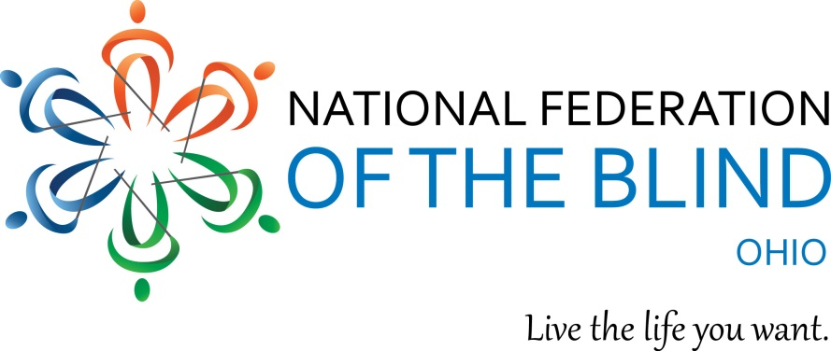
Envision Seminar

Sat. April 14, 2018
1 PM to 3 PM
Sanger Library
3030 W. Central Ave.
Toledo, Ohio 43606

Don’t let vision loss define your future.
Envision the life you want.

Join this FREE event to:

- Explore the latest adaptive technology
- Speak with representatives from Opportunities for Ohioans with Disabilities to begin building the future you want
- Learn more about transportation, health, reading techniques, and mobility aids such as guide dogs
- Network with people dedicated to changing what it means to be blind

Call 937-657-5134 or email dr.carolyn.peters@gmail.com
to learn more.

