Northeast Ohio Region, of the National Federation of the Blind of Ohio
partners with
The City of Cleveland Planning Commission

to Discuss Scooter Information and Pedestrian Safety in Cleveland
and its Surrounding Areas

Cleveland City Hall
601 Lakeside Avenue, Cleveland, Ohio 44114
December 12, 2019
4:00 p.m. – 6:00 p.m.

More information will be forthcoming.
For questions, contact Suzanne Turner at
(216) 990-6199 or SMTurner.234@gmail.com

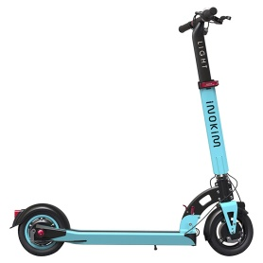 | 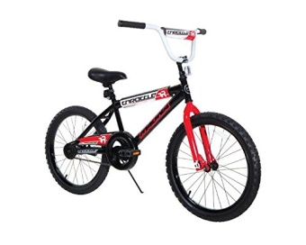 | 