Ohio Association of the DeafBlind
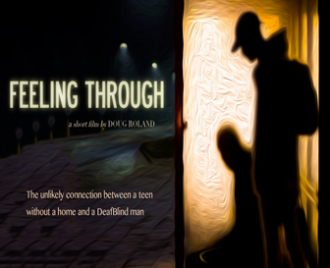
Welcome Everyone!

March Workshop 2020

WHEN: Saturday, March 7, 2020
TIME: 10:00 a.m. – 3:00 p.m.

WHERE: Columbus Colony Housing 2
Multi-Purpose Room (MPR)
1105 Colony Drive
Westerville, Ohio 43081

Be Awesome: Empowering DeafBlind to Succeed
& Movie: "The Feeling Through Experience”

ACTIVITY: Ryan Odland, HKNC North Central Regional Representative
Chris Woodfill, HKNC Associate Executive Director
will give presentation in the morning & Movie, By-Law voting
and Social in the afternoon

Cash Prizes & Benefits will proceed to DeafBlind Retreat

Lunch Menu Option - see attached. Please fill out lunch form and mail.
Will serve three different kind of sandwiches.
You can bring your own lunch

Please remember to bring your favorite SSP!
Voice Interpreters will be present
Please email to Co-Chairpersons, Donna Schultz Donna.schultzdb@gmail.com or Bryan Grubb brgms415@gmail.com
if you have any questions.

If you plan to attend, PLEASE fill out and return 2 forms ASAP. POSTMARK DATE is February 26, 2020. Mail it to:

OADB
P.O. Box 763
Brice, OH 43109

