# ABOUT THE FILM

**For film about the unlikely connection between a teen without a home and a Deaf-Blind man. It serves as a companion documentary about the filmmaking process.**

**For the first time, a Deaf-Blind man as a lead in a film. *Feeling Through* is a short film.**

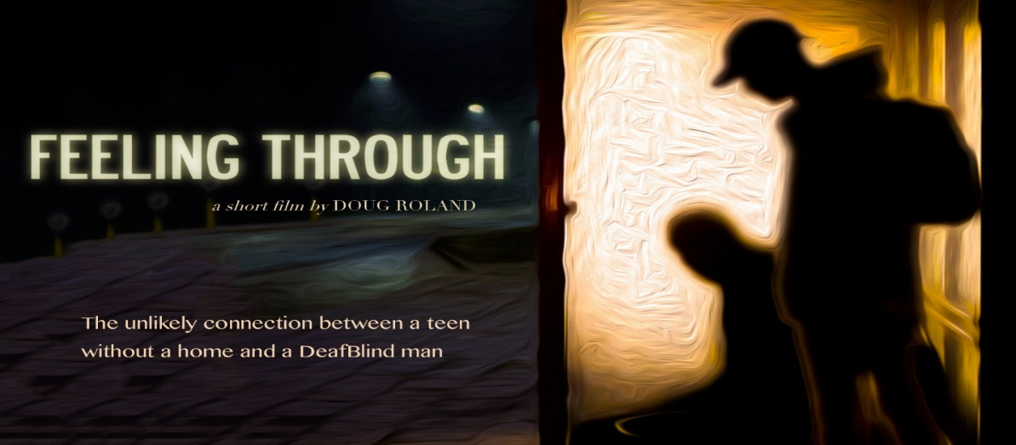

**HKNC Helps Make Film History with *Feeling Through***

**Doug Roland, writer/director who is making this film.**

**Former HKNC student and current staff member Robert**

**Tarango's acting debut**

**For updates and screening information:**

**Website: FeelingThrough.com Facebook: @feelingthrough**

**Instagram: @feelingthrough Twitter: @feelingthrough1.**