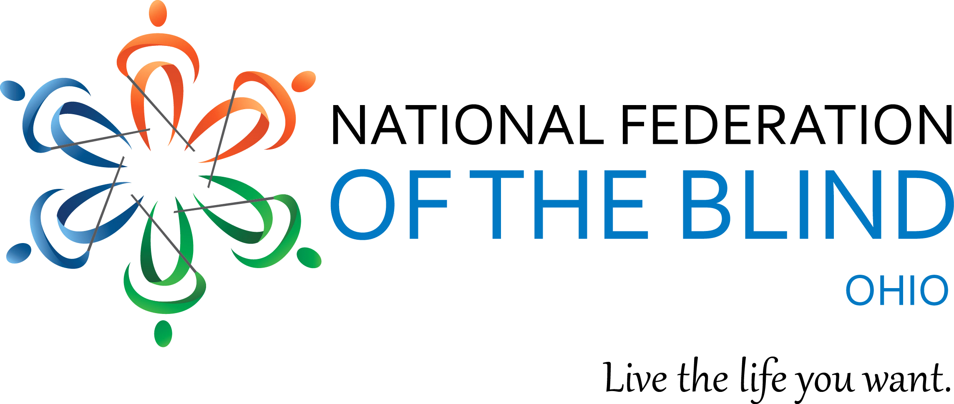

National Federation of the Blind of Ohio Welcomes You To Our 74th Annual Ohio State Convention Exhibit Seminar.

Thursday, November 5th, 2020
3:00P.M. EST.

The Ohio Exhibit Seminar, which is virtual this year will be a wonderful opportunity to learn about an array of accessible products, technology and services that will provide the blind with the means to be healthy, safe, independent and productive. Every year the anticipation is raised when the NFB of Ohio Convention gets closer to the Exhibit date.

the Seminar will be virtual and assembly style with Q/A. So Zoom in on November 5, 2020 at 3:00 P.M. to attend the best event of 2020. Come and hear from vendors, such as, HumanWare, HIMS-INC, See3D Inc, A. T. Guys, WayAround and more! Did I mention that there will be generous door prizes as well?

To join the fun and be eligible for all door prizes at pre-Convention and Ohio’s 2020 Convention “The Vision, Beyond Vision” November 6th and November 7^{th.} Please go to WWW.NFBOhio.org to register now.
Note: There will be several Ways to connect to all events in the upcoming Agenda.

