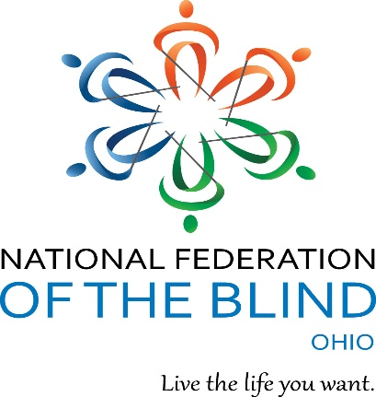
National Federation of the Blind of Ohio
Richard Payne, President
PO Box 20544
Dayton, OH 45420
www.nfbohio.org
937-396-5573
Rchpay7@gmail.com

Inclusion Policy

The National Federation of the Blind of Ohio is committed to providing a safe and inclusive space for all individuals, as deeply expressed in the organization’s constitution. This principle resonates through all levels of the organization, from national to local, ensuring that all individuals have a place in our organization. Blindness is the characteristic that binds us together, but it is our intersectionalities and unique lived experiences that allow us to continue to be a thriving community for the collective action and support of the blind.

The Board of Directors of the National Federation of the Blind of Ohio affirms the following policy in March 2022: we intend this consumer organization of blind people to be a safe place for individuals of every race, color, religion, sex, sexual orientation, age, national origin, disability, nonveteran or veteran status, political affiliation, and gender identity. We expect our members to respect themselves and others and to refrain from taunting or insulting others or using derogatory language for those who do not share their convictions or life experience. We expect members to conduct themselves with civility and courtesy and to apologize any time they have failed to conduct themselves to this standard. Behavior that opposes these standards is unacceptable, and anyone unwilling to live up to these standards shall be subject to discipline up to and including expulsion from the organization by the Board of Directors.

Together we can learn what it means to be an ally to others. By being open to learning about the experiences of those with differing backgrounds from our own, we ensure the growth of a community inclusive of all. If you witness or fall victim to discrimination or insult within the National Federation of the Blind of Ohio, please notify any elected officer as soon as possible. The elected officer who receives notification of the complaint shall immediately notify the NFB of Ohio President or forward the complaint in accordance with the NFB Code of Conduct.

Enacted by the NFB of Ohio Board of Directors March 5, 2022

