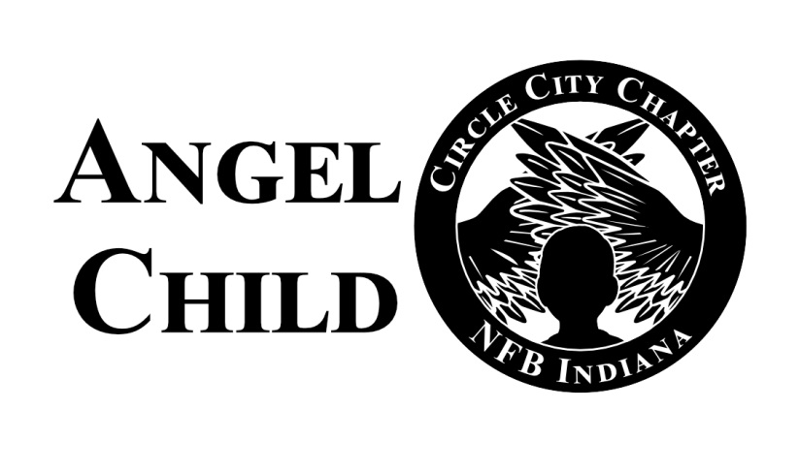

The National Federation of the Blind-Circle City Chapter of Indiana cordially invites you to attend our virtual Angel Child gifting and service awards Christmas  program  on:

Date: December 2, 2023

Time: 4:00p.m. to 6:00pm. (EST)

Theme: From the Wings of an Angel; To The Heart of a Child

This year’s Angel Child is truly touching the hearts of children throughout Indiana and Ohio, please join us with the enclosed Zoom information

the Zoom room will open at 3:30p.m. and the program will start promptly at 4:00p.m. )EST)

Zoom connection information:

[https://zoom.us/j/9908141333](https://nam12.safelinks.protection.outlook.com/?url=https%3A%2F%2Fzoom.us%2Fj%2F9908141333&data=04%7C01%7Ceasimmonsree%40bsu.edu%7Cf4760051131149671c2308d8956ccd77%7C6fff909f07dc40da9e30fd7549c0f494%7C0%7C0%7C637423641827975905%7CUnknown%7CTWFpbGZsb3d8eyJWIjoiMC4wLjAwMDAiLCJQIjoiV2luMzIiLCJBTiI6Ik1haWwiLCJXVCI6Mn0%3D%7C1000&sdata=AtNro8fkS20Lqn1RAlXduj0sQtlLskwx9d7A8NinHFI%3D&reserved=0)

One Tap Mobile:

+16468769923,,9908141333,,#

Call with your home phone:

646 876 9923

Enter the 10-digit pin:

990 814 1333#

The objective of the NFB Circle City Chapter of Indiana’s Angel Child Gifting & Service Awards is to collectively celebrate the lives of families and children during the Holiday Season, lift up families in need with a small financial gift, and to recognize those who have served in the advancement  of our community.

Come join us in the great spirit of lifting and gifting.

Lee Martin, Sr. - President

Florence Myers McSwine, Vice President

Enrique Alleyne, 2nd Vice President

Ray Montgomery, Secretary

Jessica  Dalton, Treasure

Board members:

Angela Timberlake

Michael Lauf