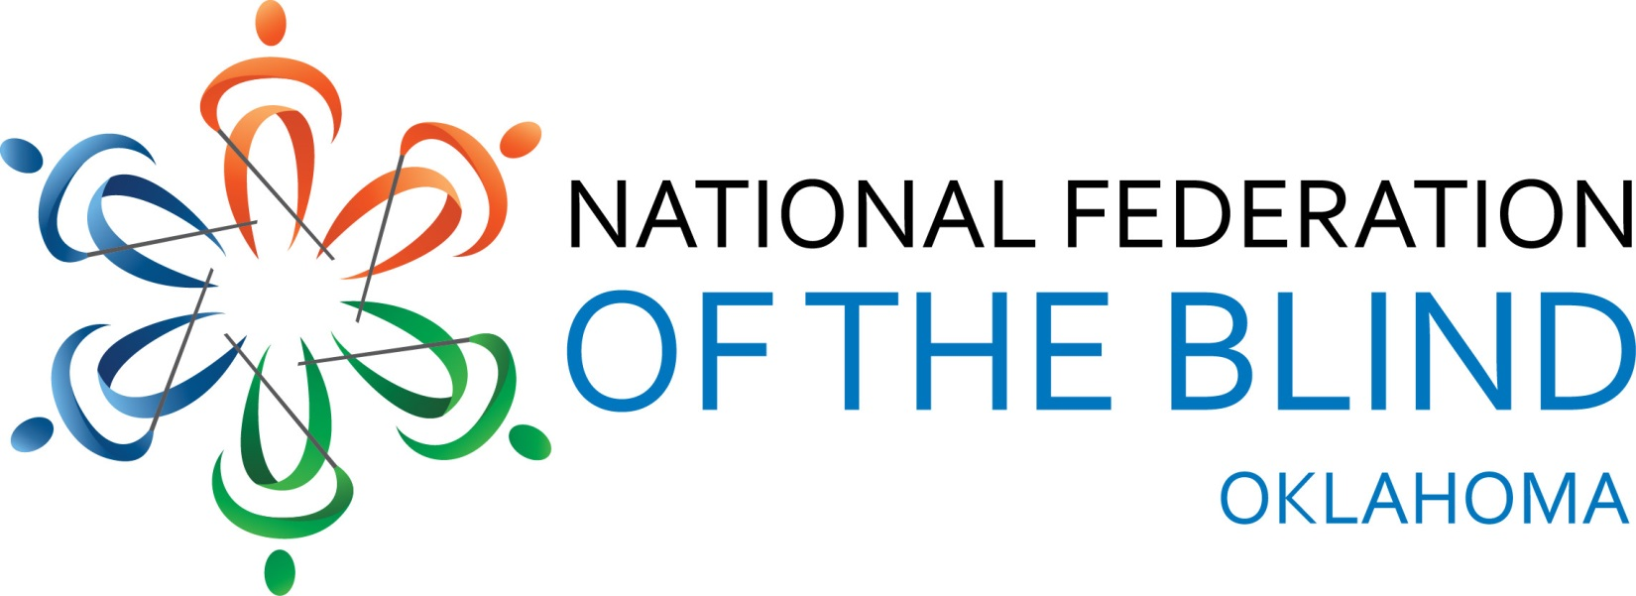

2016 National Federation of the Blind of Oklahoma Convention
March 31 –April 3, 2016

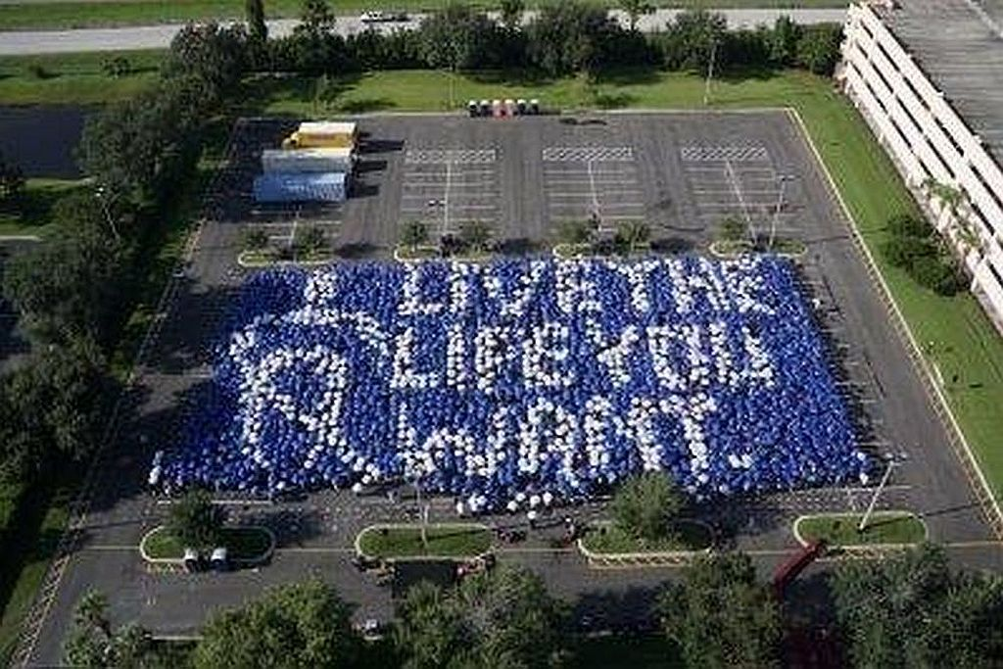

The National Federation of the Blind knows that blindness is not the characteristic that defines you or your future. Every day we raise the expectations of blind people, because low expectations create obstacles between blind people and our dreams. You can live the life you want; blindness is not what holds you back.

The Board of Directors of the National Federation of the Blind of Oklahoma welcome you to our 42nd Annual convention!

Jeannie Massay, President
Audrey T. Farnum, 1st Vice President
Rex Schuttler, 2nd Vice President
Glenda Farnum, Treasurer
Jedi Moerke, Secretary
Cammie Loehr, Board Member
Mike Harvey, Board Member
Mike Floyd, Board Member

The mission of the National Federation of the Blind of Oklahoma is to seek equality, education and employment for all blind people in Oklahoma. We offer public education about blindness, serve as a source of information and referral, provide literature and publications about blindness, share information about and demonstrate assistive technology and other adaptive equipment for the blind, participate in advocacy efforts in the protection of civil rights, and offer support for blind persons and their families. Our members are blind children and their parents, blind students from high school to college, adults and seniors. We wholeheartedly believe that blindness is not the characteristic that defines anyone or their future. Every day we raise expectations of the blind because low expectations create obstacles between blind people and our dreams. Blindness is not what holds us back. We are living the lives that we want!

Keynote Speaker & National Representative
Ever Lee Hairston

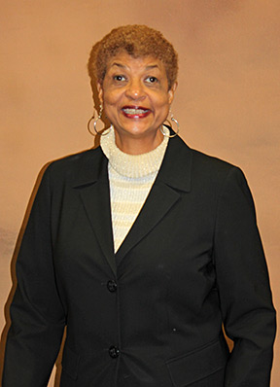

This year we are thrilled to have Ever Lee Hairston serve as our national representative and keynote speaker. Ms. Hairston is a dynamic and charismatic woman, a published author and a person whose story you will want to hear. A bit about Ever Lee:

Mentor, Advocate, Motivational Speaker
Born to Arizona and Clarence Hairston on the Coolemee plantation in Mocksville, North Carolina, Ever Lee is the third of seven children. She grew up and attended schools in the segregated South. “I felt like a second-class citizen, using hand-me-down books in school; and, due to unexplained vision problems, I had to struggle to read from the bulletin board,” Ever Lee noted. In spite of the challenges of growing up in the segregated South and continuing visual problems, Ever Lee had a strong desire to become a nurse. Ever Lee’s parents simply could not afford to send her to college; so after high school, Ever Lee went to New York City to earn money for college by working as a live-in maid. She returned to North Carolina at the end of the summer anxious to pursue a nursing career. However, she failed the required eye examination and was told that she would not be suitable for admission to Duke University Nursing School. “I was heartbroken but refused to be defeated,” she said. She was accepted at North Carolina Central University, where she earned a teaching degree.
After graduating from North Carolina Central, Ever Lee taught high school business courses in New Jersey. While working as a high school teacher in New Jersey, Ever Lee’s eyesight continued to deteriorate. She finally sought answers and medical care. Ever Lee, along with three siblings, were diagnosed with a genetic eye disease, retinitis pigmentosa (RP). And, four years after starting a challenging teaching career, Ever Lee was forced to resign from her position because of her impending blindness.
At the age of twenty-nine, facing total blindness, with a failed marriage, a child to raise alone, and uncertainty about future employment, Ever Lee admitted to being devastated and feeling sorry for herself. However, she held on to the hope that a better way of life was in store for her. Ever Lee admits to believing in the old adage that “When God closes a door, He opens a window.” She began looking for the window.
After inventorying her strengths, she stepped through a window of opportunity at New Jersey’s Rutgers University, where she took graduate courses in counseling. In 1983 she landed a Counselor Trainee position with the Camden County Department of Health and Human Services. But, as Ever Lee explains it, “With no blindness skills, I was faking my way through.” She notes that she relied heavily on sighted people to read to her and to act as guides.
In 1987 Ever Lee was invited to a NFB convention in Phoenix, Arizona. At first she made excuses because she was afraid of requesting the time off from her job. The most profound experience, as Ever Lee explains it, came when she started through the registration line. She remembers being asked, "Would you like a Braille or print agenda?" She could no longer read print and did not know Braille. It was then, according to Ever Lee, that a light bulb went off. She talked to as many people as she could at that convention in Phoenix, Arizona, and learned about the NFB centers. From then until 1990 she continued to function without blindness skills but worked on a plan to get to Louisiana where she could be trained.
Ever Lee attended the Louisiana Center for the Blind from October 1990 until April 1991. She learned to read Braille, mastered cane travel and independent living skills, and learned to utilize adaptive technology. She returned to New Jersey, after the Freedom Bell rang for her at the Louisiana Center, with a confidence she never had before, integrating blindness skills into her everyday life.
Ever Lee credits her training at the Louisiana Center for the Blind with enabling her to succeed at her chosen career. After twenty-six years holding many successive positions with the Department of Health and Human Services, Division of Alcohol and Substance Abuse Program in New Jersey, Ever Lee retired from the position of program director in 2006.

In July of 2006 she moved to California. She continues to devote tireless hours mentoring and advocating for the blind, as well as delivering inspiring speeches to blind and visually impaired audiences and educating the sighted public about blindness. Ever Lee is blessed with one son, Victor; a wonderful daughter-in-law, Brenda; and three energetic grandchildren: Briana, Kendall, and Jasmine. She enjoys traveling, reading a good novel, and spending time with family
Most recently, Ever Lee has authored and published a book titled Blind Ambition: One Woman’s Journey to greatness despite her blindness

NFB of Oklahoma wishes to recognize NanoPac for supporting our convention as a Silver Level Sponsor. Be sure to visit their booth in the Exhibit Hall on Friday, April 1st.

NanoPac, Inc.
4823 South Sheridan Road, Suite 302
Tulsa, OK 74145-5717
Phone: 918-665-0329
Fax: 918-665-0361
Technical Support: 800-580-6086
TTY: 918-665-2310
Email: info@nanopac.com
Web Site: www.nanopac.com
Holiday Inn - City Centre
17 West 7th
Tulsa, Ok 74119
918-585-5898
www.holidayinn.com/tulsda-cc

The rate for the hotel this year is a fantastic $89.00 for singles or doubles. All applicable taxes apply. Each attendee must make their own hotel reservations.

Convention Rates and Packages:

Convention Package $95.00
Includes Registration, Boxed lunch for Friday and Saturday, 1 Banquet meal for Saturday evening.

Ala Carte Pricing
Registration - $25.00
Boxed Lunch (Available Friday and Saturday) - $20 each
Banquet Meal - $40.00
*If you require specialized meal ACCOMODATIONS, please indicate so on your registration.

You may register and pay online using a Credit card or Pay Pal account. If you prefer to register online and mail a check or pay at the door with a check or cash, you may do so at the same link. Our awesome Webmaster (1st Vice President, Audrey Farnum) has completely redesigned our website and has worked very hard to make this happen for us! Go to this link to register online: http://nfbok.org/state-convention/
Any questions about registration should be directed to Glenda Farnum, Treasurer, at 405-255-6482 or by e-mail at treasurer@nfbok.org
If you are a student and plan on attending the Student Seminar Sessions, please contact Cammie Loehr , President of the Oklahoma Association of Blind Students at cammieloehr767@gmail.com or by phone at 580-678-8222.

Convention Activities

Thursday, March 31, 2016

7:00-8:30 Registration

6:00 -10:00 Federation Family Gatherings

Informal gatherings and fellowship for students, and anyone else wanting to have a good time together before we get down to business. More information will be forthcoming regarding specific times and locations.

Friday, April 1, 2016

8:00-9:00 Registration

9:00 – 10:00 NFB of Ok Board meeting

Open to all convention attendees.

10:00- 11:00 Resolutions Committee Meeting, Mike Harvey, Chair

Any member may submit, at least 2 weeks in advance of the convention, a resolution which may be considered by the Committee. All members are encouraged to attend as this is where you will learn about the resolutions for this year. Resolutions which pass the committee will then be voted on by the membership at the annual business meeting on Sunday, April 3rd. Resolutions are considered to be the policy of our organization.
Resolutions for consideration may be sent to Mike Harvey at mike.harvey149@gmail.com

The Exhibit Hall will be open from 10:00 to 8:00. (Friday ONLY)The Exhibit Hall is located in the Cimarron Room B.

Raising Expectations
A day of seminars for all blind Oklahomans, their friends and family members relating to the development of blindness skills and the achievement of independence. How to live the life you want!
11:15-12:30 Session 1 rotation

1. Student Seminar: Self-Advocacy Terrace Room A

2. Cane Travel – Cimarron Room A
Professional Orientation & Mobility Instructors will be on hand to dynamically teach participants the basics of using a long white cane to navigate the world as a blind person. Led by Jedi Moerke, Mike Harvey, and others.

3. Tech Talk & Demonstrations- Terrace Room B
Do you have a Love/ Hate relationship with your technology? This seminar is for beginners to those who are tech savvy. Bring questions about the technology that you depend on. Hopefully, we can provide the answers. Led by Audrey Farnum.
12:30 – 1:30 Lunch

1:30- 2:45 Session 2 rotation

1. Student Seminar – Technology Matters - Terrace Room A

2. Why I am a Federationist!- Cimarron Room A
Discussion of what the National Federation of the Blind is and why members on this panel got involved and remain so.

3. Seniors successfully living with blindness- Terrace Room B
Discussion about blindness for seniors along with their family and friends. Living the life you want with blindness. Discussion led by Mike Floyd

3:00-4:15 Session 3 rotation

1. Student Seminar – Terrace Room A

2. Obtaining & Retaining the job - Cimarron Room A

Are you looking for a job? Want to excel at the one you have? This session is for you! Interactive presentation led by Buna Dahal, Employment Specialist and Motivational Speaker

3. Cane Travel-Terrace Room B - Professional Orientation & Mobility Instructors will be on hand to dynamically teach participants the basics of using a long white cane to navigate the world as a blind person. Led by Jedi Moerke, Mike Harvey, and others.

4:15 -6:30 Dinner Break – Dinner on your own. Restaurant menus are available in Braille and Large-print. Local restaurants are happy to serve you as well! Enjoy! Fuel up and get ready to finish out the day!

5:30-6:30 Fencing demonstration – Cimarron Room A
Hosted by the Oklahoma Sports & Recreation Division

6:30-8:00 Session 4 rotation

1. Student Seminar Terrace Room A

2. Tech Talk & Demonstrations – TerraceRoom B
Do you have a Love/ Hate relationship with your technology? This seminar is for beginners to those who are tech savvy. Bring questions about the technology that you depend on. Hopefully, we can provide the answers. Led by Audrey Farnum.

3. The Working Blind -A panel discussion with employed individuals who happen to be blind. Panelists from a variety of interests and jobs will speak about their jobs and the skills that they use daily to bring home their pay! Moderated by Buna Dahal

8:30-10:00 Activities

1. Student Seminar - Confidence Building (Open to all seminar and convention attendees!)-Terrace Room A
Activities include but are not limited to: How to find your seat in a large room, lighting candles and Using power tools.
2. Meet & mingle/ Game night, Cimarron Room A

3. NFB of Oklahoma Sports & Rec. Division Meeting, Terrace Room A

Saturday, April 2, 2016

8:00 Registration

9:00 Call to order, Welcome and Introductions , Jeannie Massay, President, National Federation of the Blind of Oklahoma

9:10 Invocation , Marc Freiden, Treasurer, T-Town Chapter, National Federation of the Blind of Oklahoma

9:15 The Honorable Kevin Matthews, Senator, State of Oklahoma, District 11

9:25 Sgt. William Barnes, USA RET., Veterans & Military Representative, Congressman Markwayne Mullin

9:35 The Honorable Mary Fallin, Governor, State of Oklahoma

9:45 National Report, Ever Lee Hairston, Member, Board of Directors, National Federation of the Blind

10:35 PAC Plan, OK PAC & Live the Life You Want Fund updates, Glenda Farnum, Treasurer, National Federation of the Blind of Oklahoma

10:40 Update on services and programs, Doug Boone, Division Administrator, Visual Services, Oklahoma Department of Rehabilitation

11:10 OLBPH, Services from your Library, , Kevin Trease, Director, Oklahoma Library for the Blind and Physically Handicapped

11:35 Adult Independent Living and Senior Programs at our Centers, Julie Deedan, Director, Colorado Center for the Blind

12:00 Adjourn for Lunch – Grab your Boxed lunch, go to your Division meeting or hang out!

12:15-1:45 Oklahoma Association of Blind Merchants Division Meeting, Room TBD

12:15-1:45 Oklahoma Association of Blind Students Division Meeting. Room TBD

2:00 Vision, possibility and noble living, Buna Dahal Entrepreneur and Motivational Speaker

2:50 KNFB Reader Mobile App.: Access print wherever you’re at, Tiffany Dugan, NFBOK KNFB Reader Coordinator

3:05 BELL Academy: Braille Enrichment for Literacy and Learning, Audrey T. Farnum, 1st Vice President, NFBOK, BELL Co-Chair

3:20 The ABLE Tech Programs and the transition to UEB in Oklahoma Public Schools, Kimberly Berry, Oklahoma ABLE Tech

3:40 Adolescent and youth programs for the blind, Eric Guillory, Director of Youth Services, Louisiana Center for the Blind

4:05 Beyond K-12: College Prep. Programs at our Centers, Dan Burke, Public Relations Specialist, Colorado Center for the Blind

4:30 Preparing for life; Graduating from an Adult Training Center, Cammie Loehr, President, Oklahoma Association of Blind Students

4:45 Closing remarks, Jeannie Massay, President, National Federation of the Blind of Oklahoma

5:00 Adjourn

5:15 Nominating Committee, Audrey T. Farnum, Chair, Meeting location TBD

7:00 Banquet and keynote address featuring Ever Lee Hairston, Member, Board of Directors, National Federation of the Blind

Sunday, April 2, 2016

9:30-12:00 Annual Business Meeting

9:30 NFBOK Presidents report, Jeannie Massay, President, National Federation of the Blind of Oklahoma

9;50 NFBOK Treasurer’s Report, Glenda Farnum, Treasurer, National Federation of the Blind of Oklahoma
10:10 Chapter Reports by Chapter

10:50 Resolutions Committee Report to the Membership

11:50 Nominating Committee Report & Elections

12:00 Adjourn

Convention Committee
Mike Floyd, Chair; Glenda Farnum; Rex Schuttler; Cammie Loehr; Jedi Moerke; Audrey Farnum; Jeannie Massay

Thank you for your attendance and participation in this weekend’s activities. By doing so you are helping others to come to the understanding that blindness is not the characteristic that defines them or their future because you are choosing to not let blindness hold you back! Together with love, hope and determination, we transform dreams into reality!

I am filled with hope, energy and love by participating in the National Federation of the Blind because my expectations are raised, my contributions make a difference to me and to others, and I can celebrate the realization of my dreams with my Federation family. Thank you for allowing me and your Affiliate Board to serve you in the past year. We will work together to earn your support and trust as we lead the National Federation of the Blind of Oklahoma boldly into the future.

Warmly, and with love,

Jeannie Massay, President, NFB of Oklahoma

Let’s go build the Federation!

Registration Packet Pick Up - Your registration packet contains a name badge. We will be recycling name badge holders and will have a drop off box available to collect the name badge holders.

Meal Tickets - Friday Lunch: color-yellow, shape-round, location-bottom left
Saturday Lunch: color-pink, shape-rectangle, location bottom right
Banquet: color-orange, shape-rectangle, location bottom middle
Meal tickets will be required to receive box lunches and to attend the banquet.

Hospitality Suite

The Hospitality Suite is located in Room 1407.
The T-Town Chapter is graciously hosting our convention this year. Many of the T-Town members have put in serious effort to making this a great convention for each of us. You will find light snacks and beverages from 7:30 AM-10:00 PM, before, between and after sessions, and in the evening. Beverages graciously and thankfully donated by Rhonda Hudson, Member, Oklahoma Asssociation of Blind Merchants.

Sponsors, Exhibits & other Donations

Thanks to all of our sponsors, exhibitor’s and door prize donors. Your support of our convention is much appreciated.

Silver Level Sponsor-

NanoPac, Inc.
4823 South Sheridan Road, Suite 302
Tulsa, OK 74145-5717
Phone: 918-665-0329
Fax: 918-665-0361
Technical Support: 800-580-6086
TTY: 918-665-2310
Email: info@nanopac.com
Web Site: www.nanopac.com

Exhibitors
- Oklahoma Library for the Blind and Physically Handicapped
- Precision Optical
- ABLE Tech
- New View Oklahoma
- NFB of Oklahoma

Other Contributers

Oklahoma Department of Rehabilitation Services, Division of Visual Services

