Save The Date
Biennial Candidates Forum

This is an opportunity for people with disabilities and those who work with them to learn about legislative candidates and their positions on the current issues. It is also an opportunity to educate candidates about the issues of concern to the disability communities.

Date:
Saturday, July 23, 2016

Location:
Oklahoma History
800 Nazih Zuhdi Drive
Oklahoma City, OK
(Across from the Capitol)

Time:
10:00 a.m. to 12:30 p.m.

Encourage candidates in your district to participate.
More information to follow as the event date gets near.
Please be there by 9:45am as we will start at 10:00am sharp.

Sponsored & Hosted by:
Heartland Council of the Blind, Oklahoma Rehabilitation Council (ORC), State Independent Living Council (SILC), Oklahoma Council of the Blind, Sight-Hearing Encouragement Program (SHEP), Oklahoma Association for the Education and Rehabilitation for the Blind and Visually Impaired (OAER). All logos attached to document.

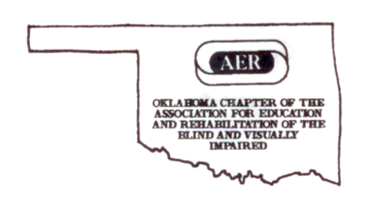
Every Informed Vote Makes a Difference!

