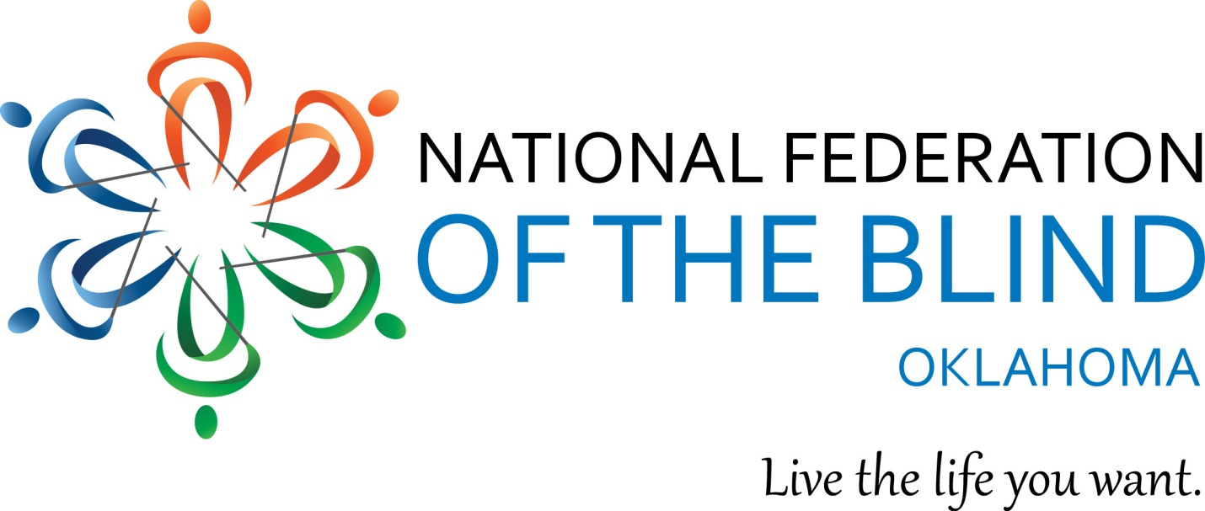

National Federation of the Blind of Oklahoma
2017 Convention
April 7 - 9, 2017
Please join us for our 43rd Annual Convention!

The National Federation of the Blind knows that blindness is not the characteristic that defines you or your future. Every day we raise the expectations of blind people, because low expectations create obstacles between blind people and our dreams. You can live the life you want; blindness is not what holds you back.

Holiday Inn Airport
4401 Southwest 15th
Oklahoma City, OK 73108
405-601-7272

Hotel reservations

Room reservations must be made by each participant. The room rate for singles through quads is $89.00 + tax. You may book online using the link below or by calling the hotel directly at the number listed above.

When booking rooms online, the hotel website defaults the dates to a 3 night stay with a check in on April 6 and a check out on April 9. This can be easily changed. There is a link called "change search". When you click this link, a box appears where you can edit the dates. After entering the desired dates, click the button that says "change search". From there, you can navigate down the screen to see the available room options. Click the "book this room button" for the room configuration you desire (1 king bed or 2 queen beds).

Online Reservations: National Federation of the Blind Oklahoma

Convention Rates and Packages:

Convention Package
Preregistration - $100.00 thru 5:00, Monday, April 3, 2017
At the Door - $115.00 beginning 8:00 AM Friday, April 7, 2016
Includes Registration, Friday Luncheon, Boxed lunch for Saturday and 1 Banquet meal for Saturday evening.

Ala Carte Pricing (Listed below are pre-registration rates. At the door add $5 to each.)
Registration - $25.00
Friday Luncheon - $20
Saturday Boxed Lunch - $20
Saturday Banquet Meal - $40.00
*If you require specialized meal ACCOMODATIONS, please indicate so on your registration.

You may register and pay online using a Pay Pal account or credit card. If you prefer to register online and pay by check or money order you may mail payment to Glenda Farnum, NFBOK Treasurer at the address below. You may also preregister and pay at the door.
If preferred, you may register by filling out the form at the end of this e-mail and sending it along with a check to Glenda Farnum, Treasurer of the NFB of Oklahoma at the following address:

Glenda Farnum
6116 Gunhill Way
Warr Acres, Ok 73132

Should you have questions about convention registration please contact Glenda Farnum by phone at 405-255-6482 or by e-mail gfarnum@cox.net.

Should you have questions about becoming a sponsor or participating as a vendor at the NFBOK 2017 convention, please contact Rex Schuttler, 918-955-6761 or Cammie Loehr at 580-678-8222. Rex and Cammie are serving as co-chairs for this year’s Convention Arrangements Committee.

This year’s convention is shaping up nicely! Among many great sessions and speakers, NFBOK and OKABS, the Oklahoma Association of Blind students) are proud to host a Regional Conference for Blind Students and their parents as well.

Other sessions will focus on Education, the Work Force Investment Act and Transition, Employment, Developing the skills of blindness, and many more. Truly, there is something for everyone! Business meetings and activities are planned for the Oklahoma Association of Blind Merchants, the Oklahoma Association of Rehabilitation Professionals and the NFBOK Sports & Rec. Division.

A screening of the documentary film Bottom Dollars, which highlights the payment of sub-minimum wages to workers with disabilities is scheduled for Friday with an interactive discussion of the practice and of new, improved successful models of employment for individuals with disabilities. .

This year we are happy to welcome Jim Gashel, Secretary of the National Federation of the Blind as our national representative. The following is an excerpt from Jim’s bio on the Board of Directors page on the National Federation of the Blind website. You can read the entire bio at this link:

https://nfb.org/james-gashel-bio

Jim Gashel was born in 1946 and grew up in Iowa. After his early introduction to the National Federation of the Blind as Kenneth Jernigan's student at the Iowa Commission for the Blind during the 1960s, he has been devoted to serving the Blind community in various capacities. A 1969 graduate of the University of Northern Iowa with work toward a master's degree in Public Administration at the University of Iowa, Jim started his career teaching speech and English for one year in Pipestone, Minnesota. He then accepted a position as assistant director at the Iowa Commission for the Blind in Des Moines. With that move he found his calling is working with the blind and finding ways of solving the problems that face them as individuals and as a minority.

On January 1, 1974, Jim joined the staff of the National Federation of the Blind as chief of the Washington office, where he became one of the best known advocates for the blind of the United States, combining his commitment to blind people with his interest in the political process.

As the Federation's scope and influence evolved, so did his roles and responsibilities. In his professional career of almost thirty-four years with the Federation, he held the positions of chief of the Washington office, director of governmental affairs, and executive director for strategic initiatives. Jim's Federation work has led to significant changes in virtually every law directly affecting blind Americans: the Social Security Act, the Rehabilitation Act, the Randolph-Sheppard Act, the Americans with Disabilities Act, the Copyright Act, the Individuals with Disabilities Education Act, and the Help America Vote Act. In addition to championing these causes, Jim has won the love and respect of the thousands of blind men and women across America who have directly benefited from his informed and effective personal advocacy.

National Federation of the Blind Oklahoma
2017 Convention Registration

Name:
Address:
Phone:
E-mail address:

Convention Package - $100.00 x ____ = _______
Ala Carte Pricing
Registration - $25.00 x ____ = _______
Friday Luncheon - $20 x ____ = _______
Saturday Boxed Lunch - $20 x ____ = _______
Saturday Banquet Meal - $40.00 x ____ = _______

Total = ________
Please mark the appropriate below regarding how you will pay for your registration.
- I have enclosed a check or money order for the above amount.
- I will pay with a check or money order at registration.
- I will pay with a credit card at registration.
- I will pay with cash at registration.

Registration packets including purchased meal tickets will be available for pick-up beginning at 7:00 PM on Thursday, April 6th. Be on the look-out for the full agenda. Coming soon, stay tuned!

