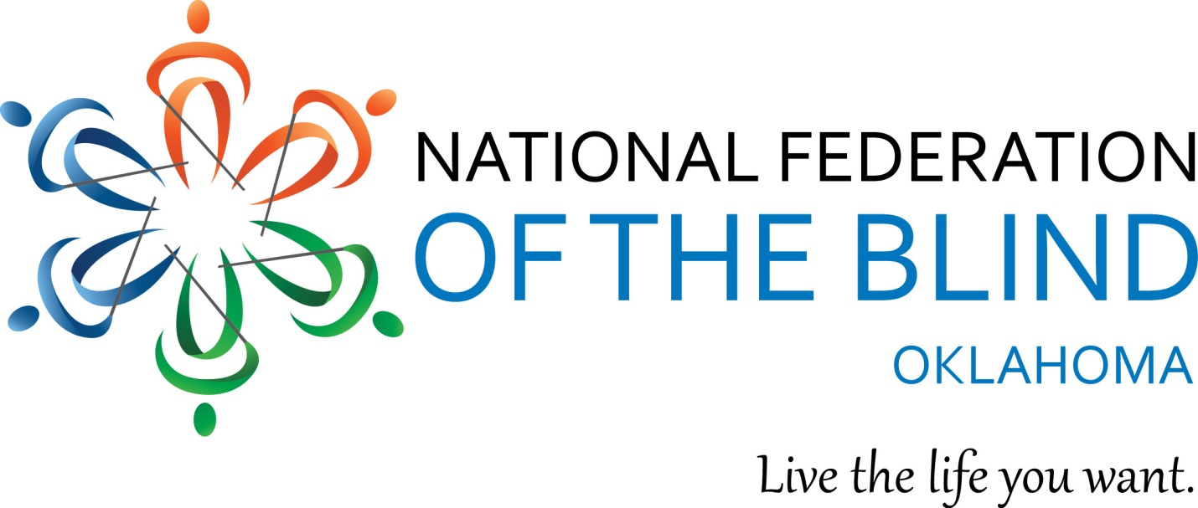

State Convention
&
Regional Student Conference
April 7 - 9, 2017
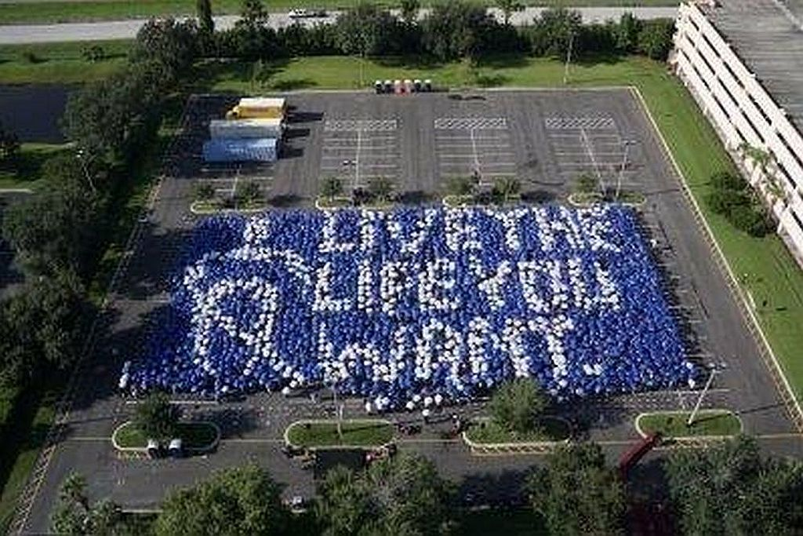

Cover photo: umbrella mosaic which spells out Live the Life you want, letters in white on a purple background.

The National Federation of the Blind knows that blindness is not the characteristic that defines you or your future. Every day we raise the expectations of blind people, because low expectations create obstacles between blind people and our dreams. You can live the life you want; blindness is not what holds you back.
Holiday Inn Airport
4401 Southwest 15th
Oklahoma City, OK 73108
405-601-7272

Overflow Hotel:
Staybridge Suites Oklahoma City Airport
4411 SW 15th
Oklahoma City, Oklahoma, 73108
405-429-4400

Hotel reservations

Room reservations must be made by each participant. The room rate for singles through quads is $89.00 + tax. You may book by calling the Holiday In directly at the number listed above for reservations at either hotel. You must specifically ask to speak to Nikki Ayers in sales in order to receive our rate if there are any rooms available. We have sold out of our room block extension twice. Do not delay. Call ahead.

Convention Rates and Packages:

Convention Package
Preregistration - $100.00 thru 5:00, Monday, April 3, 2017
At the Door - $115.00 beginning 8:00 AM Friday, April 7, 2016
Includes Registration, Friday Luncheon, Boxed lunch for Saturday and 1 Banquet meal for Saturday evening.

Ala Carte Pricing (Listed below are pre-registration rates. At the door add $5 to each.)
Registration - $25.00
Friday Luncheon - $20
Saturday Boxed Lunch - $20
Saturday Banquet Meal - $40.00
*If you require specialized meal ACCOMODATIONS, please indicate so on your registration.
You may register and pay online using a Pay Pal account or credit card. You may also preregister and pay at the door. The following link will take you directly to the registration page on our website: http://www.nfbok.org/state-convention
Should you have questions about convention registration please contact Glenda Farnum by phone at 405-255-6482 or by e-mail gfarnum@cox.net.

Should you have questions about the NFBOK 2017 convention, please contact Rex Schuttler, 918-955-6761 or Cammie Loehr at 580-678-8222. Rex and Cammie are serving as co-chairs for this year’s Convention Arrangements Committee.

This year’s convention is shaping up nicely! Among many great sessions and speakers, NFBOK and OKABS, the Oklahoma Association of Blind students along with TABS, the Texas Association of Blind Students are proud to host a Regional Conference for Blind Students and their parents as well.

Other sessions will focus on Education, Employment, Developing the skills of blindness, and many more. Truly, there is something for everyone! Business meetings and activities are planned for the Oklahoma Association of Blind Merchants, the Oklahoma Association of Rehabilitation Professionals and the NFBOK Sports & Rec. Division.

A screening of the documentary film Bottom Dollars, which highlights the payment of sub-minimum wages to workers with disabilities is scheduled for Friday with an interactive discussion of the practice and of new, improved successful models of employment for individuals with disabilities. . There will also be a screening of the documentary film Do you dream in color?, the coming-of-age story of four blind high school students as they strive to prove that their disability will nothold them back from achieving their dreams.

This year we are happy to welcome Jim Gashel, Secretary of the National Federation of the Blind as our national representative. The following is an excerpt from Jim’s bio on the Board of Directors page on the National Federation of the Blind website. You can read the entire bio at this link:
https://nfb.org/james-gashel-bio

Jim Gashel was born in 1946 and grew up in Iowa. After his early introduction to the National Federation of the Blind as Kenneth Jernigan's student at the Iowa Commission for the Blind during the 1960s, he has been devoted to serving the Blind community in various capacities. A 1969 graduate of the University of Northern Iowa with work toward a master's degree in Public Administration at the University of Iowa, Jim started his career teaching speech and English for one year in Pipestone, Minnesota. He then accepted a position as assistant director at the Iowa Commission for the Blind in Des Moines. With that move he found his calling is working with the blind and finding ways of solving the problems that face them as individuals and as a minority.

On January 1, 1974, Jim joined the staff of the National Federation of the Blind as chief of the Washington office, where he became one of the best known advocates for the blind of the United States, combining his commitment to blind people with his interest in the political process.
As the Federation's scope and influence evolved, so did his roles and responsibilities. In his professional career of almost thirty-four years with the Federation, he held the positions of chief of the Washington office, director of governmental affairs, and executive director for strategic initiatives. Jim's Federation work has led to significant changes in virtually every law directly affecting blind Americans: the Social Security Act, the Rehabilitation Act, the Randolph-Sheppard Act, the Americans with Disabilities Act, the Copyright Act, the Individuals with Disabilities Education Act, and the Help America Vote Act. In addition to championing these causes, Jim has won the love and respect of the thousands of blind men and women across America who have directly benefited from his informed and effective personal advocacy.

Hotel Description

A description of the Holiday Inn and its sister property, the StayBridge Inn next door is located at the very end of the agenda. Please note that many meetings will be held at the Staybridge Suites hotel as well as the Holiday Inn. The agenda is online and will be made available in both large print and Braille at the convention.

Registration- Pre-event area (Outside Ballroom)
Registration will be open on Thursday, April 6th from 6:30 to 8:30 PM, Friday, April 7, from 8:00 to 9:00 AM and Saturday, April 8, from 8:00 to 10:00 AM. If you need to pick up registration at any other time please contact Rex Schuttler or Cammie Loehr.

Exhibit Hall - Lake Draper Room (StayBridge, second on right )
The Exhibit Hall will be open for our members on Friday, April 6 from 12:30 to 7:00 PM and on Saturday, April 7th from 8:00 to 11:30 a.m.

Hospitality Suite
The Hospitality Suite will be open for members and visitors on Thursday, April 6 from 7:00 to 9:00 PM, Friday, April 7, from 1:30 to 7:00 PM and Saturday, April 7th from 8:00 AM to 12:00PM.
The Central Oklahoma Chapter along with the Oklahoma Association of Blind Merchants is providing snacks and beverages for members who need a minute or so to take a break, have a snack and hang out with Federation family!Thanks to the COC & OABM!
Door prizes& Action Auction items
Please bring door prizes and Action Auction items to the Registration desk or to the Hospitality suite.
Action Auction items will be on display during the hours that the Exhibit Hall is open. Similar to a Silent Auction, bidf sheets will be placed for each item with the last bid being taken when the Exhibit Hall doors close. The Action Auction will occur throughout General Session on Saturday afternoon. The live Action Auction bidding begins where the silent bids ended. All proceeds go to the Live the Life You Want fund established in 2016. The Live the Life YOU Want fund is the Member Development fund of the National Federation of the Blind of Oklahoma. The fund provides assistance to members in the form of scholarships to attend state and national conventions, Washington Seminar and to further educational opportunities.

Thursday, April 6

6:30 to 8:30 PM Registration- Pre-event area (Outside Ballroom)
7:00 - 9:00 PM Student conference Kick-off - Lake Overholser Room (StayBridge, first on right)
Federation family gathering and pizza party. Meet & Greet fellow students from across Oklahoma, Texas and Kansas. Food, music and fun!

8:00 -10:00 Rookie Round-Up - Ballroom (Holiday Inn)

If this is your first time to the NFB of Oklahoma convention this session is for you! Learn about what your convention experience can be and meet many leaders and long term Federationists who will show you the ropes and lead you in navigating convention.

Friday, April 7

8:00-9:00 Registration -Pre-event area (Outside Ballroom)
9:00 General Session- Ballroom (Holiday Inn)
9:00 – 9:05 Welcome to the 43rd Annual National Federation of the Blind of Oklahoma convention, Jeannie Massay, President

9:05 – 9:10 Invocation

9:10 –10:10 National Federation of the Blind of Oklahoma Board Meeting
This is an open Board meeting. Please join us as we welcome each other, our special guests and visitors to our convention.

10:10 – 11:00 National Report, Jim Gashel, Secretary, National Federation of the Blind,

10:50 – 12:00 Resolutions Committee Meeting, Steve Shelton, Chair

Any member may submit, at least 1 week in advance of the convention, a resolution which may be considered by the Committee. All members are encouraged to attend as this is where you will learn about the resolutions for this year. Resolutions which pass the committee will then be voted on by the membership at the annual business meeting on Sunday, April 3rd. Resolutions are the birth place of what becomes the policy and action of our affiliate.

Resolutions for consideration may be sent to Steve Shelton at steve@sbshelton.com

12:00 – 12:30 Why I am a Federationist! – Panel discussion
Participants: Cathy Tuton, Cammie Loehr, Mike Harvey, Fatos Floyd, Kayliegh Joiner, Jonathan Franks
Moderated by Audrey T. Farnum, 1st Vice President, NFB of Oklahoma

12:45 – 2:15 Luncheon - Ballroom (Holiday Inn)
Screening of Bottom Dollars, a documentary by Rooted in Rights followed by a panel led discussion. Moderated by Mike Floyd, President, T-Town Chapter, Board Member, NFB of Oklahoma

2:30 – 3:45 Break-out Sessions

1. Student Conference - Lake Overholser Room (StayBridge, first on right)
2:30-3:15 Advocating for yourself as a Blind student
What are your rights & Responsibilities of being a Rehabilitation client?
Come and here about what being a DRS client as a student in tails from the source.
Speaker: Fatos Floyd

3:15 – 3:45 College life! – A Panel discussion-
Are you a high schooler considering attending college but don’t know what to expect, a student already in college and struggling with courses or social life or just a college student wlooking to find other college studetns who are blind? This session is absolutely the one for you. Successful blind students want to share their college experience with you.

2. Cane Travel: Where can your long white cane take you? - Ballroom (Holiday Inn)
Professional Orientation & Mobility Instructors will be on hand to dynamically teach participants the basics of using a long white cane to navigate the world as a blind person. Led by Mike Harvey, Board Member, NFB of Oklahoma

3. Tech Talk & Demonstrations - Lake Hefner Room (Staybridge, first on left)
Do you have a Love/ Hate relationship with your technology? This seminar is for beginners to those who are tech savvy. Bring questions about the technology that you depend on. Hopefully, we can provide the answers! Demonstration of the KNFB Reader Mobile app. And others.
Led by Audrey Farnum, Rex Schuttler and Jim Gashel

4:00 – 5:15 Break-out Sessions

1. Student Conference - Lake Overholser Room (StayBridge, first on right)
4:00pm-4:45pm Computer science careers: Yes, Blind people do!
Are you a student who has thought about going into a computer science field or are you currently a computer science major but do not know how you will get through your course work, then come and hear what being a blind computer science major is really like and how you could have success in the field.
Speaker: Harry Staley

4:45-5:15pm Learning to advocate for yourself in Mid & High school
An open discussion for mid and high schoolers to learn to advocate for themselves in high school and a chance for college student mentors to learn how to help high schoolers to become their own advocates.

2. What is the National Federation of the Blind?- Ballroom (Holiday Inn)
Discussion of what the National Federation of the Blind is and why members on this panel got involved and remain so. Who we are and what we do!
Led by Members of the Board, National Federation of the Blind of Oklahoma and family members from across the Federation!

3. Social Media butterflies?
If the thought of posting and tweeting leavrs you befuddled and afraid, have no fear! Come learn about the ins and outs of social media. From posting to sharing and beyond, with the unified message of the NFB, we’ve got you covered!
Presented by Audrey Farnum

5:15 - 7:00 Dinner Break

Dinner on your own or with friends, whatever you choose. The hotel has a full restaurant on property and there are lots of local and national chain restaurants nearby as well. See the restaurant guide in your registration packet.

7:15 – 8:30 Sports & Recreation Division Annual Division Meeting and activities - Ballroom (Holiday Inn)
Cathy Tuton, President

7:15 - 8:30 Blind parenting: Yes, we do! - Lake Draper Room (StayBridge, second on right )
A gathering of parents who happen to be blind. Discussion of the blind parenting initiative
Led by Mike Harvey

7:15 – 8:30 Raising expectations for and with your blind child - Lake Hefner Room (Staybridge, first on left)
A gathering of parents of blind children and discussion of forming a parents division of the National Federation of the Blind of Oklahoma.
Led by Glenda Farnum, Treasurer, Central Oklahoma Chapter, Treasurer, NFB of Oklahoma

7:15 – 10:00 Belt it out and get down! - Ballroom (Holiday Inn)
Drop in to the National Federation of the Blind of Oklahoma Student social to make new friends or reconnect with old ones. Enjoy music, karaoke, dancing, food and fun!

8:45 – 11:00 Meet & Mingle with your Federation family - Lake Hefner Room (Staybridge, first on left)
Catch up with old friends and, hopefully, make new ones too!

Saturday, April 8

8:00 – 9:00 Registration - Pre-event area (Outside Ballroom)

8:30 – 10:00 Break-out Sessions

1. Student Seminar - Lake Overholser Room (StayBridge, first on right)
8:30-9:15am What is a Training center?
If you want to know where and how you can learn independence, confidence, and blindness training. Than come to our panel on NFB training centers. Speakers: Bre Brown, Cammie Loehr, Cathy Tuton

9:15-10:00am What You Need to Know to advocate for yourself while in school
Do you wish to know what rights you have as a blind college student according to the law? Do you want to know how best to speak to your university about accommodations? Learn how to work alongside your universities disability services to have a quick, easy, and efficient experience.

2. Overcoming obstacles in finding a job: A Panel discussion - Ballroom (Holiday Inn)
Are you looking for a job? Want to excel at the one you have? This session is for you! It shouldn’t be a question of what a blind person can do. It should be about what you want to do and how to get the necessary skills to be able to do that and everything else that you want to do!

3. Legislation & Advocacy - Lake Hefner Room (Staybridge, first on left)
Presentation and discussion of current Oklahoma and National legislation affecting the blind, why it’s important and how you can get involved.
Led by Glenda Farnum

10:15 – 11:45 Break-out Sessions

1. Student Seminar - Lake Overholser Room (StayBridge, first on right)
10:15-11:00am NFB Newsline& the KNFB Reader Mobile
Come and learn about NFBNewsline service and the KNFB Reader Mobile App. Learn about what they are all about, live demonstrations, and assistance in getting them.
Presentors: Jim Gashel and Rex Schuttler

11:00-11:45am The Marshmallow challenge
Come and explore the field of science with us, as we show students that even the most visual fields of study are not out of their reach. A group exercise and discussion:

2. Screening of the film Do you Dream in Color? - Ballroom (Holiday Inn)
A coming-of-age story of four blind high school students as they strive to prove that their disability will not hold them back from achieving their dreams.
Sponsored by the Oklahoma Association of Rehabilitation Professionals (OARP).
If you are interested in joining this division of the National Federation of the Blind of Oklahoma, stick around! The OARP Annual business meeting follows the screening.

3. The Working Blind – Lake Hefner Room (Staybridge, first on left)
A panel discussion with employed individuals who happen to be blind. Federationists from a variety of interests and jobs will speak about their jobs and the skills that they use daily to bring home their pay!

11:45 – 12:45 Working lunch
If you have paid for a boxed lunch pick it up and go to the division meeting of your choice.

Oklahoma Association of Blind Students Division Business Meeting - Lake Overholser Room (StayBridge, first on right)
Cammie Loehr, President

Oklahoma Association of Blind Merchants Division Business Meeting - Lake Hefner Room (Staybridge, first on left)
Mmike Spencer, President

Oklahoma Association of Rehabilitation Professionals Division Business Meeting -- Ballroom (Holiday Inn)
Mike Harvey, President

General Session

1:00- 1:20 NFBOK President’s Report, Jeannie Massay, President, NFB of Oklahoma, Treasurer, National Federation of the Blind

1:20 – 1:25 Action Auction

1:25 – 1:40 Live the Life you want Fund, NFBOK PAC and PAC reports, Glenda Farnum, Treasurer, NFB of Oklahoma

1:40 – 1:45 Action Auction

1:45 – 2:05 Teresa McDermott, Division Administrator, Visual Services, Oklahoma Department of Rehabilitation

2:05 – 2:10 Action Auction

2:10 – 2:25 Kevin Treese, Director, Oklahoma Library for the Blind & Physically handicapped

2:25 – 2:30 Action Auction

2:30 – 3:30 My Educational Experience as a blind child; : A panel discussion.
Moderated by Norma Crosby , President NFB Texas, Board Member, National Federation of the Blind

3:30 – 3:35 Action Auction

3:35 – 4:05 Adolescent and youth programs for the blind - Bre Brown and Rex Schuttler

4:05 – 4:10 Action Auction

4:10 – 4:30 Beyond K-12: College Prep. Programs at our Centers, Bre Brown, Louisiana Center for the Blind

4:30 – 4:35 Action Auction

4:40 – 4:50 Preparing for life; Graduating from an Adult Training Center, Cathy Tuton
4:50 – 5:00 Closing remarks & Adjournment, Jeannie Massay, President, NFBOK

5:15 Nominating Committee, Audrey T. Farnum, Chair, Meeting location TBD. This meeting is closed, limited to committee members only.

7:00 – 10:00 Banquet and keynote address featuring, Jim Gashel, Secretary, National Federation of the Blind

Scholarship presentation – Central Oklahoma Chapter

Sunday, April 2, 2016

9:30-12:00 Annual Business Meeting - Ballroom (Holiday Inn)

9:30 Call to Order NFBOK Business Meeting, Jeannie Massay, President, National Federation of the Blind of Oklahoma

9:35 NFBOK Treasurer’s Report, Glenda Farnum, Treasurer, National Federation of the Blind of Oklahoma

9:40 Secretary’s Report, Mike Harvey, Interim Secretary, National Federation of the Blind of Oklahoma

9:50 Chapter & Division Reports
Central Oklahoma Chapter, Rex Schuttler, President
Green Country Chapter, Tiffany Watts, President
Southeastern Oklahoma Chapter, Cammie Loehr, President
T-Town Chapter, Mike Floyd, President
Oklahoma Association of Blind Merchants, Mike Spencer, President
Oklahoma Association of Blind Students, Cammie Loehr, President
Oklahoma Association of Rehabilitation Professionals, Mike Harvey, President
NFBOK Sports & Rec Division, Cathy Tuton, President
10:30 Resolutions Committee Report to the Membership followed by vote of membership on Resolutions

11:45 Nominating Committee Report & Elections

12:00 Adjourn

We would like to take the opportunity to thank our sponsors for contributing to the success of our 43rd Annual convention of the National Federation of the Blind of Oklahoma! Your sponsorship and participation have helped us to make this a great convention!

Sponsors

Bronze

Oklahoma ABLE Tech
Connecting Oklahomans with Disabilities to Assistive Technology

Exhibitors

Nannopak

Oklahoma Department of Rehabilitation, Division of Visual Services

Oklahoma Library for the Blind & Physically Handicapped

Sumpa Ahkter Ceramics

Tactile Art by Simmone

A mesage from the President:

Thank you to the Co-chairs and committee members of the convention arrangements committee for your hard work in putting this convention together, without you it wouldn’t have come together as smoothly as it has! Our 43rd Annual convention is set to be the biggest and best yet!

Additionally, I would like to thank each and every one of you for choosing to come to and participate in this convention. I have come to think of our conventions more as a working family reunion than as merely a convention. It is my hope that you will come to know and love us as we want to come to know and love you. The National Ffederation of the Blind knows that blindness is not the characteristic that defines you or your future. Every day we raise the expectations of blind people because low expectations create obstacles between blind people and our dreams. You can live the life you want. Blindness is not what holds you back. The leaders and members of the National Federation of the Blind helped me to come to believe this deeply.

The National Federation of the Blind has brought hope, love and determination to me as an individual, as a blind woman and as a leader. I strive to continually learn and grow as a member, a leader and hope that you will choose to do so with us as we do the same within the National Federation of the Blind of Oklahoma and as members of the National Federation of the Blind. There is little that we cannot accomplish together.

If I can be of assistance in your growth and development as a member or answer questions that you may have, talk about ideas that you have in growing and developing our affiliate, please feel free to call me. I look forward to hearing from you.

Safe travels and warm regards,

Jeannie

Jeannie Massay, President
National Federation of the Blind of Oklahoma
405-600-0695, Jeannie.massay@nfbok.org
Hotel Description
The National Federation of the Blind of Oklahoma 2017 state convention will be held in two hotels. The Holiday Inn will be the main hotel, and the Staybridge Inn and Suites which is right next door will be the overflow hotel and will also be the location for some of our meetings. Here is a brief description of the main hotel along with information on navigating to the second hotel and finally a description of the Staybridge Inn and Suites.
The main entrance to the Holiday Inn is located on the south side of the lobby, so as you enter the hotel, you are facing north. Immediately to your left or west as you enter the front door is a hallway that runs west and contains the meeting rooms. If you keep walking north after entering the front door, you will find the front desk on your left hand side just past where you would have turned to go to the meeting rooms. Continuing north past the front desk, you can turn left or west and enter the restaurant area of the hotel. On your right past the front desk on the east wall of the lobby is a glass door that serves as the entrance to the pool and hot tub. North of the entrance to the pool, still on the east wall are the two elevators. North of the elevators, in the Northeast corner of the lobby, is an ATM. Just to the left of that ATM on the north wall of the lobby is a back door that leads out to a patio area. This patio door is facing the front entrance to the hotel. Once you exit the patio door, there is a relief area for dogs to the right or east of you.
Meeting rooms hallway: Turning west (left) as soon as you enter the front door of the lobby, or turning right before you were to exit the front door of the hotel takes you to the hallway where the meeting rooms are located. As you enter this hallway, you are walking west. On your left hand side or south side of the hallway are windows and our registration area. All of the rooms of interest are on your right hand side or north side of the hallway. The very first door on the right is a storage room, followed by a small tile hallway connecting the meeting rooms hallway with the restaurant. Continuing west past the small hallway is the business center. Past the business center still on the right hand side of the hallway is the Oklahoma River meeting room. After the Oklahoma meeting room is the Canadian River meeting room, and the final meeting room down the meeting rooms hallway is the Washita River meeting room. All three of these meeting rooms will be combined in to one big ballroom for general sessions and the banquet. These 3 rooms are collectively referred to as the ballroom in the agenda; just know that all three the river rooms are all collectively part of the ballroom. Go back to the short tile hallway to your right before you get to the business center, if you turn right or north in to the small tile hallway, you will first come to a women’s restroom on your right hand side, and that is followed by a men’s room. So, the men’s room is closest to the restaurant while the women’s room is closest to the meeting room hallway.
The Restaurant of the hotel can be access from the lobby area just north of the front desk by turning west. It can also be access via the short tile hallway which connects the Meeting rooms hallway to the restaurant. The bar is on the far north side of the restaurant.
As you exit the elevators on the sleeping floors, you are facing west. “Turning left/South will take you to the hallway containing the sleeping rooms. The hallway containing the sleeping rooms runs east/west, so one must turn down this hall to locate their room. There are ice and vending machines located to the right or north of the elevators on even floors only. There will be a door to your right which will lead you in to a room with these machines. On odd floors, these rooms are used for office spaces, so ice and vending machines can only be accessed from even floors.

The Staybridge Inn and Suites is located just west of the Holiday Inn right next door. To get to the Staybridge from the Holiday Inn, walk out the front door of the lobby. When you exit the Holiday Inn, you are facing south. Take a quick right outside the door and walk west. The sidewalk leads you to a spot where you have to step down and cross an entrance. The sidewalk picks up and continues west on the other side of this crossing, but it is offset a little to the right/north of you when you are going to the Staybridge. So after taking a step or two to your right/north to locate the sidewalk again, continue walking west to arrive at the front door of the Staybridge. When you arrive at Stay Bridge, you will turn right or north to enter the hotel. As you enter the lobby of the Staybridge, you are facing north and the front desk is on your left. Past the front desk, if you turn east, you will find a hallway the contains restrooms, elevators and the meeting rooms. The first door on your right or south side of this hallway is a ladies’ room. Just east of the ladies room is a small hallway where the elevators are located. Continue east without turning in to the elevator bank and you will then find a men’s room which is also located on the right/south side of the hallway. Across from the men’s room is an ATM. After passing the men’s room and continuing east, you will hit carpet. You are now in the hallway that contains the meeting rooms at the Staybridge. Once you get to the carpeted area, the first two rooms on your left hand side/north side of the hallway are entrances to the Lake Hefner room. On the South side or right side of the hallway across from the Lake Hefner room is the Lake Overholser Room which has two entrances as well. Continuing east past the Lake Overholser Room, you will find the Lake Draper room on the south side of the hallway. If you continue east past the meeting rooms, there is a hallway that goes off to your left or north. This hallway contains the pool and the fitness center. The pool is at the far north end of this hallway, and the fitness center is on the left/west side of the hallway just before the hall ends at the entrance to the pool.
If you take the elevators up to the floors with the sleeping rooms at the Staybridge, you are facing east as you exit the elevators. If your room is between 23/36, keep walking east upon exiting the elevators to find the hallway which will take you to your room. If your room contains a number lower than 23 in its last two digits, then you need to make a left after exiting the elevators and then make a second quick left to walk back west to locate your room.
The front entrance to the Staybridge is on the south side of the lobby, so you are facing north as you enter the hotel. On the back side of the lobby is a little dining area, and past that dining area on the north side of the hotel are two exit doors that lead out to a patio area. There is plenty of grassy area on both sides of you once you exit these doors that can serve as a relieving area for dogs. Finally, both hotels have a “pantry” area near the front desk that has vending items such as drinks, candy bars, chips and more available for purchase at the front desk via cash, credit card or charging to your room.
Have fun, explore and know there will be lots of Federationists there to answer questions and encourage exploration! Happy Convention Everyone!!

