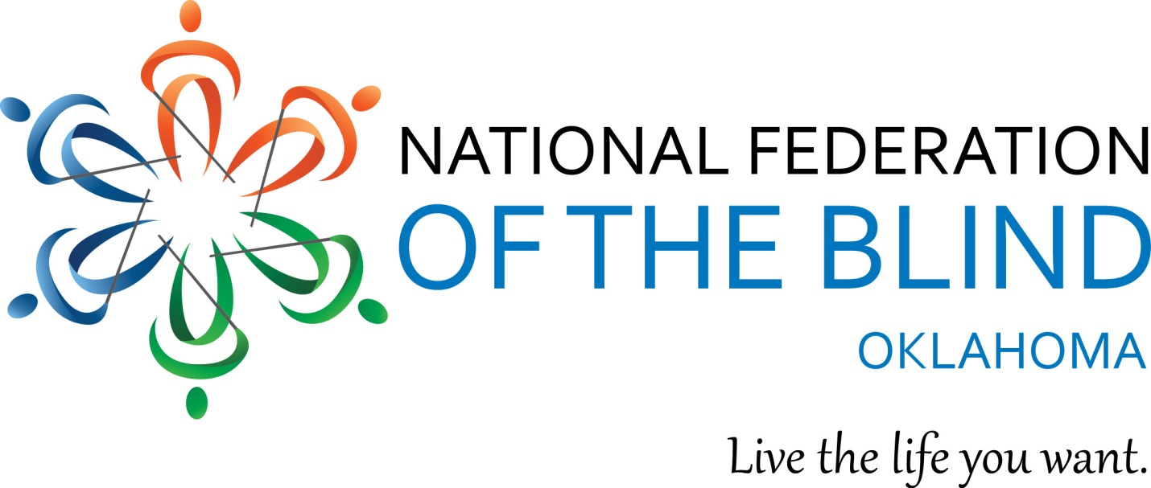

National Federation of the Blind of Oklahoma
2019 State Convention
March 29-31, 2019

“Building the Lives We Want”

The National Federation of the Blind knows that blindness is not the characteristic that defines you or your future. Every day we raise the expectations of blind people, because low expectations create obstacles between blind people and our dreams. You can live the life you want; blindness is not what holds you back.
Renaissance Waterford Oklahoma City
6300 Waterford Boulevard
Oklahoma City, OK 73118
405-848-4782

Hotel reservations

Room reservations must be made by each participant by March 14, 2019. The room rate for singles through quads is $109.00 + tax. You may book by calling the Renaissance Waterford directly at the number listed above for reservations or by going directly to this link:
NFBOK Book hotel online

Convention Rates and Packages:

Convention Package - Saves you money!

Preregistration - $110.00 thru 5:00 PM,
Includes Registration, Friday Luncheon, Boxed lunch for Saturday, 1 Banquet meal for Saturday evening and a National Federation of the Blind of Oklahoma t-shirt.

Ala Carte Pricing (Listed below are pre-registration rates. At the door add $5 to each.)
Registration - $25.00
Friday Luncheon - $25
Saturday Boxed Lunch - $25
Saturday Banquet Meal - $45.00
T- shirt - $15.00

*If you require specialized meal ACCOMODATIONS, please indicate so on your registration. If you do not indicate a meal accommodation on your registration we cannot guarantee that special requests can be honored.

You may pre-register and pay online using a Pay Pal account or credit card. You may also register and pay at the door. The following link will take you directly to the registration page on our website:
http://nfbok.org/convention-registration/

Should you have questions about convention registration please contact Glenda Farnum by phone at 405-255-6482 or by e-mail at Gfarnum5474@gmail.com

Should you have questions about the NFBOK 2019 convention, please contact Audrey Farnum, 405-590-6110 or Glenda Farnum at405-255-6482. Audrey and Glenda are serving as co-chairs for this year’s Convention Arrangements Committee.

This year’s convention is shaping up nicely! We are happy to welcome our national representative, Everett Bacon. Everett serves as President of the National Federation of the Blind of Utah and on the Board of Directors of the National Federation of the Blind. Everett works as a Field Service Coordinator for the Utah Division of Services for the Blind and Visually Impaired in Salt Lake City Utah. Everett has a compelling story about his family and blindness, discrimination and ultimately how the members of the National Federation of the Blind helped him to change his life. Everett will also lead several break-out sessions in his time with us.
**Of note, Everett’s session on Project STRIVE. The transition mentoring program developed by the National Federation of the Blind of Utah.

To read Everett’s complete bio go to Everett Bacon bio

Hotel Description

A description of the Renaissance Waterford by Marriott is located at the very end of the agenda. The agenda is online and will be made available in both large print and Braille at the convention.

Registration

Registration on Thursday March 28 will be from 5:30 – 7:00 outside of the Rookie Round-Up located to the northeast of the elevators on the first floor. Registration on Friday, March 29, will be from 7:30 – 8:45 AM in the pre-function area in the hallway west of the ballroom. Registration on Saturday, March 30, will be from 7:30 – 8:45 AM in the pre-function area in the hallway west of the ballroom. If you have not registered by Sunday, March 31, please locate Glenda Farnum at the head table to register.

Exhibit Hall

The Exhibit Hall will be open for our members on Friday, March 29 from 1:00 to 7:00 PM and on Saturday, March 30 from 8:30 to 12:30.

Door prizes& Action Auction items
Please bring door prizes and Action Auction items to the Registration desk.
Action Auction items will be on display during the hours that the Exhibit Hall is open. Similar to a Silent Auction, bid sheets will be placed for each item with the last bid being taken when the Exhibit Hall doors close. The Action Auction will occur throughout General Session on Saturday afternoon. The live Action Auction bidding begins where the silent bids ended. All proceeds go to the Live the Life You Want fund established in 2016. The Live the Life YOU Want fund is the Member Development fund of the National Federation of the Blind of Oklahoma. The fund provides assistance to members in the form of scholarships to attend state and national conventions, Washington Seminar and to further educational opportunities.
We are proud to welcome Everette Bacon to our affiliate to serve as national representative for our convention. When serving in this capacity Everette represents President Riccobono. Everette serves on the Board of Directors of the National Federation of the Blind and as President of the National Federation of the Blind of Utah. Please make Everette feel welcome and give him a great big Oklahoma “Hey!” I know you will love Everette because everyone loves Bacon! Here is Everett’s bio:
Everette Bacon was born in Huntington Beach, California. At the age of five he was diagnosed with cone-rod dystrophy, a condition which had run in his family on his mother’s side for thirteen generations, causing rapid-onset blindness primarily in female family members. Despite the diagnosis, Everette’s family took the advice of teachers and medical experts, believing (or, more accurately, hoping) that since Everette was male and his vision was not deteriorating rapidly like that of other family members, he was unlikely to go blind. As a result, Everette did not learn Braille or other alternative techniques during his school years. Looking back, Everette says, his mother and other family members wish that they had encouraged him to learn Braille and other blindness skills.
When Everette was around eighteen his entire family moved to Texas. Everette pursued a degree in church music at Dallas Baptist University. He jokes that he was pushed toward music because “you know, blind people sing.” His first job was teaching a seventh grade choir, but he found it not to his liking. Searching for other employment in order to earn money to help his wife through medical school, Everette ultimately accepted a management position with Blockbuster Video in 1997. He was very successful in this position, winning several awards and steady promotions. By 2004, he was managing ten stores in the Houston area.
Everette’s eye condition began to worsen, and instead of giving up, he adapted by using alternative techniques. “I started carrying a cane, mainly for identity, but I was using it when I felt I needed it.” “I was never embarrassed or ashamed about becoming blind, because I grew up around blind people, adapting was something you just became accustomed to doing.” However, when he asked for reasonable accommodations from his employer, instead of granting these accommodations, Blockbuster terminated his employment despite his outstanding record. The company even went so far as to describe Everette’s conduct as “fraudulent,” implying that he had deceived the company about his capabilities, even though he had previously been praised and awarded for his work.
This experience traumatized Everette and his family. His wife, mother, and other family members sent angry emails to everyone they could; urging readers to avoid shopping at Blockbuster based on discrimination against the blind. One of these emails found its way to Scott LaBarre, the president of the National Federation of the Blind of Colorado and a successful disability rights attorney. Scott took Everette’s case, and ultimately Everette received a settlement from Blockbuster. More importantly, though, he learned about the National Federation of the Blind and the many battles the organization has fought in the effort to advance and protect the civil rights of blind people. “I had heard of the Federation and been told that they were militant,” Everette says, “but my experience taught me the importance of our advocacy.” There are so many reasons to be proud of whom we are as blind people, and the Federation has paved the way for our climb to the top of the mountain of civil rights!
Thursday March 28
7:00 - 10:00 Rookie Round-Up

If this is your first time to the NFB of Oklahoma convention this session is for you! Learn about what your convention experience can be and meet many leaders and long term Federationists who will show you the ropes and lead you in navigating convention. All are welcome.

Light hors d’ oeuvres will be available along with a cash bar.

Friday, March 29

7:30-8:50 Registration -Pre-event area (Outside Ballroom)
9:00 General Session
12:15 – 1:45 Luncheon hosted by NFB Newsline
2:00 – 3:30 Round 1 Break - out sessions
3:45 – 5:15 Round 2 Break - out sessions
Specific times and room names for the following Friday afternoon break-out sessions are TBD and will appear in the final agenda available in print, braille and on the NFBOK website:
- Mentoring Blind Youth in Utah- Everette Bacon
- College prep for blind students
- Helping our clients find their path to living the lives they want – Fatos Floyd
- Structured Discovery: What is it really
- Newsline at work and school -Mike Floyd
- Walk this way: An introduction to the long white cane – Jane Lansaw and others

5:15 – 7:30 Dinner on your own! We do receive a 10% discount on food at the hotel. Additionally, there are a number of restaurants in the general vicinity of the hotel. A list of these are at the end of the agenda.
7:45 – 9:30 Resolutions Committee
Steve Shelton, Chair

Any member may submit, at least 1 week in advance of the convention, a resolution which may be considered by the Committee. All members are encouraged to attend as this is where you will learn about the resolutions for this year. Resolutions which pass the committee will then be voted on by the membership at our annual business meeting on Sunday, April 15th. Resolutions are the birth place of what becomes the policy and action of our affiliate.

Resolutions for consideration may be sent to Steve Shelton at steve@sbshelton.com

Saturday, March 30

8:30 – 9:00 Walk this Way!
Come join in an interactive cane walk. Learn tips and techniques to use the long white cane and dispel the misperceptions of why we use long white canes. Oh yes, we’ll also have fun!

Times and room names for the following Saturday morning break-out sessions are TBD:
Specific times and room names for the following Friday afternoon break-out sessions are TBD and will appear in the final agenda available in print, braille and on the NFBOK website:

9:15 – 10:45 Round 1 Break - out sessions

11:00 – 12:30 Round 2 Break - out sessions
Specific times and room names for the following Saturday morning break-out sessions are TBD and will appear in the final agenda available in print, braille and on the NFBOK website:
- Self-Advocacy: Your Rights and Responsibilities
- Living the Good Life: Independent home skills
- Legislative Seminar: Our current legislative priorities in Oklahoma and the nation
- Training Centers: What are they all about?
- What is the National Federation of the Blind?
- Help! My child is Blind, What do I do?

12:45 – 2:15 Lunch!

Grab your Boxed Lunch and find a Division of the NFBOK you may be interested in: OABM (Oklahoma Association of Blind Merchants), OARP (Oklahoma Association of Rehabilitation Professionals), OKABS (Oklahoma Association of Blind Students, Parents of Blind Children. If you are not specifically a member of any of the above but have interest in helping out please join in wherever you feel that you fit best!

2:15 – 5:15 General Session

6:00 Cash Bar – pre-function area

7:00 – 10:00 Banquet

Keynote address: Everette Bacon, President, National Federation of the Blind of Utah, Board member. National Federation of the Blind, and, most importantly, member, National Federation of the Blind

Scholarship and Award Presentations

Sunday, March 31, 2019
7:30 – 9:00 Chapter President’s Breakfast
By invitation only to those who are Chapter Presidents

9:30 – 12:00 Business Meeting

- Treasurer’s Report
- Secretary’s Report
- Chapter & Division Reports
- Resolutions Committee Report to the Membership followed by a vote of the dues paying members present.
- Nominating Committee Report and Elections

12:00 Adjourn
Remember to sign up for committees that you may be interested in helping out with!

Sponsorship and Exhibitor opportunities are still available. Please see below for available opportunities to support the National Federation of the Blind of Oklahoma! For more information call Glenda Farnum at 405-255-6482.

Dear Friends of the National Federation of the Blind of Oklahoma:
The National Federation of the Blind of Oklahoma, an affiliate of the National Federation of the Blind is the largest and most influential force for change for the blind in this country. We are the blind speaking for ourselves. We invite you to partner with us as we work for better lives and new opportunities for blind and visually impaired people in Oklahoma. Our annual state convention will occur March 28 to 31, 2019 in Oklahoma City at the Renaissance Waterford, 6300 Waterford Blvd. The exhibit Hall will be open on Friday, March 29 from 12:00 a.m. to 8:00 p.m. and on Saturday, March 30, from 8:00 a.m. to 12:30 p.m. Opportunities for sponsors and exhibitors are as follows:
Convention Sponsorship
Convention Sponsors receive recognition in our convention agenda, on our website at www.nfbok.org and during the convention. Convention sponsors will also receive exhibit space on Friday and Saturday along with a brief presentation time during general session. Sponsorship levels are:
- Platinum - $3,000
- Gold, $1,500
- Silver, $1,000 and bronze, $500.

Convention Exhibitor - Exhibit space $200
Exhibitors will receive exhibit space and recognition in our program.

Donations of funds or door prizes
If you are unable to sponsor or exhibit but would like to make a monetary donation or donate a door prize, we would appreciate your support. Agencies or companies who donate items or financial support will be recognized in our program.
Registration for Sponsors or Exhibitors
Registration can be completed on line at http://www.nfbok.org/vendors/
The NFB of Oklahoma commends you for your support of our mission. Any assistance you can provide is greatly appreciated.

