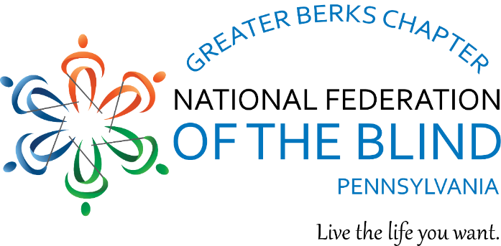

The Greater Berks Chapter of the National Federation of the Blind welcomes in 2024.
We are rebuilding!
We are revitalizing!
We have a new meeting time and location
West Lawn Library, 101 Woodside Avenue, West Lawn, 19609
Third Saturdays at 10:00 am
We hope you will join us!

Purposes, Goals, and Objectives

- to advance the general welfare of the blind of the Greater Berks area

- to be integral part of the National Federation of the Blind of Pennsylvania and the

National Federation of the Blind

- to be a mechanism through which the blind and interested sighted persons can come

together to plan and carry out programs to improve the quality of life of the blind

- to be an avenue of information for parents of blind children and students

- to promote the vocational, cultural, and social advancement of the blind

- to strive to improve the overall condition and standard of living of the blind

- to assist the blind to live the lives they want

For more information:

President: Brian Mackey, berks@nfbofpa.org, 609-680-8488

Facebook: https://www.facebook.com/BerksFederation

