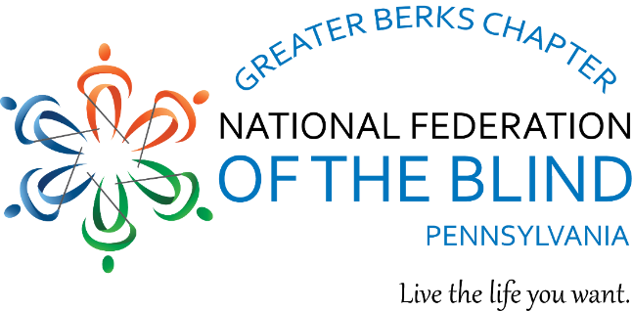

Greater Berks Chapter

We’re rebuilding, revitalizing, and growing — and we want you with us!

Are you blind, low vision, DeafBlind, or a sighted ally?

At the Greater Berks Chapter, we care, we share, we grow, and we make a difference. Through advocacy, education, mentorship, and mutual support, we empower people who are blind, low vision, DeafBlind, and their families, friends, professionals, and sighted allies—so blind people can live the life they want.

Meeting Information
West Lawn Library, 101 Woodside Avenue, West Lawn, PA 19609
Also via Zoom – contact us for the participation details
Third Saturdays at 10:00 a.m. (no meetings in July and December)

Our purposes, goals, and objectives:
- Advance the welfare and quality of life of blind people in the Greater Berks area
- Active participation in the National Federation of the Blind of Pennsylvania and the National Federation of the Blind
- Bring blind and interested sighted individuals together for meaningful programs
- Provide information and support for parents of blind children/students
- Work to improve independence, opportunity, and overall quality of life so blind people can live the lives they want
- Share experiences, encouragement, and practical solutions
- Advocate to promote independence, accessibility, and equal opportunity

Contact Information
Brian Mackey, President
Email: berks@nfbofpa.org Phone: 609-680-8488
Facebook: https://www.facebook.com/BerksFederation

