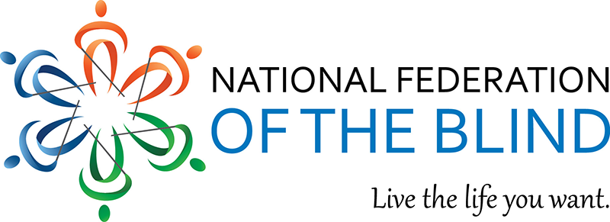

Hello, The National Federation of the Blind Greek and Masonic group will be conducting their convention seminar on July 6th from 2:00pm – 4:00pm. This meeting will afford the opportunity for blind individuals who are Greek and masonic members to listen to personal experiences of Federationists, who are members of these prestigious organizations. When entering the meeting room, please show your spirit by stating your name and your Fraternity, Sorority or Masonic affiliation. The zoom information for participation is:
Zoom meeting ID: 982 5999 5697

Thanks, and I hope to see you there!

Shawn Callaway
Chairman
Blind Greek & Masonic Group

