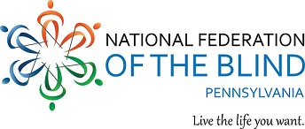

Bake Sale, Auction, & Chair Massage Fundraiser

Come out to support a great cause and enjoy some great food!

The National Federation of the Blind of Pennsylvania (NFBP) Greater Philadelphia Chapter will be sponsoring its bake sale, auction, and chair massage fundraiser on Thursday, April 4, 2019.

Times for the event:
- Bake Sale: 12 to 4 PM
- Chair Massage: 12 to 2 PM
- Auction: 2 to 4 PM

The event will take place at:
919 Walnut Street
10th Floor, Conference Rooms B & C
Philadelphia, PA 19107

All proceeds will benefit programs provided by the Greater Philadelphia Chapter.

Items in Bake Sale:
- Cake and Pie Slices: $2 each
- Cupcakes: $1 each
- Cobbler: $2 each
- Cookies (small): 3 for $1
- Cookies (large): 2 for $1
- And much more!
Special items can be bought for $1, $2 and $5.

Great items will be auctioned off that can enhance any room in your home. Come out and bid on something you want.

Chair Massages are $1 per minute. You can get a massage up to 10 minutes.

For further information, please contact any member of the Greater Philadelphia Chapter or its president, Denice Brown, at 215-808-5875.

