NFB4th Annual Blind Womens Empowerment Conference2019
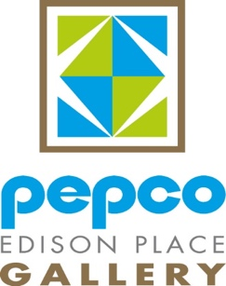

“Sister to Sister, Heart to Heart”

THE NFB OF DC PROUDLY PRESENTS OUR 4TH ANNUAL
BLIND WOMEN’S EMPOWERMENT CONFERENCE

Bringing to you an awesome panel of diverse blind women along with dynamic keynote speaker, Denise Avant. These talented sisters will be telling it to you from their hearts to your hearts. Get ready to be dazzled, rejuvenated, and inspired to live the life you want.

Pepco Edison Place Gallery

Thursday, October 31, 2019 702 8th Street, NW
10:00 A.M. - 3:00 P.M. Washington, DC 20004
Ticket Price: $25.00 [Nearest Metro Station is Gallery Place 9th & G St.]

All Women Are Welcome
- To RSVP or for more information contact Libra Robinson at (202) 427-3600 or email leelibra342@gmail.com no later than October 24, 2019

- All sales are final/no refunds

