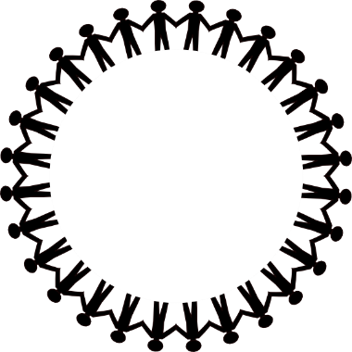  Building a  Better  Community | SCOPE  Showing Community  Other Perimeters of  Education | It’s Not Your Fault

PRESS RELEASE
Senior Summit: Seniors Count

The year 2020 changed our lives. Eighty percent of individuals who died due to Covid-19 were senior citizens. Those who had pre-existing health conditions and compromised immunity were the most vulnerable. The senior population has still not recovered from the effects of the pandemic. Many are struggling in the areas of healthcare, finances and mental health.
Many are suffering needlessly because they are not aware of the resources that are available to them. The purpose of the senior summits is to educate and empower Senior Citizens through exposure to governmental agencies, non-profits, medical and mental health agencies and care-giving agencies that can help them to manage the intricacies of their lives.
The Senior Summits will be held at different facilities throughout the city of Philadelphia hosted by churches and other community organizations during the months of March, April, May and June in this year of 2023,
During the Summits there will be breakout sessions on mental health, diabetes, hypertension and other health issues, pharmaceutical information, employment, housing, life insurance, wills and estate planning. There will be presentations and opportunities for individual consultation. Seniors will learn how to access available resources.
Summits will begin at 10 AM and end at 2Pm. There will be healthy refreshments.
Senior Summits are being sponsored by SCOPE and It’s Not Your Fault Community Based Organization
For further information concerning locations and dates, contact Yvonne Hughes at 215-966-9614 or
Marvon22253@gmail.com

