BEST Saturday Activity

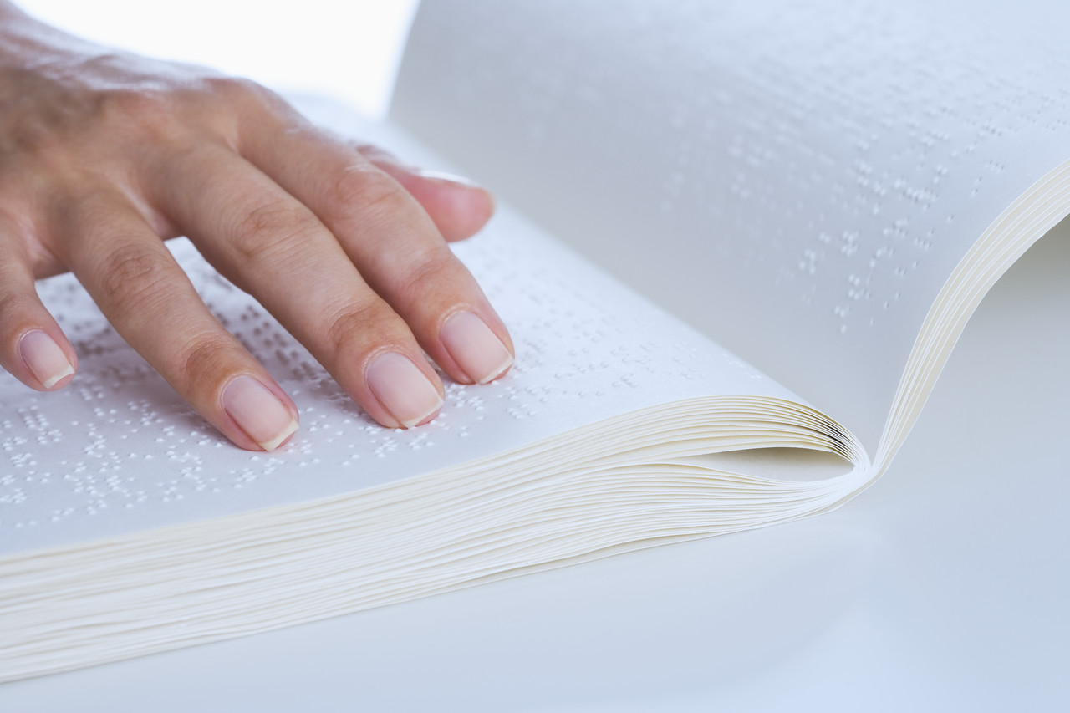

Blind and visually impaired students:

Strive to be the BEST you can be!

BEST = Braille Education and Skills Training

Sponsored by Texas Parents of Blind Children (TPOBC)
www.tpobc.org

BEST O&M: An Introduction to Public Transportation
When: Saturday, January 23rd, 9:00 a.m. – 12:00 p.m.
Where: The Lighthouse of Houston
3602 West Dallas, Houston, TX 77019
Who: Blind and visually impaired students ages 12-18
Blind students will travel from the lighthouse to a Starbucks outside of the Texas Medical Center using the MetroBus and the MetroRail. Metro Qcards and money for a Starbucks drink will be provided. Afterwards, students and parents can have lunch with blind adults from the Houston area and then attend the monthly meeting of the Houston chapter of the National Federation of the Blind.
THERE ARE ONLY 10 SPOTS AVAILABLE FOR THIS ACTIVITY!
A licensed O&M instructor from the Criss Cole Rehabilitation Center is coming in from Austin and blind adults from the Houston area will be in attendance to teach O&M skills and mentor participants. Please register with Emily Gibbs at elgibbs@gmail.com or at 979-202-1961 as soon as possible to reserve your child's place!
Our purpose is to have a free monthly activity* to:
☻Supplement Braille and cane travel skills ☻Introduce blind children to successful blind adults
☻Expose kids to new experiences ☻Provide resources and information to families
The activities will be led by teachers of blind students, parents of blind children and blind adults from the Houston Chapter of the National Federation of the Blind. Activities are for blind children only. Child care for siblings will not be provided. Parents are welcome to drop their blind children off and then return for the monthly meeting of the Houston Chapter of the National Federation of the Blind

For more information, contact:

Emily Gibbs, Teacher of Blind Students - (979) 202-1961

*Mark your calendars for future BEST activities:
BEST Activities coincide with the Houston NFB Chapter meeting
The 3rd Saturday of every month

February 20th – Braille Reading Skills
March 20th – Grocery Shopping and Cooking
April 17th – Tactile Games
May 15th – Pool Party (tentative)

Note: There will not be BEST activities during the summer months (June, July, August). Activities will resume in September.
BEST Saturday Activity
Registration Form

Please e-mail the following information to elgibbs@gmail.com

Child’s name:

Child’s age:

Child’s grade and school district:

Parent’s or guardian’s name:

Parent’s cell phone number:

Parent’s home phone number:

Mailing address:

E-mail:

(circle one)
I do / do not grant permission to TPOBC, use of images of myself and/or minor child, for the TPOBC web site or print literature, from TPOBC associated events.

Signature

TEXAS PARENTS OF BLIND CHILDREN
Membership Application

Please mail this membership form along with your dues to TPOBC at the address at the bottom of the form.

I would like to join the Texas Parents of Blind Children and the National Organization of Parents of Blind Children.

Enclosed is my $10.00 for membership dues and a donation of $ for a
total of $ .
(Please make checks payable to Texas Parents of Blind Children or TPOBC.)

Name:

Please check all that apply: [ ] Parent(s) [ ] Teacher [ ] Other

Address: _________

City: State: Zip: ____

Home Phone:__________________Cell Phone:____________________________

E-mail: ______________

Name of Child(ren):

Child(ren)'s Birth Date(s):

School District______________________________________________________

Diagnosis__________________________________________________________

Please send me the following FREE item(s):

__Future Reflections Sample Issue __Braille Literacy Information/Resources

__Cane travel (O&M) information __Aids & Appliances Order Form

__Literature Order Form __Other Information

(circle one)
I do / do not grant permission to TPOBC, use of images of myself and/or minor child, for the TPOBC web site or print literature, from TPOBC associated events.

Mail this membership form to:
Signature Texas Parents of Blind Children
Membership Processing
PO Box 125
Friendswood, TX 77549-0125

TPOBC is a 501(c)3 non-profit organization

