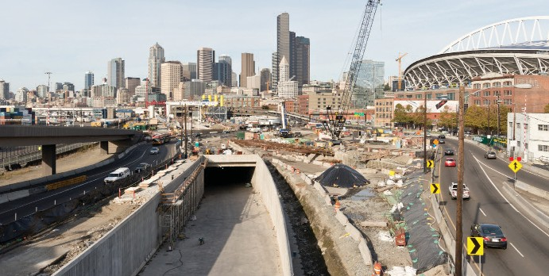
November 2018
PROGRAM
REPLACEMENT
Alaskan Way Viaduct

Get ready: three-week SR 99 closure begins Jan. 11, 2019

What: Three-week SR 99 closure and up to six weeks of traffic impacts
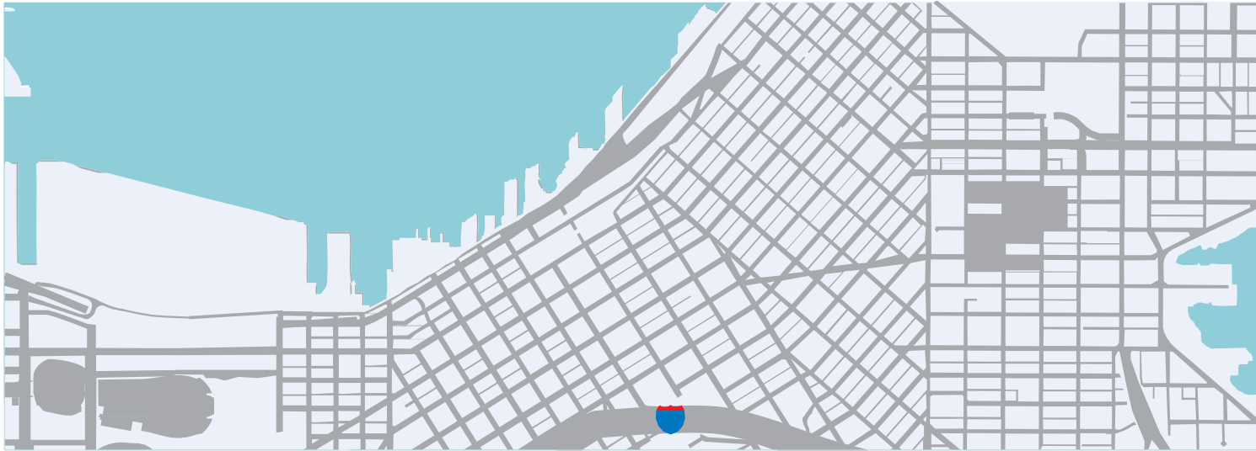When the new SR 99 tunnel is ready to open, WSDOT will need to close the highway for approximately three weeks to realign SR 99 into the tunnel. The closure will extend from the south end of the Battery Street Tunnel to the West Seattle Bridge. There will be up to three weeks of additional ramp closures before and after the three week closure.
N
5
Century
Link Field
Safeco
Field
Dexter Ave.
99
work
zone
6th Ave. N.
SR 99 closed
Duration: Approximately three weeks
One lane open in each direction at this location
Closure begins at
West Seattle Bridge
work zone
Mercer St.
Republican St.
Denny Way

All SR 99 on- and off-ramps will be closed between the West Seattle Bridge and the Battery Street Tunnel. The on- and off-ramps at Western Avenue will be open during the closure.
Yesler Way
S. King St.
S. Royal Brougham Way
S. Atlantic St.

One week before closure
Southend ramps that provide access to and from I-5 and I-90 close about one week before the full closure.

One to two weeks after closure
After the new SR 99 tunnel opens the northbound off-ramp to
downtown will remain closed for up to two weeks.

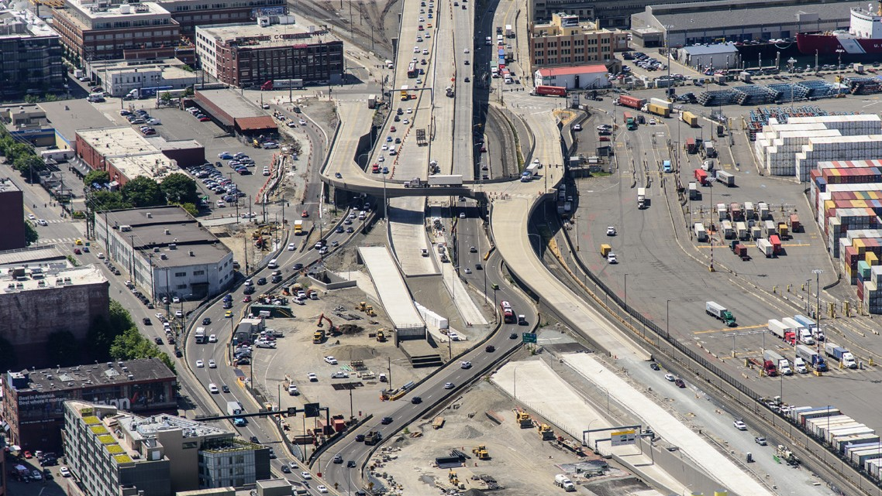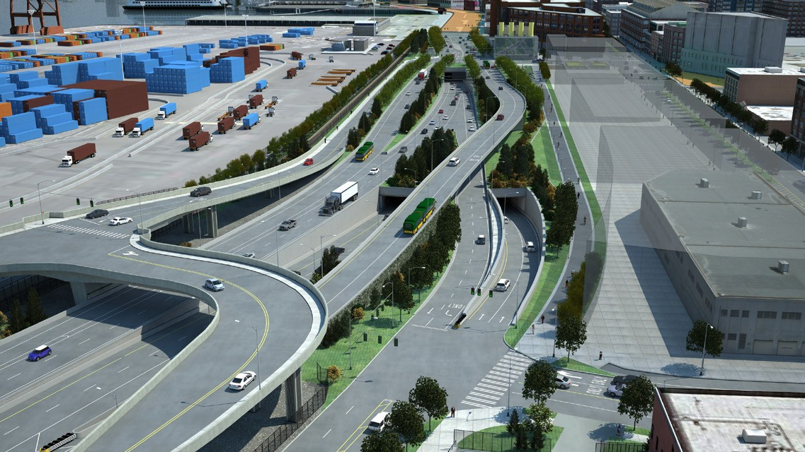
99
Southbound SR 99 off-ramp to S. Atlantic St.
Northbound SR 99 on-ramp from Royal Brougham Way
Southbound
99
99

Northbound
Downtown & Alaskan Way off-ramp

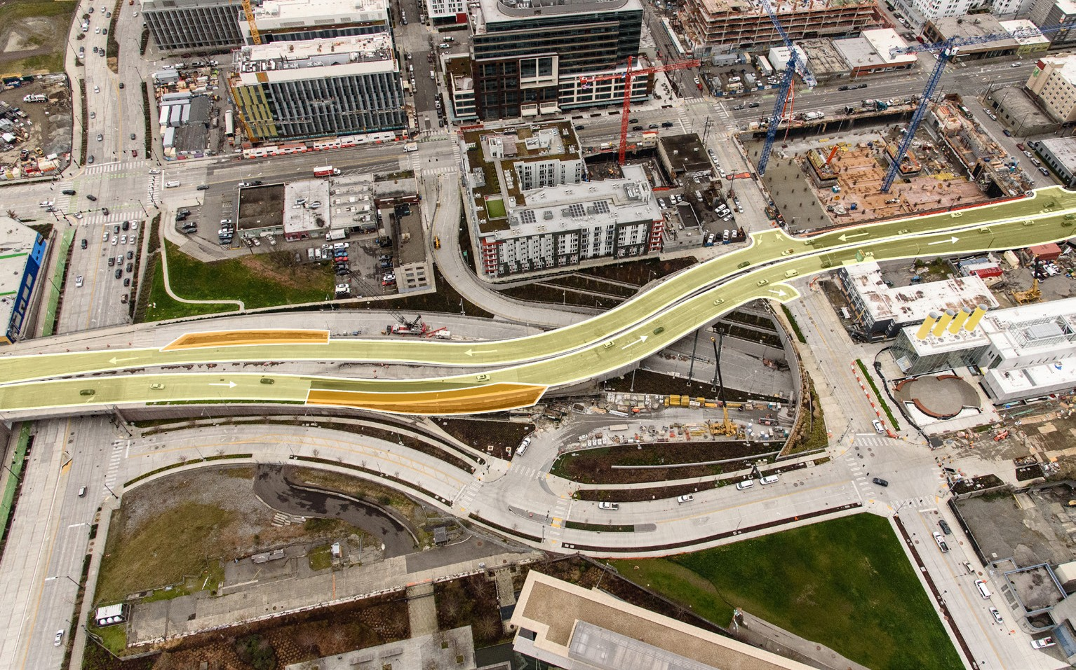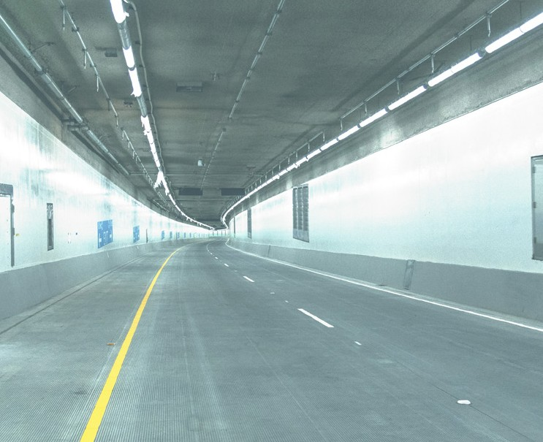Why do we need to close the highway?
N
DURING THE CLOSURE Feb. 2-3, 2019
Say goodbye to the viaduct, hello to the future waterfront, and experience the new tunnel. The Step Forward event is two action packed days of fun including a tunnel walk, STEM activities, 8K fun run/walk and bike ride.
Forward
Portal to the past, present & future
Step
Stay informed
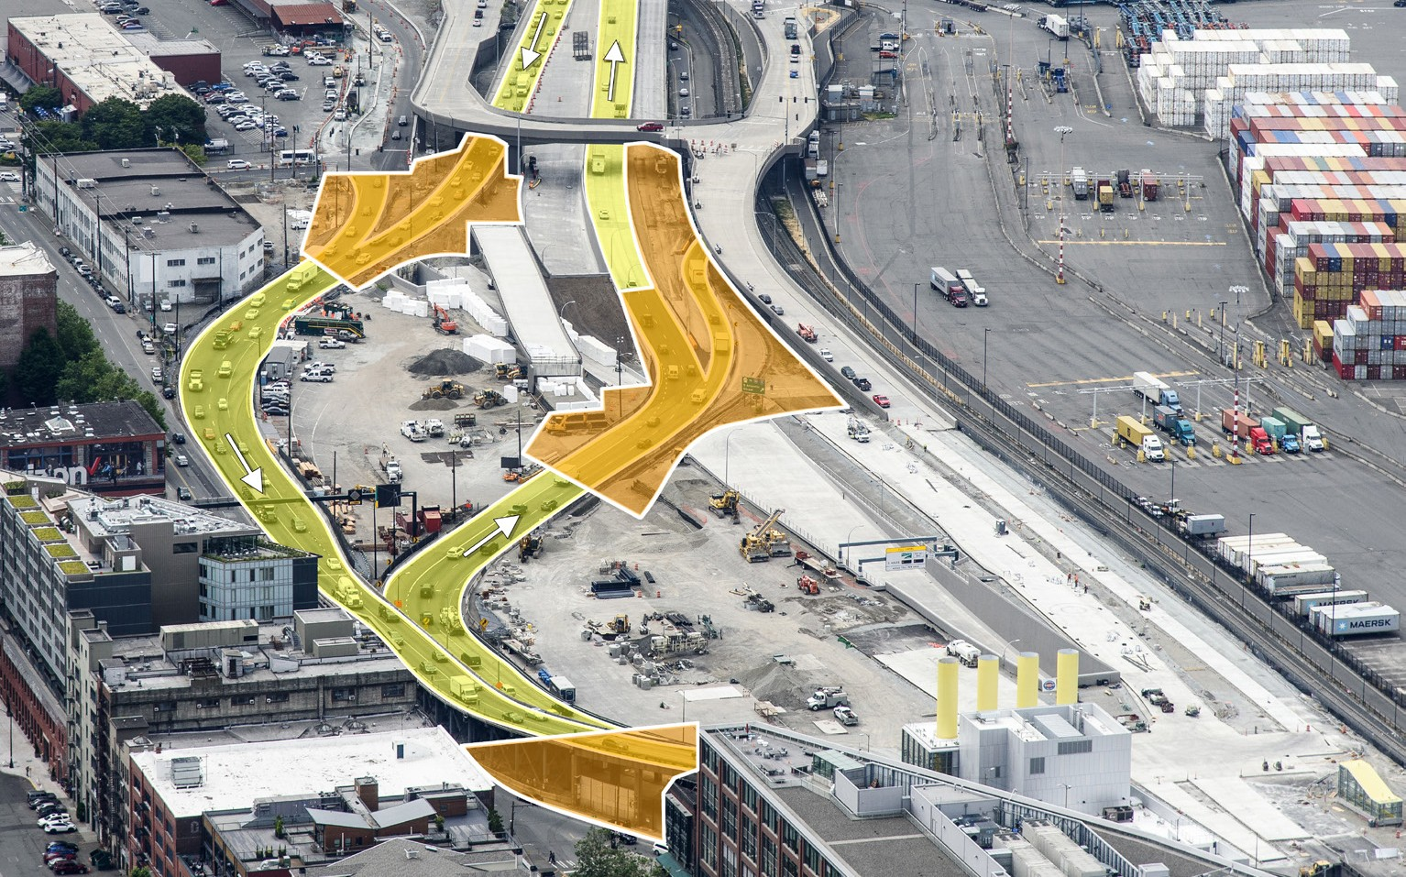The current alignment of SR 99 near the stadiums is temporary, which allows traffic to travel through an active construction zone. Crews have to work in this alignment to connect SR 99 to the new tunnel. The closure is unavoidable due to the large amount of work involved in realigning SR 99. The graphics below show the path of SR 99 today (yellow) and the work zones during the closure (orange).
N
THE TUNNEL
EXPERIENCE
Website: 99Tunnel.com
Tweet: @BerthaDigsSR99
#Realign99
Email: viaduct@wsdot.wa.gov
Call: 1-888-AWV-LINE

Americans with Disabilities Act & Title VI Information
Americans with Disabilities Act (ADA) Information: This material can be made available in an alternate format by emailing the Office of Equal Opportunity at wsdotada@wsdot.wa.gov or by calling toll free, 855-362-4ADA(4232). Persons who are deaf or hard of hearing may make a request by calling the Washington State Relay at 711.
Title VI Notice to Public: It is the Washington State Department of Transportation’s (WSDOT) policy to assure that no person shall, on the grounds of race, color, national origin or sex, as provided by Title VI of the Civil Rights Act of 1964, be excluded from participation in, be denied the benefits of, or be otherwise discriminated against under any of its federally funded programs and activities. Any person who believes his/her Title VI protection has been violated, may file a complaint with WSDOT’s Office of Equal Opportunity (OEO). For additional information regarding Title VI complaint procedures and/or information regarding our non-discrimination obligations, please contact OEO’s Title VI Coordinator at (360) 705-7090.

