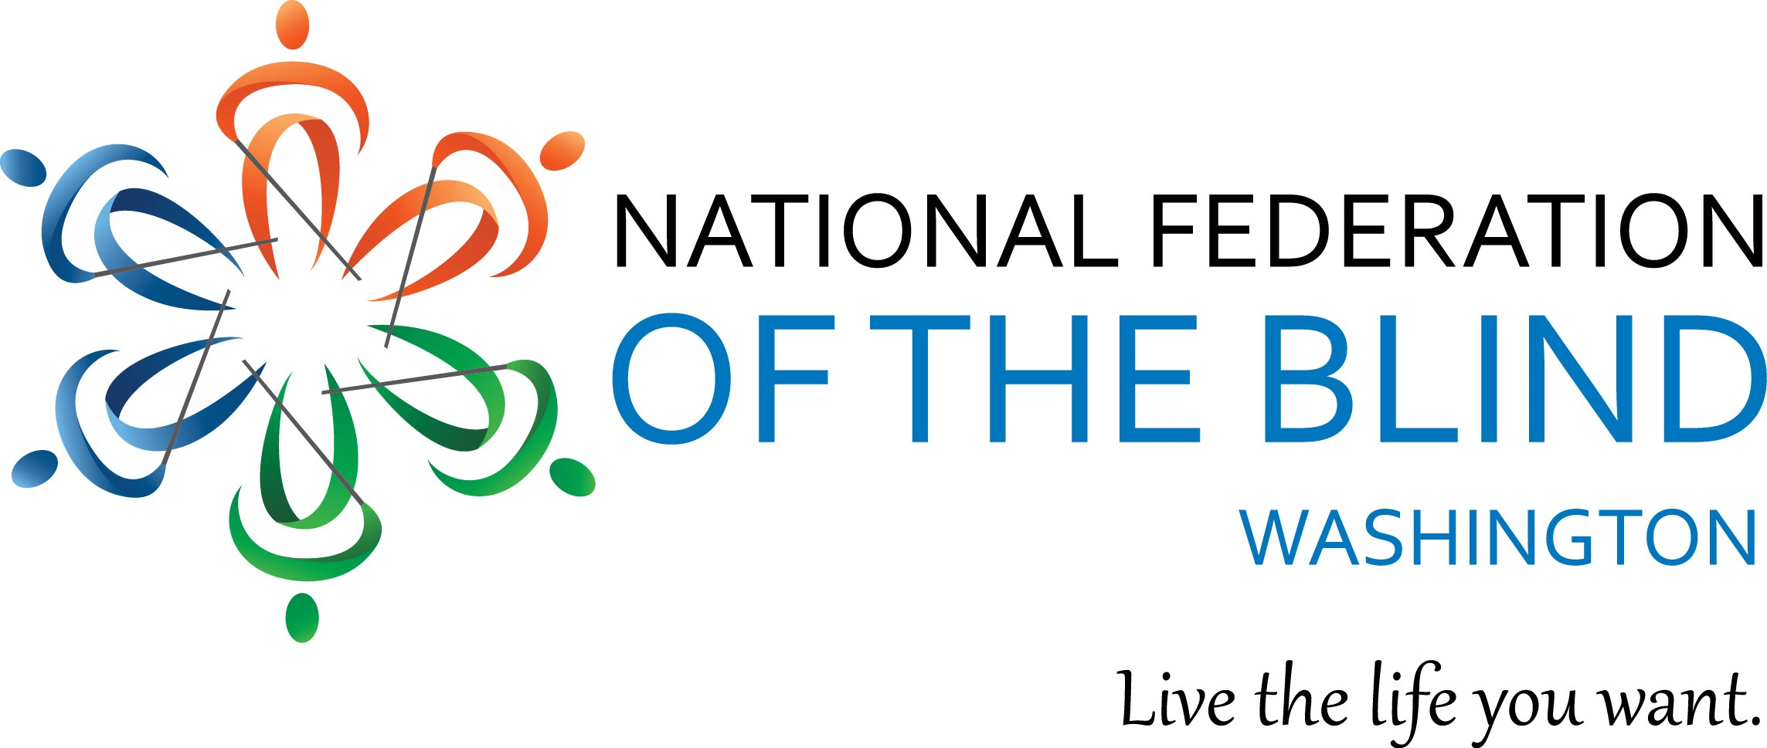
Instructions for Scholarship Application

May 10, 2021

The National Federation of the Blind of Washington is pleased to announce that we are accepting applications for our 2021 Scholarship Program. We will award 2 scholarships totaling $6,000 to 2 outstanding blind scholars in our state. The scholarships will be awarded at the banquet of our National Federation of the Blind of Washington annual convention, which will be held virtually from November 5-7 2021.

All applicants must be:

- Legally blind in both eyes
- Residents of the state of Washington
- Pursuing a full-time undergraduate or graduate course of study. If employed, part-time study will be accepted.
- Available to participate in the entire NFB of Washington state convention

In addition to a scholarship, each winner will receive directions and assistance to attend the 2021 NFB of Washington annual convention, providing an excellent opportunity for networking with active blind persons in many different professions and occupations. The scholarships are awarded at the banquet on Saturday night of the convention. Attendance at the convention is mandatory.

Each scholarship application must include:

- Completed scholarship application form
- An essay describing the applicant’s abilities, academic achievements, community leadership, future goals and philosophy of blindness
- High school and/or up-to-date college transcripts
- 3 letters of recommendation

All applicants must also contact one of the scholarship committee co-chairpersons for a telephone interview. Please contact Nikki Palm at 360-703-8641 or Bennett Prows at 425-814-4187.

All completed scholarship packets must be received by October 15, 2021.

APPLICATION PACKETS RECEIVED AFTER October 15 WILL NOT BE CONSIDERED. INCOMPLETE APPLICATIONS WILL BE DISQUALIFIED.

Send completed scholarship application packets to:
Nikki Palm & Bennett Prows
NFB of Washington Scholarship co-chairpersons
Nikki Palm: nikkirae83@gmail.com
Bennett Prows BJProws@comcast.net.

If you have any additional questions please contact Nikki Palm or Bennett Prows at the telephone numbers listed above.

Please feel free to make additional copies of this letter and application form and distribute them to any interested blind students.

Scholarship Application Form

Name: ____________________________________________
Date of Birth: ___
Home Address: Street: ___________________________________
City:______________________ State______ Zip___________
Home Phone: _____________ Cell Phone:_____________ Email:_________________________
Your Current Grade Point Average:
Your Current class standing: ___________________ (Freshman - Senior, graduate student)
High School Attended: __________________________________________
Address: ____________________________________________________________________
City: _________________________________ State:________ Zip: ___________
Dates Attended:_____________________
College/Institution to be attended in the Fall of 2020:_______________________________________
Address:_______________________________________________________
City:__________________ State:______ Zip:__________
Phone:______________________
Major:____________________________________________________
Career Goal:________________________________________________________

