**King County Metro ADA Transition Plan**

**Social Media Kit**

**Overview of this project:**

Metro is currently in the process of developing a plan to enhance accessibility in our programs, services, and activities. We're inviting people with disabilities, along with their families, friends, and caregivers, to take part in our community survey. By sharing their experiences and ideas, they can help us improve access.

**How you can help us:**

Dear Partner,

We would greatly appreciate your help in spreading the messages included in this social media kit across your social media platforms. Please use the content provided in your **email** **newsletters**, as well as on **Facebook**, **Twitter**, and **Instagram**.

**When:** Share this content between **September 18 and October 15, 2023**.

Thank you for your support sharing these messages to your community!

**Contents**

1. **Resources**
   1. Newsletter/Blog
   2. Survey Link
2. **Social Media Messages**
   1. Facebook
   2. Twitter
   3. Instagram
3. **Graphics**
   1. Facebook
   2. Twitter
   3. Instagram

# Resources

*Please share the Metro Matters blog and survey with your audience.*

* **Newsletter/Blog**

Here's a newsletter/blog post that appears on our blog "Metro Matters”: <https://kingcountymetro.blog/2023/09/18/metro-wants-to-hear-from-people-with-disabilities-about-their-mobility-needs/>

* **Survey**

Here's the link to Metro’s ADA Transition Plan website where you can find the survey: <https://publicinput.com/Project/AccessCode?id=mqYdpUGSBJOyrBJr9EeyDQ%3d%3d#2>

**Sample Email/Newsletter Message**

*please adapt to your organization and constituents*

**Metro wants to hear from people with disabilities about their mobility needs**  
   
Metro is currently developing a plan to further improve accessibility within their programs, services, and activities. Their goal is to make it possible for everyone in King County to ride Metro and get to the places they need to go. You’re invited to complete their [community survey](https://gcc02.safelinks.protection.outlook.com/?url=https%3A%2F%2Fhopelink.us3.list-manage.com%2Ftrack%2Fclick%3Fu%3D1f42b25fbcee8dda152a574f5%26id%3Dd13dee4977%26e%3D075465f015&data=05%7C01%7Ccrgonzalez%40kingcounty.gov%7C8001914efe194561e7d608dbbf764f94%7Cbae5059a76f049d7999672dfe95d69c7%7C0%7C0%7C638314287125938819%7CUnknown%7CTWFpbGZsb3d8eyJWIjoiMC4wLjAwMDAiLCJQIjoiV2luMzIiLCJBTiI6Ik1haWwiLCJXVCI6Mn0%3D%7C3000%7C%7C%7C&sdata=DBDMOuyNfAxItZNzIsdfX8tIzGxWPWVRtbw%2BBpTTDwI%3D&reserved=0)by October 15th. [Click here to learn more about Metro’s ADA Transition Plan](https://gcc02.safelinks.protection.outlook.com/?url=https%3A%2F%2Fhopelink.us3.list-manage.com%2Ftrack%2Fclick%3Fu%3D1f42b25fbcee8dda152a574f5%26id%3D5d72a9a6c5%26e%3D075465f015&data=05%7C01%7Ccrgonzalez%40kingcounty.gov%7C8001914efe194561e7d608dbbf764f94%7Cbae5059a76f049d7999672dfe95d69c7%7C0%7C0%7C638314287125938819%7CUnknown%7CTWFpbGZsb3d8eyJWIjoiMC4wLjAwMDAiLCJQIjoiV2luMzIiLCJBTiI6Ik1haWwiLCJXVCI6Mn0%3D%7C3000%7C%7C%7C&sdata=OpZ8tQkrB4YVEMmT707KMxJPGlMi5gBGMMBjCib%2F4k4%3D&reserved=0)**.**

Thank you for spreading the word and supporting Metro riders!

# Social Media Messages

*Please share these three message options on your social media accounts as you see fit.*

**Facebook**

|  |  |
| --- | --- |
| **Option 1**  Make Metro better for all riders.  Everyone should feel welcome and seen on Metro. To help, take our Americans with Disabilities Act survey by October 15. To take our survey, go to: <https://kingcountymetro.blog/2023/09/18/metro-wants-to-hear-from-people-with-disabilities-about-their-mobility-needs/> | **Images**   * *See graphics/images* *below* |
| **Option 2**  **Headline:**Speak up for access to transit.  **Body:** Help create the best Metro, for people of all abilities and needs. Take our Americans with Disabilities Act survey by October 15.  **Description:** Moving forward with Metro.  To take our survey, go to:<https://kingcountymetro.blog/2023/09/18/metro-wants-to-hear-from-people-with-disabilities-about-their-mobility-needs/> | * *See graphics/images* *below* |
| **Option 3**  **Headline:** Be a voice of equity on transit.  **Body:** Now’s your final chance to take our Americans with Disabilities Act survey. Please tell us what you think by October 15!  **Description:**Moving forward with Metro.  To take our survey, go to:<https://kingcountymetro.blog/2023/09/18/metro-wants-to-hear-from-people-with-disabilities-about-their-mobility-needs/> | * *See graphics/images* *below* |

**X - Twitter**

|  |  |
| --- | --- |
| **Option 1**  **Tweet:** Be a voice of equity on transit. <microphone emoji> Make Metro a place everyone can ride – take our Americans with Disabilities Act survey. <Computer emoji> Answer now, before the Oct 15 deadline passes!  To take our survey, go to:<https://kingcountymetro.blog/2023/09/18/metro-wants-to-hear-from-people-with-disabilities-about-their-mobility-needs/> | * *See graphics/images* *below* |
| **Option 2**  **Tweet:** Care about access to transit for all? Take our Americans with Disabilities Act survey to help create safe and comfortable spaces on Metro. The October 15 deadline will be here before you know it!   To take our survey, go to: <https://kingcountymetro.blog/2023/09/18/metro-wants-to-hear-from-people-with-disabilities-about-their-mobility-needs/> | * *See graphics/images* *below* |
| **Option 3**  **Tweet:** Taking transit isn’t always easy. Help make our services easier to find and easier to ride – for everyone. Fill out our Americans with Disabilities Act survey by Oct 15.  To take our survey, go to:<https://kingcountymetro.blog/2023/09/18/metro-wants-to-hear-from-people-with-disabilities-about-their-mobility-needs/> | * *See graphics/images* *below* |

**Instagram**

|  |  |
| --- | --- |
| **Option 1**  **Headline:**Create the best Metro!  **Body:** Help make Metro services easier to find and easier to ride. Fill out our Americans with Disabilities Act survey by Oct 15.  To take our survey, go to:<https://kingcountymetro.blog/2023/09/18/metro-wants-to-hear-from-people-with-disabilities-about-their-mobility-needs/> | * *See graphics/images* *below* |
| **Option 2**  **Headline:**We need your ideas.  **Body:** Do you care about access to transit? Take our Americans with Disabilities Act survey to help create the best Metro.  To take our survey, go to:<https://kingcountymetro.blog/2023/09/18/metro-wants-to-hear-from-people-with-disabilities-about-their-mobility-needs/> | * *See graphics/images* *below* |
| **Option 3**  **Headline:**Be a voice of equity on transit!  **Body:**Make Metro a place everyone can ride. Answer our Americans with Disabilities Act survey now, before the Oct 15 deadline.  To take our survey, go to:<https://kingcountymetro.blog/2023/09/18/metro-wants-to-hear-from-people-with-disabilities-about-their-mobility-needs/> | * *See graphics/images* *below* |

# Graphics

*Please incorporate these images into the messages above.*

**Facebook, X (twitter), Instagram**

* **Message 1**

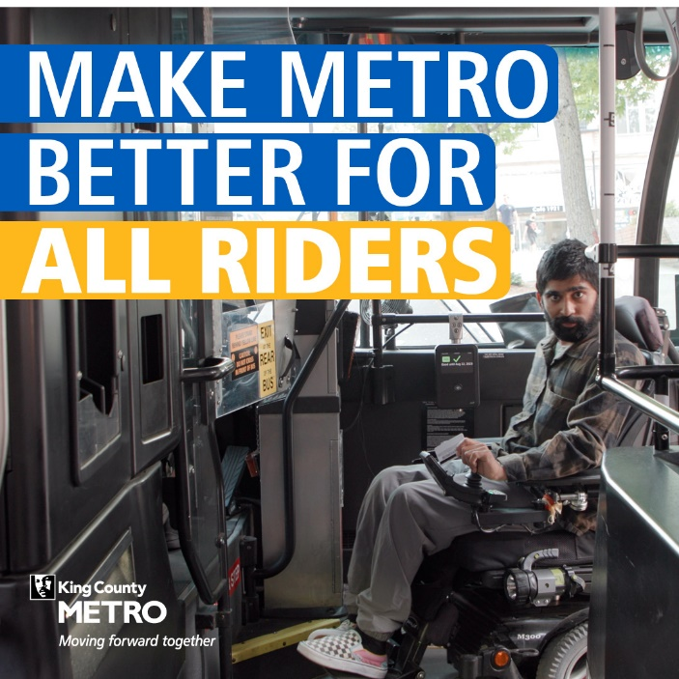

Alt text: *Man on electric wheelchair boarding a Metro bus.*

* **Message 2**

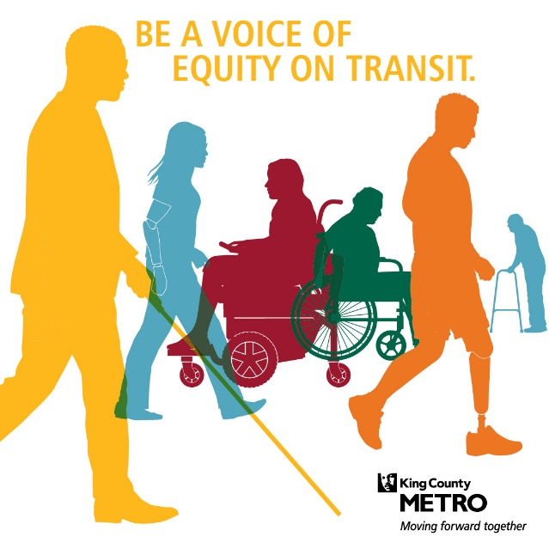

Alt text: *Graphic shows people with different abilities and a Metro logo.*

* **Message 3**

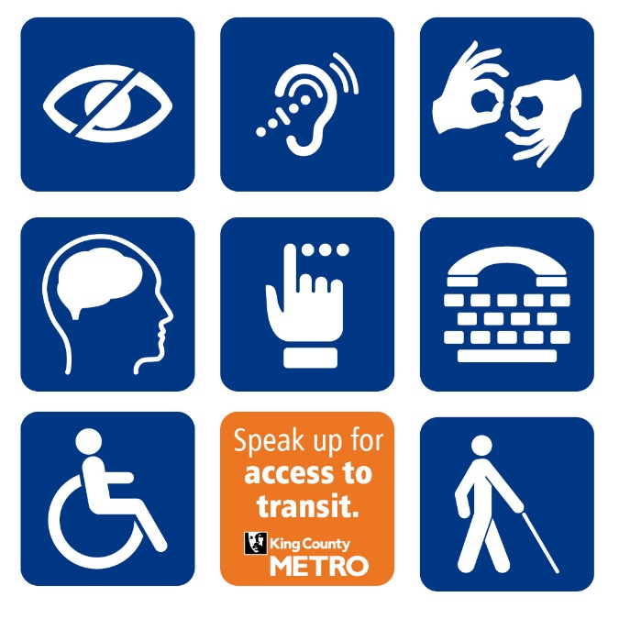

Alt Text: *Various accessibility signs with a Metro logo.*