San Francisco Chapter
Eric Holm, President
P.O. Box 150592
San Rafael, CA 94915
(415) 455-9133
ericholm@att.net

“The Voice of the Nation’s Blind”

July 29, 2026

The National Federation of the Blind is the largest organization of blind and visually impaired persons and their families. We are registered as a 501 (c) (3), IRS recognized non-profit charitable organization.

This fall, we will be holding our annual state convention on October 13-16, 2011, at the Hilton Hotel in Newark, CA. The San Francisco Chapter will also be holding a fall luncheon fundraiser and auction to advance the cause of independence and productivity of blind persons in the Bay Area and throughout California. We would be delighted to have your support and would appreciate any donation of funds or items in encouragement of our efforts.

About the NFBC

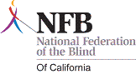
Diabetes: About 16 million people in the United States have diabetes, the most common cause of blindness in adults. The NFBC Diabetes Action Network provides mentoring and support.

Seniors: It is estimated that by the year 2020, 5.5 million people will be experiencing vision loss. Without the benefits of mentoring or expertise from positive role models, these people are often unnecessarily placed in convalescent homes by well meaning but ill-informed family members. Such tragedies can be avoided with the proper information and guidance.

Parents of Blind Children: The NFBC provides mentoring and workshops for parents of blind and visually impaired children.

Blind Students: Education is a high priority and scholarships are provided for qualified students.

Thank you for your participation and generosity.

Sincerely,

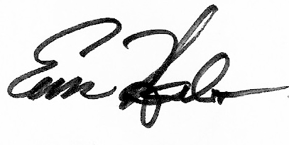
Eric Holm, J.D.
President, NFBCSF

