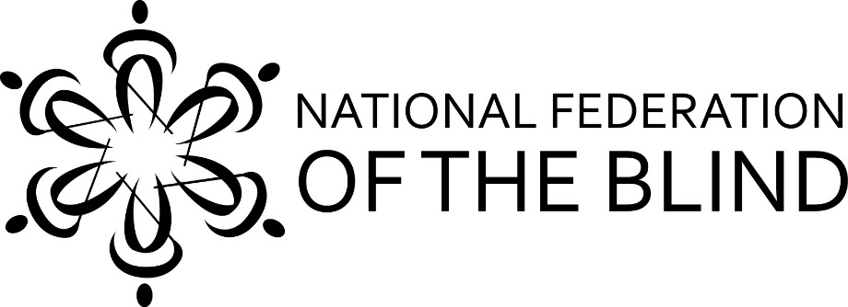

The National Federation of the Blind of California is
Uniting Blind People Through Love, Hope & Determination
to Live the Life We Want

The National Federation of the Blind of California will hold its annual state convention from Friday, October 30 through Sunday, November 1 at the Doubletree by Hilton, in Newark, California.

This convention promises to be action-packed and full of fun, from a masquerade ball to a room full of exhibitors, meetings by students, blind parents, guide dog users, and so much more—everyone will find something exciting and new to be a part of!

For hotel reservations call:
(510) 490-8390
Press 2 to make your reservation with the front desk.
Group code: NFC
Room rates are $109 per room without breakfast buffet or $129 with breakfast buffet for 2 guests.
Pre-register now to get the best rates!
You will need your hotel confirmation number to complete convention pre-registration. You can find the form at http://tinyurl.com/nfbc2015preregistration.

This year, transportation by bus to convention is free to anyone who pre-registers, so hurry and pre-register to save your seat on the bus.

For more information and to learn about convention activities, please visit www.sixdots.org or call Mary Willows, President of the National Federation of the Blind of California, at 925-462-8575.

