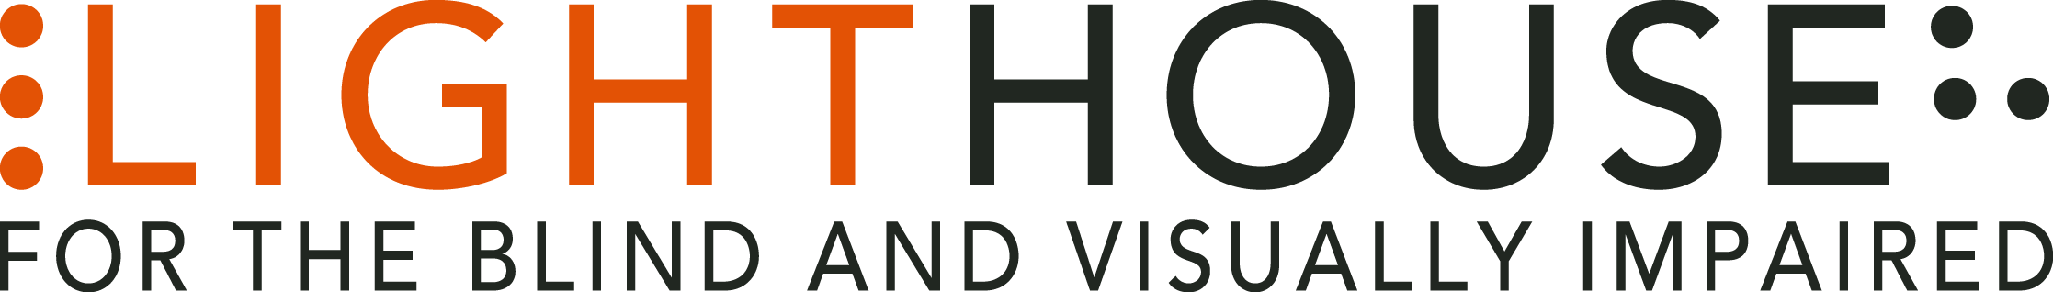

LIGHTHOUSE JOB ANNOUNCEMENT

POSITION: Director of Communications

Application Deadline: Open Until Filled
The LightHouse for the Blind and Visually Impaired, headquartered in downtown San Francisco, is looking for a full-time Director of Communications person to fill a valued role in our growing organization.
Role Overview:
The Director of Communications is responsible for leading the LightHouse’s promotional efforts so that the maximum number of people can benefit from the agency’s stellar programs. The Director of Communications will lead a team of motivated professionals as they assist LightHouse departments to meet program goals, heighten agency visibility and to promote important blind-positive stories. The Director of Communications will provide strategy and leadership for advertising, email marketing, web sites, social media, public relations, and content to benefit, reflect and support the mission of LightHouse. The Communications department also provides marketing and promotion for LightHouse’s business and consulting services and Enchanted Hills Retreat.
The Director of Communications will supervise LightHouse’s communications team to generate fresh content and expand market penetration. A key departmental goal is to strengthen active participation of students, their families and referral sources. At the direction of the CEO, this position may develop other special projects to heighten the profile of the agency both locally and worldwide.
Desirable Qualifications:
• Bachelor’s degree or higher
• Minimum 5 years in marketing, communications, journalism or related field
• Management experience
• Familiarity with blindness and web accessibility
• Experience maintaining and managing websites on WordPress.org
• Track record of running effective social media campaigns
• Demonstrated ability to “get press,” whether as an author, editor or publicist
• Wide network of contacts in the rehabilitation/training, accessibility, media and technology industries a plus.
• Ability to speak and write powerful stories about blindness and the rehabilitative journey
• Experience producing and promoting original content for a variety of channels and media formats.
• Strong penchant for problem-solving and anticipating public relations challenges or opportunities
Who We Are:
The LightHouse has an audacious mission – to transform the lives of the 40,000 blind people in the greater bay area and beyond. We do this through tech design, disability advocacy, consultation, classes and community formation in San Francisco, our five satellite offices and Enchanted Hills Camp in Napa. We are a fun, fascinating, widely diverse, warm and friendly community. We work in downtown San Francisco in a 40,000 square foot state-of-the-art workspace renowned for its universal design, steps from Civic Center Bart. LightHouse is working for nothing less than to change the future for blind people and the wider community.
Within a five-minute walk are the world headquarters for Twitter, Uber, Dolby, ZenDesk and many other tech giants. Within three blocks are all of the principal building for northern California’s federal, state and local government. Also in our neighborhood are many theaters, San Francisco Symphony and opera, the Asian Art museum and dozens of other key cultural anchors of the entire bay area.
The successful candidate will join a unique organization in which blind and sighted professionals work together at every level. Our governing Board of Directors, management and staff are all composed of roughly equal numbers of blind and sighted people, a parity unprecedented in our field.
Founded in 1902, LightHouse for the Blind and Visually Impaired provides skills, resources and community for the advancement of all individuals who are blind or have low vision. Our innovative programs have been featured in 60 Minutes, the New York Times, and the Wall Street Journal and beyond. The blind community comes to LightHouse to learn how to travel independently with a white cane, to rejoin the workforce, use technology accessibly, and meet a community of mentors and peers. From unique tactile maps, to an unparalleled camp for blind campers, to a world prize for blind ambition, LightHouse offers programs unavailable elsewhere.
Working Conditions:

LightHouse is an equal opportunity employer. LightHouse policy and the law prohibit discrimination and harassment based on an individual’s race, ancestry, religion or religious creed (including religious dress and grooming practices), color, age (40 and over), sex, gender, sexual orientation, gender identity or expression, genetic information, national origin (including language use restrictions), marital status, medical condition (including cancer and genetic characteristics), physical or mental disability (including HIV and AIDS), military or veteran status, pregnancy, childbirth, breastfeeding and related medical conditions, denial of Family and Medical Care leave, height and weight, or any other classification protected by federal, state, or local laws, regulations, or ordinances. Our policy and the law prohibit co-workers, third parties, supervisors, and managers from engaging in such conduct.
Employee Benefits:
The LightHouse offers a rich package of benefits, including medical, vision and dental insurance. Employees are eligible for an employer-matched 401(k) plan, subsidized health club membership among many other perks.
Learn About Us:
LightHouse for the Blind and Visually Impaired
1155 market Street, 10th Floor
San Francisco, CA 94103
www.lighthouse-sf.org
Compensation: “Depending on experience; industry competitive”
How To Apply:

After reviewing the complete Job Description please submit a cover letter and résumé in Microsoft Word attachments (no PDFs please), to hr@lighthouse-sf.org, including the job title in the subject line. We will not consider videos or hyperlinks to online profiles. Due to time constraints we will only respond to complete submissions. Thanks for your understanding.

To access the full Job Description for this position, please go to: www.lighthouse-sf.org/director of communications

