When I Grow Up
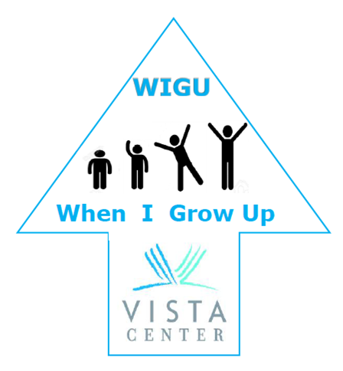
A fun new program allowing high school and college students who are blind and visually impaired to explore the lives of local adult mentors who are blind and visually impaired.
Who: Adult role models with visual impairments
What: Meet youth with a visual impairment to help them learn about independent living. Talk about home, cooking, work, volunteering, etc.
Where: Meet via teleconference, phone or at a location of your choice
When: Enroll ASAP to become a Mentor!
Are you interested? Please contact Amy Jine at
650-858-0202 X183 or ajine@vistacenter.org

