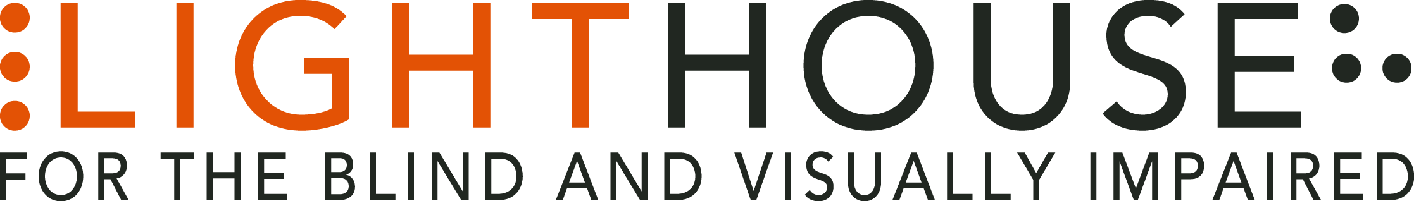

LIGHTHOUSE JOB ANNOUNCEMENT

POSITION: Reception Team Member (On-Call)

REPORTS TO: Director of Development

LightHouse for the Blind and Visually Impaired, headquartered in downtown San Francisco, is looking for an On-Call Reception Team Member to fill a valued role in our growing organization.
Role Overview: We seek a professional to consistently represent LightHouse in a welcoming, courteous and empathetic manner during all public interactions, during telephone and face-to-face exchanges involving staff and visitors alike. This is primarily done correctly directing incoming telephone calls and by greeting, directing and logging LightHouse staff and visitors.
The job is an on-call position, primarily for evening / weekend / vacation coverage.
Qualifications:
- Education: High School diploma or equivalent, at minimum.
- Experience running a multi-line telephone system preferred. A professional background within the hospitality industry would be complimentary. A history including Windows-based programs to perform administrative tasks is desired.
- Skills: Excellent attendance and punctuality required. Proficiency in MS Office Suite – primarily Word, Outlook and Excel. Effective communication is a must, and the ability to communicate in a language other than English is always appreciated. Work history within the disability community is a plus.
- Other: The ability to manage a busy front desk area with calm professionalism. Consistently positive interactions with all manner of people is expected. Provide administrative support to others as time allows.

Job Responsibilities:
• Answer incoming calls professionally, transferring to appropriate extensions.
• Monitoring the door and reception lounge, greeting visitors in a consistently warm and professional manner and announcing them to staff as needed.
• Liaising with the Information Concierge to dispense accurate information as directed.
• Direct visitors to their destination within the building.
• Call taxis and other transportation services (such as Paratransit) when requested.
• Know and be able to calmly orchestrate emergency procedure
- Be familiar with the list of problem-solver staff and contact them when needed.
• Accept and log packages, informing staff of their arrival; also arrange for packages to be sent out as needed.
• Alert the Facilities Coordinator when safety hazards are reported to the front desk.

Who We Are:
LightHouse has an audacious mission – to transform the lives of the 40,000 blind people in the greater Bay Area and beyond. We do this through tech design, disability advocacy, consultation, classes and community formation in San Francisco, our four satellite offices and Enchanted Hills Camp in Napa. We are a fun, fascinating, widely diverse, warm and friendly community. We work in downtown San Francisco in a 40,000 square foot state-of-the-art workspace renowned for its universal design, steps from Civic Center BART. LightHouse is working for nothing less than to change the future for blind people and the wider community.
Within a five-minute walk are the world headquarters for Twitter, Uber, Dolby, Zendesk and many other tech giants. Within three blocks are all of the principal building for Northern California’s federal, state and local government. Also in our neighborhood are many theaters, San Francisco Symphony and Opera, the Asian Art Museum and dozens of other key cultural anchors of the entire Bay Area.
The successful candidate will join a unique organization in which blind and sighted professionals work together at every level. Our governing Board of Directors, management and staff are all composed of roughly equal numbers of blind and sighted people, a parity unprecedented in our field.
Founded in 1902, LightHouse for the Blind and Visually Impaired provides skills, resources and community for the advancement of all individuals who are blind or have low vision. Our innovative programs have been featured in 60 Minutes, the New York Times, and the Wall Street Journal and beyond. The blind community comes to LightHouse to learn how to travel independently with a white cane, to rejoin the workforce, use accessible technology, and meet a community of mentors and peers. From unique tactile maps, to an unparalleled camp for blind campers, to a world prize for blind ambition, LightHouse offers programs unavailable elsewhere.
Learn About Us:

LightHouse for the Blind and Visually Impaired
1155 Market Street, 10th Floor
San Francisco, CA 94103
www.lighthouse-sf.org

Employee Benefits:
The LightHouse offers a rich package of benefits, including medical, vision and dental insurance. Employees are eligible for an employer-matched 401(k) plan and subsidized health club membership, among many other perks.
Compensation:
Depending On Experience; industry competitive.

How to Apply:
Please submit a cover letter and résumé in word processing document attachments (no PDFs please) and employment application, to hr@lighthouse-sf.org, including the job title in the subject line. The full job description is available here: http://lighthouse-sf.org/about/careers/.

