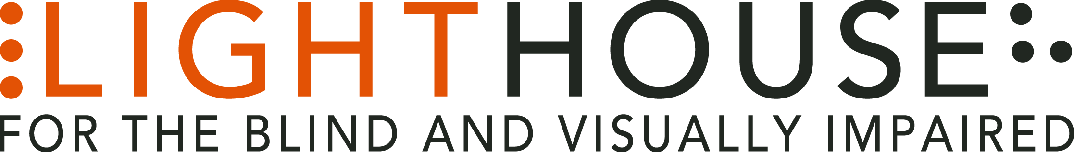

LIGHTHOUSE JOB ANNOUNCEMENT

POSITION: Administrative Assistant

REPORTS TO: Senior Director, Programs

APPLICATION DEADLINE: Open Until Filled
The LightHouse for the Blind and Visually Impaired, headquartered in downtown San Francisco, is looking for a full time Administrative Assistant to fill a valued role in our growing organization.
Role Overview:
If you’re looking for a unique administrative role in a diverse nonprofit culture, you may have just found it! You’ll be working closely with the Community Services and Access Technology departments on daily tasks. You will also provide some administrative support to the Senior Director of Programs. We are a fun, fascinating, and widely diverse community of warm and friendly folks. We work in a beautiful new building in downtown San Francisco,
steps from the Civic Center Bart stop, with spectacular views from our top floor offices.
Desirable Qualifications:
- A college degree is a plus.
- At least two years’ experience in an administrative support position, or related field. A background in non-profits is highly desirable.
- Excellent verbal and written communication skills, flexible, detail-oriented.
- Possess strong interpersonal skills and a high degree of emotional intelligence to relate to staff, board members, volunteers, and students with disabilities.
- Ability to manage multiple projects with precision and a high degree of organization.
- Ability to read English aloud in a clear and rapid manner is highly desirable. This position will often assist blind employees through reading visual materials.
- Very strong Microsoft Office suite skills, particularly Word, Excel and Outlook.
- Must have valid California Driver License and be willing to occasionally drive as
part of this position.
- Experience working with people with disabilities is a plus.

Other: Personal initiative. Curiosity about people, a sense of humor and a strong team-oriented style. Enthusiasm for LightHouse services and the transformative effect we have on the lives of individuals who are blind or have low vision.
Who We Are:
The LightHouse has an audacious mission – to transform the lives of the 40,000 blind people in the greater bay area and beyond. We do this through tech design, disability advocacy, consultation, classes and community formation in San Francisco, our five satellite offices and Enchanted Hills Camp in Napa. We are a fun, fascinating, widely diverse, warm and friendly community. We work in downtown San Francisco in a 40,000 square foot state-of-the-art workspace renowned for its universal design, steps from Civic Center Bart. LightHouse is working for nothing less than to change the future for blind people and the wider community.
Within a five-minute walk are the world headquarters for Twitter, Uber, Dolby, ZenDesk and many other tech giants. Within three blocks are all of the principal building for northern California’s federal, state and local government. Also in our neighborhood are many theaters, San Francisco Symphony and opera, the Asian Art museum and dozens of other key cultural anchors of the entire bay area.
The successful candidate will join a unique organization in which blind and sighted professionals work together at every level. Our governing Board of Directors, management and staff are all composed of roughly equal numbers of blind and sighted people, a parity unprecedented in our field.
Founded in 1902, LightHouse for the Blind and Visually Impaired provides skills, resources and community for the advancement of all individuals who are blind or have low vision. Our innovative programs have been featured in 60 Minutes, the New York Times, and the Wall Street Journal and beyond. The blind community comes to LightHouse to learn how to travel independently with a white cane, to rejoin the workforce, use technology accessibly, and meet a community of mentors and peers. From unique tactile maps, to an unparalleled camp for blind campers, to a world prize for blind ambition, LightHouse offers programs unavailable elsewhere.
Employee Benefits:
The LightHouse offers a rich package of benefits, including medical, vision and dental insurance. Employees are eligible for an employer-matched 401(k) plan, subsidized health club membership among many other perks.
Learn About Us
LightHouse for the Blind and Visually Impaired
1155 market Street, 10th Floor
San Francisco, CA 94103
www.lighthouse-sf.org

Compensation: Depending On Experience; industry competitive”
How To Apply:

After reviewing the complete Job Description please submit a cover letter and résumé in Microsoft Word attachments (no PDFs please), to hr@lighthouse-sf.org, including the job title in the subject line. We will not consider videos or hyperlinks to online profiles. Due to time constraints we will only respond to complete submissions. Thanks for your understanding.

To access the full Job Description for this position, please go to: http://lighthouse-sf.org/about/careers/administrative assistant

