**When I Grow Up**

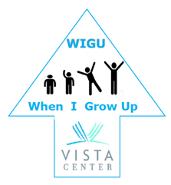

A fun new program allowing high school and college students who are blind and visually impaired to explore the lives of local adult mentors who are visually impaired or blind.

**Who**: Students ages 14-24 with visual impairments

**What**: Meet adults with a visual impairment to learn about their life. Talk about school, home, cooking, work, and ask all of your burning questions.

**Where**: Meet via teleconference or at a location of your choosing

**When**: Enroll to be paired with a Mentor!

Are you interested? Please contact Amy Jine at

415-886-7049 or [ajine@vistacenter.org](mailto:ajine@vistacenter.org)