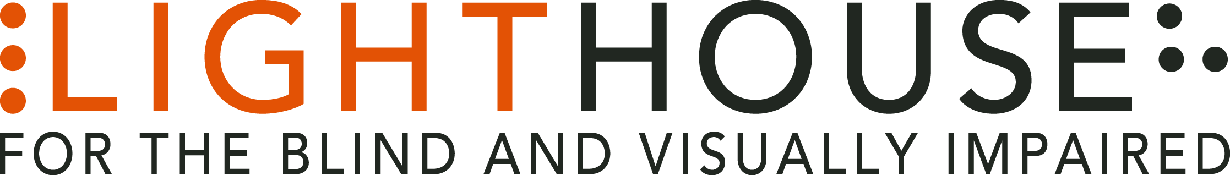

LIGHTHOUSE JOB ANNOUNCEMENT

POSITION: Community Outreach Coordinator

REPORTS TO: Senior Director, Programs

The LightHouse for the Blind and Visually Impaired, headquartered in downtown San Francisco, is looking for a full-time Outreach Coordinator to fill a valued role in our growing organization.
Role Overview:
The Community Outreach Coordinator (COC) will oversee and implement outreach strategies to promote LightHouse’s 80+ programs to the 40,000 blind and visually impaired residents of the bay area. The COC’s mission will be to interact directly with large numbers of people through general outreach and targeted, face-to-face engagement. The COC will represent the LightHouse and work with programmatic staff and the management team to develop and implement initiatives that increase the organization’s visibility within the surrounding community, and connect new students and participants to LightHouse services and programs.
The COC will be expected to be a regular presence in the community, and work directly with outside organizations on a frequent basis. Work will be largely based in San Francisco and the east bay, but the position may take you to locations throughout the San Francisco Bay Area.
Qualifications:
- Bachelor's degree in communications, marketing, business or related fields.
- 2-3 years’ experience with outreach or fund-raising activities.
- Outstanding written, verbal, and presentation skills.
- Familiarity with maintaining databases.
- Proficiency with office productivity applications (Microsoft Office, Google Suite) preferred.
- Warm, enthusiastic, and positive attitude.
- High level of Emotional intelligence.

- Ability to engage with and listen to others.
- Know the blindness community – or if not, are fully prepared to research, get acquainted and interact

Job Responsibilities:
- Liaise with programmatic staff to gain a comprehensive understanding of LightHouse programs.
- Develop talking points about student-facing programs.
- In collaboration with the Communications department, create physical and electronic collateral to promote LightHouse programs to the greater bay area.
- Grow contact reach through community networking, email and telephone communication, and targeted Internet research.
- In association with the Database manager, create an Outreach database.
- Maintain the outreach database, keeping all data current, and updated on a regular basis.
- Establish an outreach schedule for this role, including a minimum number of visits off-site each week.
- Grow and nurture relationships with established and new outreach contacts.
- Coordinate with all LightHouse departments to ensure this position is supported by programmatic staff during Outreach.
- Prepare an annual budget for community outreach activities.
- Other duties as assigned
Who We Are:
LightHouse has an audacious mission – to transform the lives of the 40,000 blind people in the greater Bay Area and beyond. We do this through tech design, disability advocacy, consultation, classes and community formation in San Francisco, our four satellite offices and Enchanted Hills Camp in Napa. We are a fun, fascinating, widely diverse, warm and friendly community. We work in downtown San Francisco in a 40,000 square foot state-of-the-art workspace renowned for its universal design, steps from Civic Center BART. LightHouse is working for nothing less than to change the future for blind people and the wider community.
Within a five-minute walk are the world headquarters for Twitter, Uber, Dolby, Zendesk and many other tech giants. Within three blocks are all of the principal building for Northern California’s federal, state and local government. Also in our neighborhood are many theaters, San Francisco Symphony and Opera, the Asian Art Museum and dozens of other key cultural anchors of the entire Bay Area.
The successful candidate will join a unique organization in which blind and sighted professionals work together at every level. Our governing Board of Directors, management and staff are all composed of roughly equal numbers of blind and sighted people, a parity unprecedented in our field.
Founded in 1902, LightHouse for the Blind and Visually Impaired provides skills, resources and community for the advancement of all individuals who are blind or have low vision. Our innovative programs have been featured in 60 Minutes, the New York Times, and the Wall Street Journal and beyond. The blind community comes to LightHouse to learn how to travel independently with a white cane, to rejoin the workforce, use accessible technology, and meet a community of mentors and peers. From unique tactile maps, to an unparalleled camp for blind campers, to a world prize for blind ambition, LightHouse offers programs unavailable elsewhere.
Learn About Us:

LightHouse for the Blind and Visually Impaired
1155 Market Street, 10th Floor
San Francisco, CA 94103
www.lighthouse-sf.org

Employee Benefits:
The LightHouse offers a rich package of benefits, including medical, vision and dental insurance. Employees are eligible for an employer-matched 401(k) plan and subsidized health club membership, among many other perks.
Compensation:
Depending On Experience; industry competitive.

How to Apply:
Please submit a cover letter and résumé in word processing document attachments (no PDFs please) and employment application, to hr@lighthouse-sf.org, including the job title in the subject line. The full job description is available here: http://lighthouse-sf.org/about/careers/.

