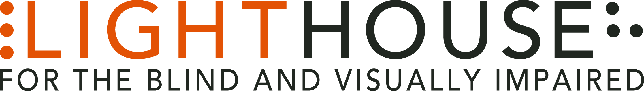

**LIGHTHOUSE JOB ANNOUNCEMENT**

POSITION: Site Manager, Enchanted Hills Camp

REPORTS TO: Director, Enchanted Hills Camp

Enchanted Hills Camp located at 3410 Mt. Veeder Rd., eight miles from Napa, California is looking for a Full Time Site Managerto fill a valued role in our growing organization and to lead operations at our historic camp and retreat, which the Lighthouse has owned since 1950. Enchanted Hills is one of the world’s leading camps for the blind and hosts blind campers and their families throughout the year. Groups from 20 to 150 enjoy its natural beauty and recreational opportunities.

**Role Overview:**

We’re looking for an idealistic people person who can lead a team toward a shared vision of customer care and disciplined operational excellence. The Enchanted Hills Camp Site Manager has overall responsibility for operations, property and facilities. This position works directly with the Director of Enchanted Hills Camp who coordinates all blindness programming. This position requires a nimble Manager to lead both external and internal aspects of Enchanted Hills.

**Qualifications:**

* A completed bachelor’s degree.
* A minimum of three years’ experience, either supervisory or direct, in general property maintenance, large multi-building facilities preferred.
* Ability to use Microsoft Word, Excel, outlook and the internet quickly and effectively for daily communication with supervisor and staff.
* Strong ability to use a smartphone for daily texts and daily email communication while in the field.
* The Site Manager must be available outside normal business hours to coordinate emergency situations.
* Know the blindness community – or if not, are fully prepared to research, get acquainted and interact

**Job Responsibilities:**

* The Site Manager must reside at Enchanted Hills Camp.
* The Site Manager must be able to work outdoors for long periods, including occasional work in rain, cold, heat and windy conditions.
* The Site Manager must be available outside normal business hours to coordinate emergency situations.
* Other duties as assigned

**Who We Are:**

LightHouse has an audacious mission – to transform the lives of the 40,000 blind people in the greater Bay Area and beyond. We do this through tech design, disability advocacy, consultation, classes and community formation in San Francisco, our four satellite offices and Enchanted Hills Camp in Napa. We are a fun, fascinating, widely diverse, warm and friendly community. We work in downtown San Francisco in a 40,000 square foot state-of-the-art workspace renowned for its universal design, steps from Civic Center BART. LightHouse is working for nothing less than to change the future for blind people and the wider community.

Within a five-minute walk are the world headquarters for Twitter, Uber, Dolby, Zendesk and many other tech giants. Within three blocks are all of the principal building for Northern California’s federal, state and local government. Also in our neighborhood are many theaters, San Francisco Symphony and Opera, the Asian Art Museum and dozens of other key cultural anchors of the entire Bay Area.

The successful candidate will join a unique organization in which blind and sighted professionals work together at every level. Our governing Board of Directors, management and staff are all composed of roughly equal numbers of blind and sighted people, a parity unprecedented in our field.

Founded in 1902, LightHouse for the Blind and Visually Impaired provides skills, resources and community for the advancement of all individuals who are blind or have low vision. Our innovative programs have been featured in 60 Minutes, the New York Times, and the Wall Street Journal and beyond. The blind community comes to LightHouse to learn how to travel independently with a white cane, to rejoin the workforce, use accessible technology, and meet a community of mentors and peers. From unique tactile maps, to an unparalleled camp for blind campers, to a world prize for blind ambition, LightHouse offers programs unavailable elsewhere.

**Learn About Us:**

**LightHouse for the Blind and Visually Impaired**

**1155 Market Street, 10th Floor**

**San Francisco, CA 94103**

[**www.lighthouse-sf.org**](http://www.lighthouse-sf.org)

**Employee Benefits:**

The LightHouse offers a rich package of benefits, including medical, vision and dental insurance. Employees are eligible for an employer-matched 401(k) plan and subsidized health club membership, among many other perks.

**Compensation:**

Depending On Experience; industry competitive.

**How to Apply:**

Please submit a cover letter and résumé in word processing document attachments (no PDFs please) and employment application, to [hr@lighthouse-sf.org](mailto:hr@lighthouse-sf.org), including the job title in the subject line. The full job description is available here: <http://lighthouse-sf.org/about/careers/>.