Annual Summer BBQ Picnic
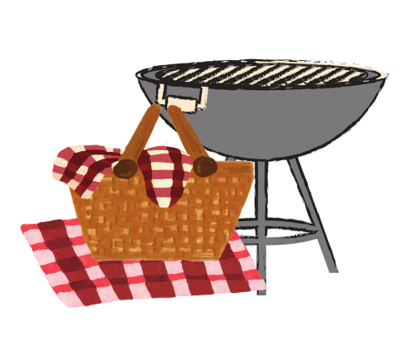

Join us at our Super Summer BBQ Picnic & Kick-Off event “Together Again!” Enjoy fabulous food, shimmering sunshine and the perky presence of our valued Vista Center clients, friends and family. Heroically hosted by lovable Lions Club.

Live Band Entertainment – So don’t miss out on the fun!

Saturday, July 10, 2021
11:00 am – 3:00 pm

Los Gatos Creek Park
1250 Dell Avenue
Campbell, CA 95008

Menu: BBQ meat sandwich (vegetarian options available), sides, chips, drinks

To reserve your space for you and up to 3 guests, please RSVP no later than Wednesday, June 30th^{th} by sending email to Lisa at lquan@vistacenter.org, or by calling Vista Center at (408) 295-4016 and leaving a message. Please indicate how many vegetarian meals when you RSVP. Masks not required for those fully vaccinated. Masks are required for non-vaccinated or keep a 6ft distance.

Hosted by: Almaden Super Lions Club

