TRY BLIND HOCKEY

2018
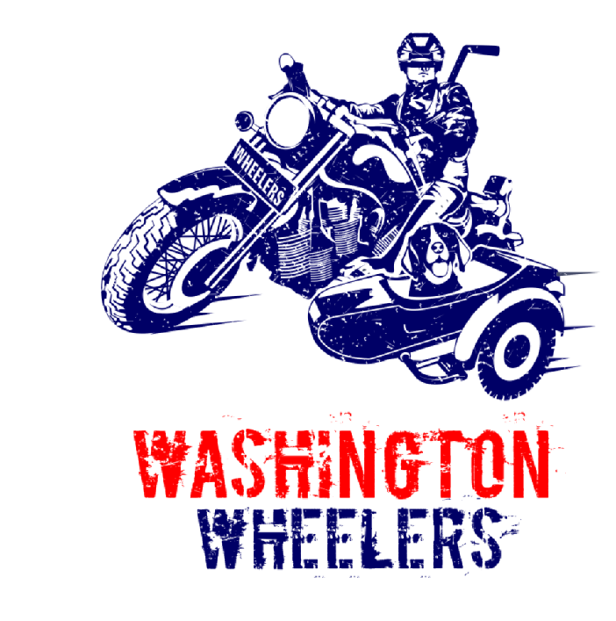

Sunday, January 7, 2018
Kettler Capitals Iceplex
627 N Glebe Rd, Arlington, VA 22203

Adaptive Skate: 10:00 -11:50 am
Blind Hockey Game: 12:00 -1:00 pm
Pizza Party: 1:00-2:00 pm

To register please click on the following link: https://goo.gl/forms/lGSUm6R9GWgPYuDb2
To support this event, please contact: info@washingtonwheelers.org
To volunteer for this event, please contact: mailto:info@washingtonwheelers.org

