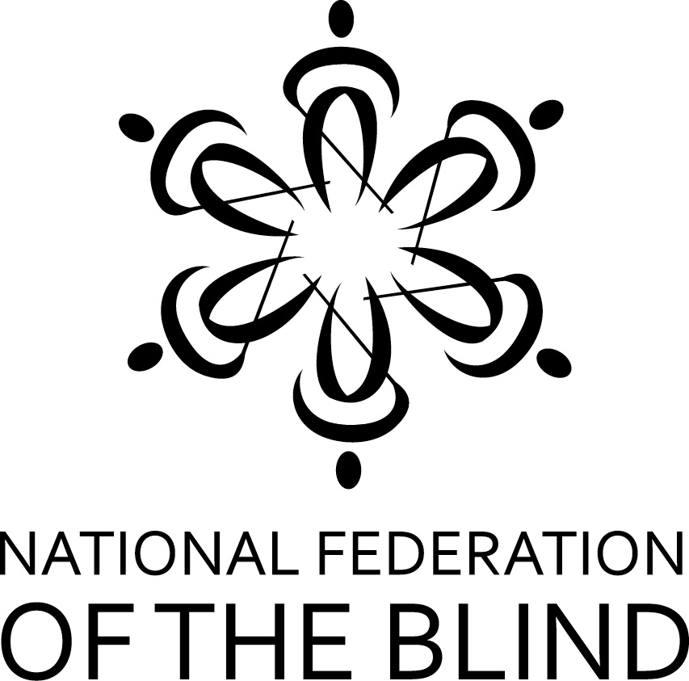

The National Federation of the Blind of Illinois, in partnership with the NFB Jernigan Institute and The American Action Fund for Blind Children and Adults, again announces the annual Nation-wide Braille Readers Are Leaders (BRAL) contest for kids. Students must be K-12, and must reside in a state registered for the contest. Entrants compete to read the most Braille pages, going against other students in similar grades across all participating states. The contest runs for seven weeks, encouraging students to be proud of their Braille reading ability and to work to improve their Braille skills -- while possibly winning prizes in the process.

A thumbnail sketch of the contest:
- For each student who enters, a certifying official (parent, teacher, etc.) must fill out and submit a registration form. This can be done as early as November 1 2018 and as late as January 19 2019.
- Students enter in one of five grade categories: K-1, 2-3, 4-5, 6-8, & 9-12.
- Participants record Braille pages read between December 1 2018 and January 19 2019 on a reading log.
- The certifying official must submit the completed reading log form by February 2 2019.
- Prizes in each grade category are: first, $25; second, $15; third, $10.
- Every contestant, whether a winner or not, will receive a gift bag of Braille-related items at the end of the contest.
- To get the complete contest rules, registration form, and the reading log form, visit the website, http://www.nfbofillinois.org/nationwide-bral-contest.
- Both the registration form and the reading log form can be submitted by email as attachments to Deborah Stein at dkent5817@att.net. Please put Nationwide BRAL plus the contestant’s name in the subject line. Alternatively, you can mail to: Deborah Stein, 5817 N. Nina Ave., Chicago, IL 60631
- In addition to awards in the five grade categories, Kelly Doty Awards of $25 will be given to students who have met unusual challenges in order to learn and read Braille. Such challenges include, but are not limited to, having other disabilities in addition to blindness or being an English language learner.

If you have questions, email the contest administrator, Deborah Stein, at dkent5817@att.net (please put “Nationwide BRAL Question” in the subject line).
Or phone 773-203-1394

“LIVE THE LIFE YOU WANT”

