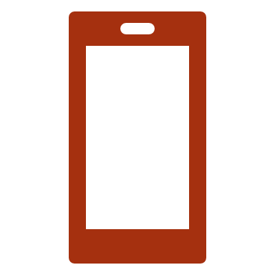
Hands-On Nonvisual Technology Fair

For persons who are Blind

Or Low Vision

Free Admission!
  - Saturday
  - June 22, 2019
10 AM to 2 PM
Lyon Village Community House
1920 N. Highland Street
Arlington, VA 22201

Demonstrations include:

Smartphone Accessibility
NFB Newsline
Smart Home Devices
Braille Displays and Notetakers
Navigation Devices
Household Labeling
Medical Devices
Audio Description Services

And More!

Come join us and get hands-on experience with various technologies that can guide you toward self-confidence and independence!

For questions, more information, or to register, please contact Nancy Yeager by calling (703) 812-0953 or
e-mailing nancyyeager542@comcast.net
You can also register at https://hands-on-technology-fair.eventbrite.com
WALK-INS ARE WELCOME

Hosted by the Potomac Chapter of the National Federation of the Blind of Virginia

