National Federation
of the Blind of Virginia

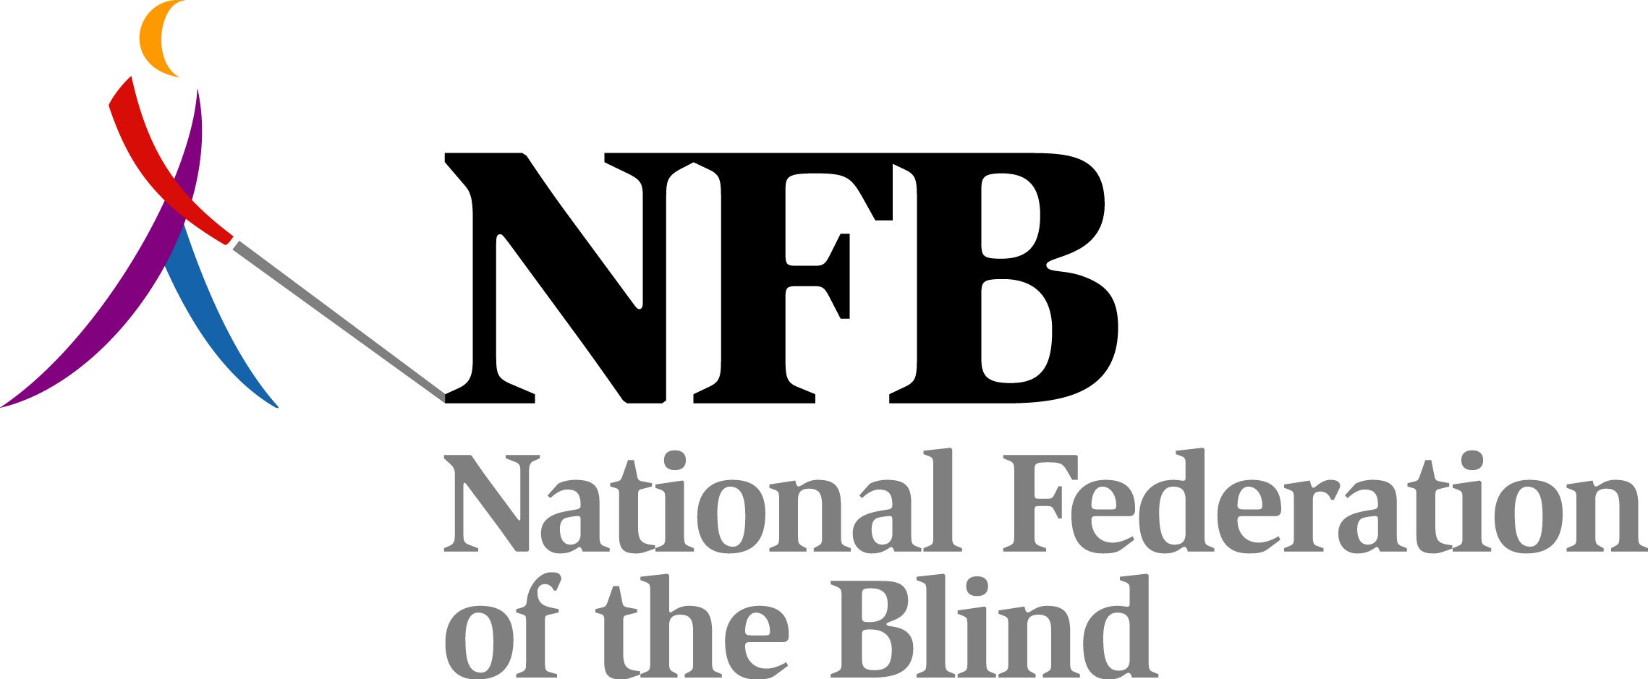

Braille Enrichment for Literacy and Learning
(BELL) Summer Program

Sponsored by the National Federation of the Blind Jernigan Institute, in partnership with the National Federation of the Blind of Virginia and the Virginia Parents of Blind Children.

Are you the parent, guardian, or teacher of a low vision child who would benefit from learning Braille? If so, we have a wonderful opportunity for them this summer!
The BELL program is designed to provide children ages 4 through 12 with low vision or who are beginning braille readers with two weeks of intense braille instruction via hands-on learning and fun activities. Each day, children will be immersed in Braille and increase their use of tactile skills for reading Braille. Children will receive Braille instruction and learn alternative nonvisual techniques through a combination of arts and crafts, games, outdoor activities, and field trips related to the braille curriculum.
A parent seminar will be held to offer parents practical strategies to incorporate non-visual learning and Braille into their children’s daily life.
This program will be led by a certified teacher of the blind and a teacher of the blind in Virginia who are serving as the core instruction team from the National Federation of the Blind Jernigan Institute, along with the participation of positive blind role models and local volunteers.

Program Dates: July 26 through August 6th, 2010.(week days only)
Time: 9:00 a.m. – 4:00 p.m. (before and after care available)
Location: Lion Village Community House
1920 N. Highland St., Arlington, VA 22201 (.5 miles from the Clarendon metro station on the orange line)
Price: $200.00 per student (on or before June 15th)
$225.00 after June 15th
^{Financial} assistance may be available.
Make checks payable to NFBV and mail to Sandy Halverson at
810 22nd St. South, Arlington, VA 22202

For further information contact:
Michael Fish
Teacher of blind students
Phone: 716-353-5986, or
Sandy Halverson
BELL Coordinator
Phone: 703-379-1141
Or you can e-mail questions to: virginiabellprogram@gmail.com

