Important Announcement!!!
The National Certification in Literary Braille (NCLB) test will be administered by the National Blindness Professional Certification Board (NBPCB)
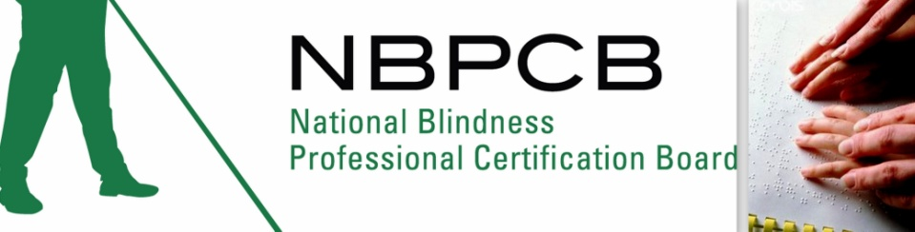

in Baltimore, Maryland
on Saturday March 26, 2011 at
Blind Industries and Services of Maryland (BISM)

Please go to our Website, www.nbpcb.org/nclb to find out more information and to register for this important test! You may also contact Deja Powell at dpowell@latech.edu or at 318.257.2029.

