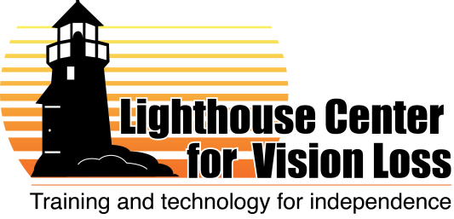

Case Manager/Employment Services Coordinator
Lighthouse Center for Vision Loss
Posted April 20, 2012
Updated May 2, 2012

Note: Job descriptions and duties are subject to change and will depend on the skills and background of the selected candidate, as well as the needs and opportunities of the organization. What is below reflects our best guess of how this position might be structured within our organization.

Overview of the organization:
The Lighthouse has a staff of 12 professionals, and last year we served nearly 1,000 individuals. Our goal is to empower individuals of all ages – and all stages of vision loss -- to live safer, more independent and more fulfilling lives. Our professional instructors teach a wide range of adaptive skills for home and the workplace. We are experts in assistive technology, and we operate a store that offers hundreds of adaptive devices.

Job duties:
The case manager will serve as the primary coordinator of services for clients who are receiving intensive training services at the Lighthouse (approximately 60 students per year). This professional will also provide clients with employment skills instruction and coaching to help clients achieve the goal of long-term employment. The case manager will help coordinate other training services and seminars within the community.
In particular, under the direction of the Executive Director, the case manager will:
- Coordinate intake, individual goal-setting and instructional services for each client, working in collaboration with State Services for the Blind counselors (if applicable) and Lighthouse teaching staff.
- Monitor overall progress for each student and work with instructors to adapt programming to meet individual needs.
- Provide individualized and group counseling sessions to clients to assist them in adjusting to vision loss.
- Provide information about services to prospective clients – answering individual inquiries and making presentations in public.
- Coordinate new client intake.
- Maintain knowledge of other services in the community and coordinate access to needed services.
- Facilitate support groups in the community.
- May serve as liason for volunteers for radio service.
- Provide employment counseling and workforce readiness instruction, assist students with job searches, and help students and employers understand options for job accommodations. Empower participants to be successful in the place of employment. Mentor participants about protocols and expectations for future places of employment.
- Working in conjunction with the Executive Director, this professional will likely play a key leadership role in helping the Lighthouse develop new employment-related programs, for instance internship programs in the community and possibly a job placement program. Ability to build relationships with local businesses and agencies will be important.
- Collect, analyze and report data on client progress and program outcomes.

Qualifications:

- Preferred: bachelor’s or masters’ degree in social work, education, vocational rehabilitation, vision rehabilitation or related. Work experience and other training may be considered as a substitute.
- Must have: computer skills, counseling skills, writing skills, ability to work with basic data, flexibility to do a variety of work, and ability to work occasional weekend and evening hours.
- Must have: demonstrated capacity for problem solving and working collaboratively in a dynamic work environment.
- Personal experience with vision loss would be an asset. If not trained with adjustment to vision loss techniques, must be willing to undergo training at the Lighthouse and via other course work (probably mostly distance learning) to develop expertise.
- Desired: 2+ years’ work experience with one or more of the following areas: employment services, social work, program development, project management, advocacy, public relations, customer service, disability services and/or vision loss services.
- Must know about or have ability to learn about ADA and other disability-related issues as they relate to individuals with vision loss.
- Must have: willingness/ability to travel occasionally around northern Minnesota and Wisconsin, to sit and stand for extended periods, to work in close contact with Lighthouse students, and to work around service dogs.

Compensation:
- Position will likely be full-time, but part-time arrangements might also be considered.
- Salary will be competitive and will depend on experience, qualifications and skills.
- The Lighthouse currently offers generous benefits, including health and life insurance, a retirement savings plan and paid vacation and sick leave.

To Apply:

Send resume, cover letter and list of references to mjunnila@lighthousefortheblind-duluth.org. Call Mary at 218-624-4828 with questions.

