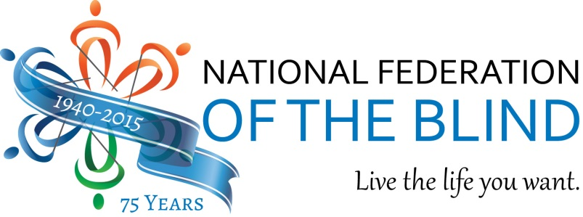

Student Leadership Seminar
Ready Set Go: Lead the Federation

The goal of our student leadership seminar is to offer Blind and visually-impaired high school seniors and college students the opportunity to learn and grow with established federation leaders and to participate in a variety of leadership activities.

Where: The National Federation of the Blind Jernigan Institute
200 East Wells Street at Jernigan Place, Baltimore, MD 21230

When: Friday July 24 thru Sunday July 26

Please RSVP by July 17 by emailing David Bouchard at Davidb521@gmail.com or call 443-529-2976.

The National Federation of the Blind is the largest organization of blind and low-vision people in the United States. Founded in 1940, the Federation has grown to over fifty-thousand members. The organization consists of affiliates and local chapters in every state, the District of Columbia, and Puerto Rico.

