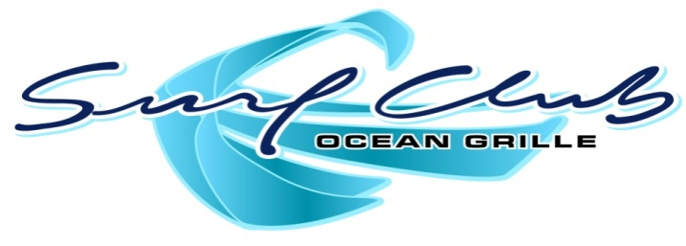
Daily Specials

Philly Cheesesteak
Shaved Ribeye on a Hoagie Roll with Onion,
Peppers and Provolone with Shoestrings
$10

Deep South BLT
Toasted Sourdough with Bacon, Lettuce, Tomato
House Pimento Cheese with Shoestrings
$10

