FOR IMMEDIATE RELEASE
Blind Ambition: International Award for Visually Impaired Adventurers Announces First Three Winners
The LightHouse for the Blind and Visually Impaired Announces First ‘Holman Prize’ Winners from Uganda, the United States and the United Kingdom
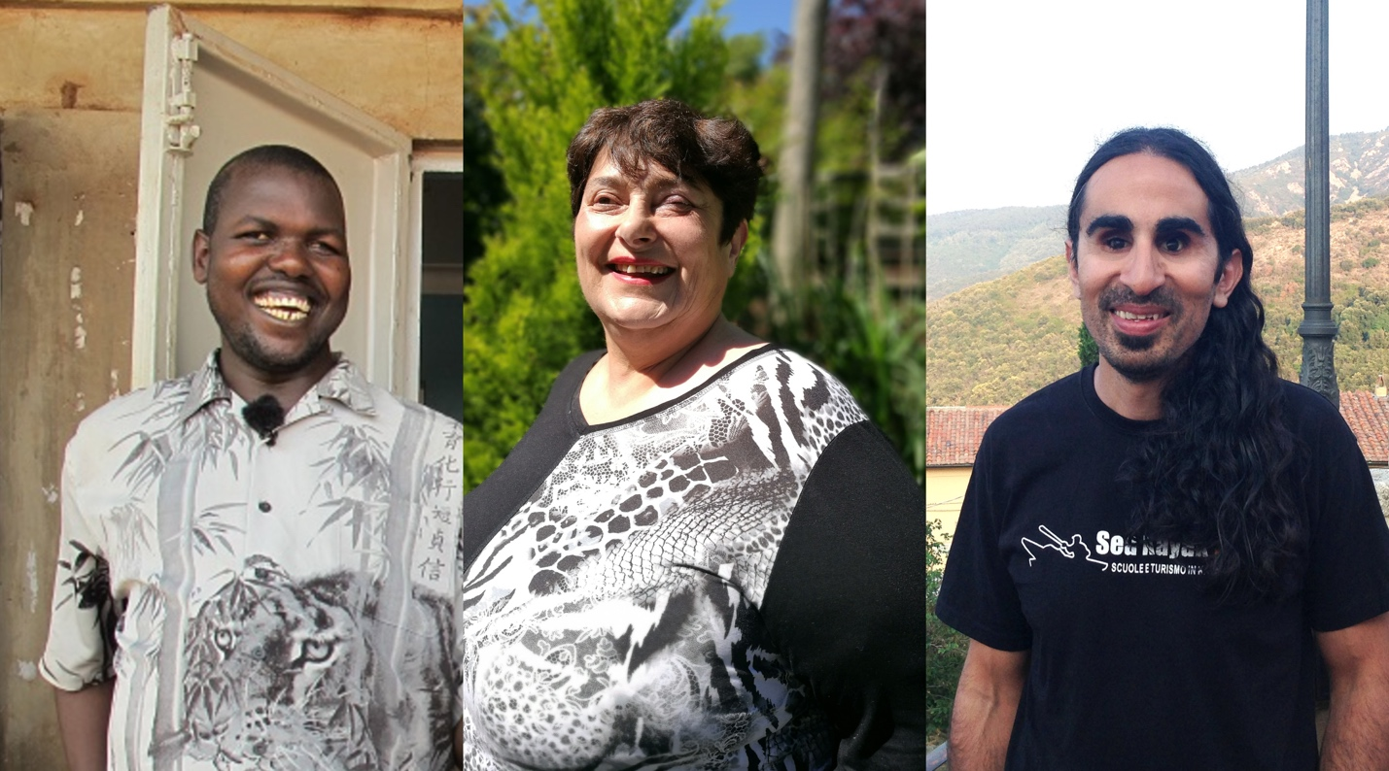
Image: Ojok Simon, Penny Melville-Brown and Ahmet Ustunel, from left to right, are the winners of the first-ever Holman Prize for Blind Ambition, awarded by The LightHouse for the Blind and Visually Impaired in San Francisco.
SAN FRANCISCO – June 29, 2017 – This fall, three exceptional blind individuals will set off around the world on adventures they never imagined possible, thanks to a new award called The Holman Prize for Blind Ambition.
Created by the LightHouse for the Blind and Visually Impaired in San Francisco to honor “blind ambition” in all its forms, the annual $25,000 awards will spring-board future generations of entrepreneurs, adventurers and ambassadors in the blindness community.
With over 200 applicants from 27 countries, The Holman Prize saw stiff competition in its first year. All applicants were required to upload 90-second YouTube videos to pitch their idea for a dream project with a $25,000 budget, and later asked to submit formal proposals.
The three winners, Ahmet Ustunel, Penny Melville-Brown, and Ojok Simon, were announced Thursday morning after a rigorous judging process that narrowed down the applicants to eleven highly competitive finalists. Each winning project embodies its own sense of adventure and ambition – whether it takes the winners around the world or allows them to build and foster social impact in their immediate community.
Named after the 19th century explorer James Holman (known around the world as “the blind traveler”) The Holman Prize aims to launch worthy projects that will change the public perception of blindness for years to come.
“We are thrilled to support these three individuals,” LightHouse CEO Bryan Bashin noted Thursday with the announcement. “They are all incredibly ambitious in different ways, and their projects will have a real effect on the way blindness is perceived globally. I think about Ahmet’s determination, Penny’s cultural savvy, and Ojok’s entrepreneurial spirit – this is what blindness looks like today. These three will change minds about what blind people can accomplish.”
The 2017 Holman Prize Winners
The Three Holman Prizewinners will fly to San Francisco in September 2017 for a week-long orientation before starting their projects on October 1. Once they land in San Francisco, the winners will not only meet and learn from each other, but they will engage with other blind teachers, technologists and leaders from LightHouse’s extended network. The winners will also create comprehensive plans to document and share their experiences along the way through video, audio, writing and other storytelling mediums.
Ahmet Ustunel’s project has a clear, unprecedented goal: to kayak solo, without eyesight, from Europe to Asia. With potential for a dramatic climax and high stakes, Ustunel’s proposal to cross the 3-mile Bosphorus Strait caught the attention of the Holman Prize Committee and proved to be a compelling and unprecedented undertaking. By training in California and working to develop a suite of non-visual guidance technology to thrive on his own in the water, Ustunel hopes to join the ranks of other great blind outdoor heros such as Erik Weihenmayer, Lonnie Bedwell and others.
Learn more about Ahmet.

Penny Melville-Brown has a project with a universal focus: food. With a deep belief in the power of food to connect people, Penny’s project is a bid to claim a place at the stove for blind chefs everywhere. Penny’s intentions are less about competition and perfection and more about connecting with others through culture and shared experience. Maybe she’s the blind Julia Child – or the blind Anthony Bourdain – either way, as Penny documents her travels and successes in her series, “Baking Blind,” the world will follow along with her.
Learn more about Penny.

Ojok Simon will take on a drastically different kind of project than his fellow winners. Simon seeks to raise employment rates for blind and partially sighted individuals in rural regions of his home country of Uganda. His method? Teach them a very specialized and somewhat unlikely skill: beekeeping. For decades, Simon has been a passionate beekeeper finding ways to tend bees in nontraditional and non-visual ways. Simon wants to impart his warm attitude and entrepreneurial spirit on other blind individuals in Africa and abroad, rather than seeing them relegated to poverty and reliance on charity.
Learn more about Ojok.

Interviews and images available upon request.

Holman Honorees: Meet this year’s finalists.
Meet the blind judges who picked the winners.

Support the Holman Prize
The LightHouse for the Blind and Visually Impaired, which is a 501(c)(3) nonprofit organization based in San Francisco, is actively seeking sponsorships and support for the 2018 Holman Prize, including donations of equipment for the winner’s projects. To offer your support, contact holman@lighthouse-sf.org. Individuals may donate any amount using LightHouse’s secure form. For sponsorship inquiries, email us or call +1 (415) 694-7333.
About LightHouse for the Blind and Visually Impaired
Founded in 1902, San Francisco’s LightHouse for the Blind and Visually Impaired promotes the independence, equality and self-reliance of people who are blind or have low vision. LightHouse offers blindness skills training and relevant services such as access to employment, education, government, information, recreation, transportation and the environment. LightHouse also pursues the development of new technology, encourages innovation, and amplifies the voices of blind individuals around the world. To receive services, volunteer or make a donation, visit lighthouse-sf.org.

Press contact:

Will Butler, Director of Communications
+1 (415) 855-1642
press@lighthouse-sf.org

